EPS@ISEP | The European Project Semester (EPS) at ISEP



Author(s):
- Marta Majewska
- Melanie Tscholl
- Manuel Baptista
- Christopher Mahon
- Sven Bergervoet

Table of Contents
- Report
  - Acknowledgement
  - Glossary
  - 1 Introduction
    - 1.1 Presentation
    - 1.2 Motivation
    - 1.3 Problem
    - 1.4 Objectives
    - 1.5 Requirements
    - 1.6 Functional Tests
    - 1.7 Project Planning
    - 1.8 Report Structure
  - 2 State of the Art
    - 2.1 Introduction
    - 2.2 Existing Solutions
    - 2.3 Electronics/Technology
    - 2.4 Conclusion
  - 3 Project Management
    - 3.1 Scope
    - 3.2 Time
    - 3.3 Cost
    - 3.4 Quality
    - 3.5 Human Resources
    - 3.6 Communications
    - 3.7 Risk
    - 3.8 Procurement
    - 3.9 Stakeholders management
    - 3.10 Conclusion
  - 4 Marketing Plan
    - 4.1 Introduction
    - 4.2 Market Analysis
    - 4.3 SWOT Analysis
    - 4.4 Strategic Objectives
    - 4.5 Segmentation
    - 4.6 Strategy/Positioning
    - 4.7 Adapted Marketing-Mix
    - 4.8 Budget
    - 4.9 Strategy Control
    - 4.10 Conclusion
  - 5 Eco-efficiency Measures for Sustainability
    - 5.1 Introduction
    - 5.2 Environmental
    - 5.3 Economical
    - 5.4 Social
    - 5.5 Life Cycle Analysis
    - 5.6 Conclusion
  - 6 Ethical and Deontological Concerns
    - 6.1 Introduction
    - 6.2 Engineering Ethics
    - 6.3 Sales and Marketing Ethics
    - 6.4 Environmental Ethics
    - 6.5 Liability
    - 6.6 Conclusion
  - 7 Project Development
    - 7.1 Introduction
    - 7.2 Architecture
    - 7.3 Components Product
    - 7.4 Components Prototype ​
    - 7.5 Functionalities
    - 7.6 Tests and Results
    - 7.7 Conclusion
  - 8 Conclusions
    - 8.1 Discussion
    - 8.2 Future Development
  - Bibliography
    - List of figures
    - List of tables

Acknowledgement

Glossary
Abbreviation | Description
CO₂ | Carbon Dioxide
CPU | Central Processing Unit
EPS | European Project Semester
GDP | Gross Domestic Product
ISEP | Instituto Superior de Engenharia do Porto
RACI | Responsible, Acountable, Consulted, Informed
RAM | Responsibility Assignment Matrix
ROHS | Restriction of Hazardous Substances
SMART | Specific, Measurable, Achievable, Relevant, Timed
SWOT | Strenghts, Weaknesses, Opportunities, Threats
USB | Universal Serial Bus
PDCA | plan–do–check–act or plan–do–check–adjust
RTC | Real Time Clock

1 Introduction

1.1 Presentation
Team N.4 consists of five students, all with different backgrounds of education and all from different countries. We are spending the spring semester of 2018 in Porto working at ISEP on our European Project Semester
The team members:
- Marta Majewska (Logistics) from Poland
- Melanie Tscholl (Media Technologies) from Italy
- Manuel Baptista (Mechanical Engineering) from Portugal
- Christopher Mahon (Electric, Electronic and Energy Engineering) from United Kingdom
- Sven Bergervoet (Industrial Product Design) from The Netherlands
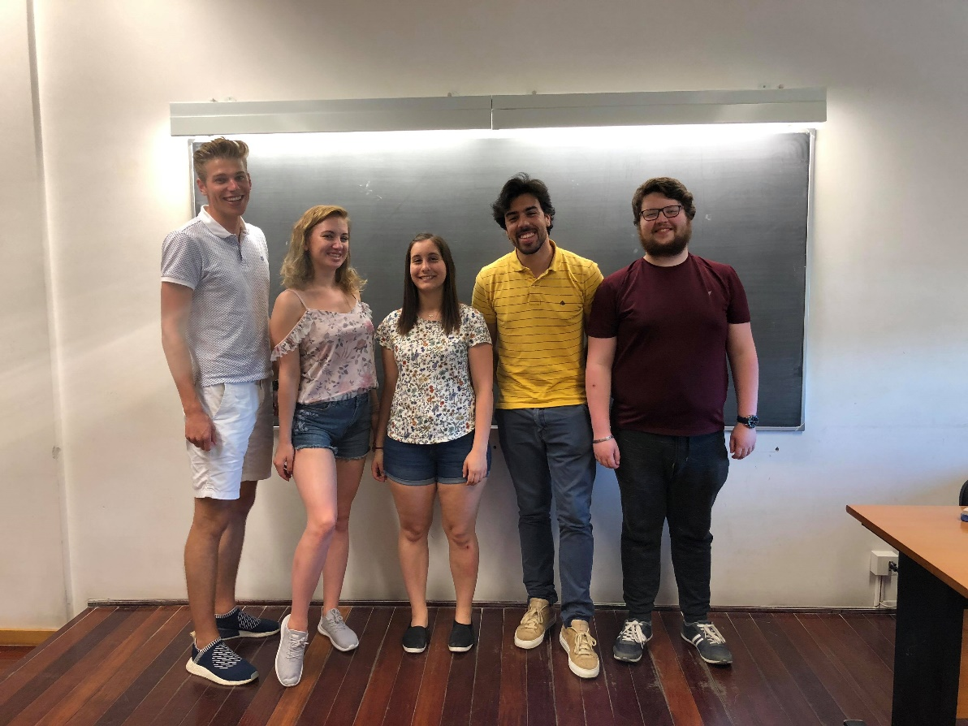
Figure 1: Group Photo

Five foreign people have been connected to create one big project. Our mascot during the integration day was a colourful unicorn - to remind us to be creative and fun during the implementation and development of our project.
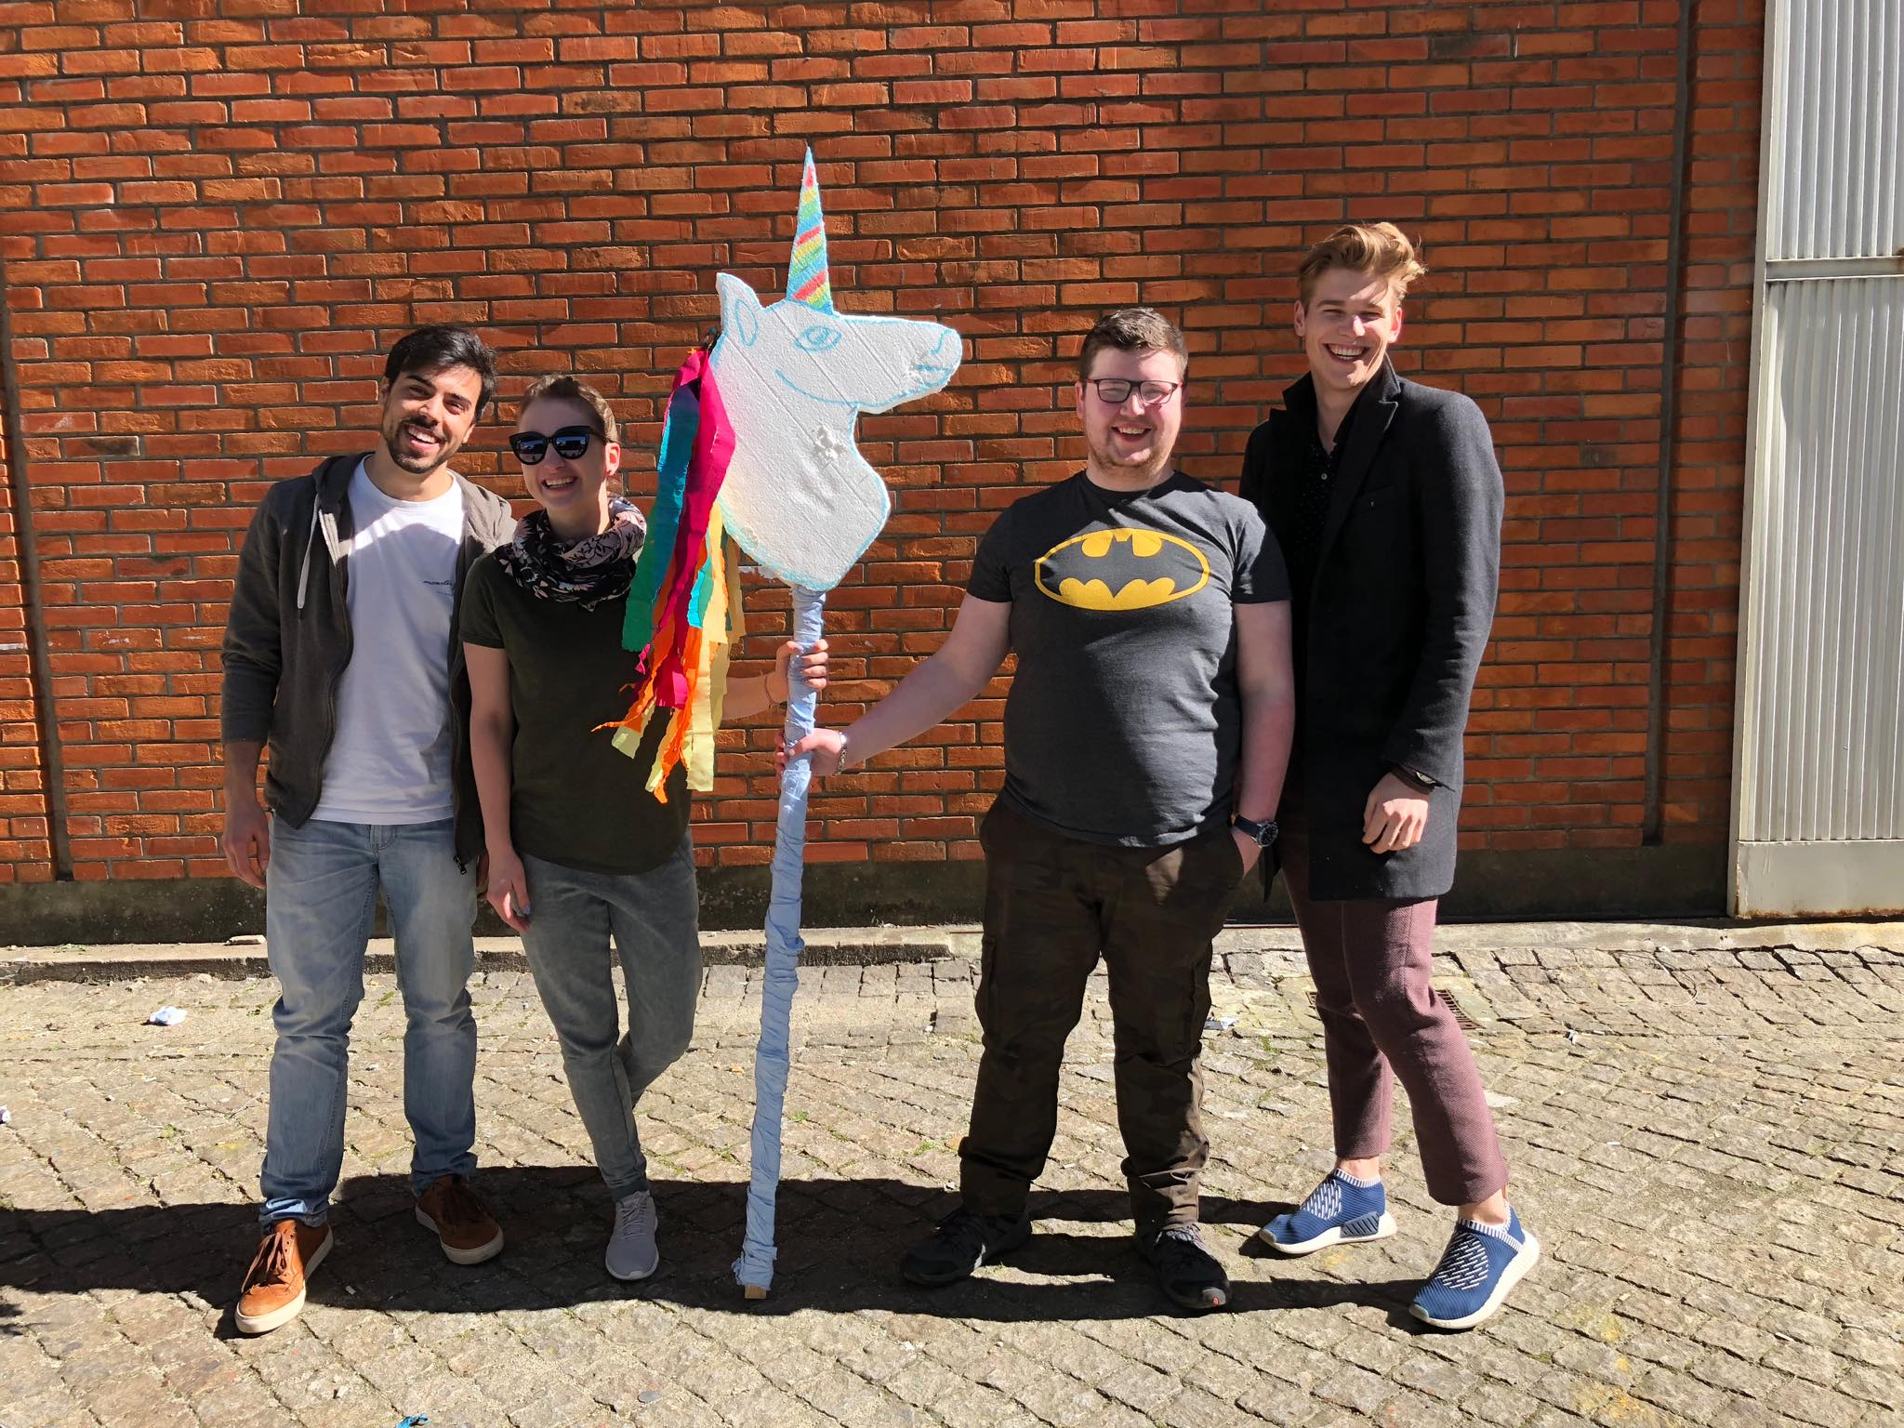

Figure 2: Teambuilding day photo
We hope that by using our already acquired knowledge from our countries and the new knowledge gained in Portugal in ISEP, we will be able to implement the whole project with a satisfactory final result for teachers and us as members of the team, as well as meet all the requirements related to it.

1.2 Motivation

Before ​starting ​a project ​there is always a motivation behind it and figuring out why are you doing this project is one of the key elements of our motivation. Always remember ​what is at the the core is of the project. At the beginning of this semester we started with a group from all sorts of backgrounds, all from different countries to work on a project that is in our case the Outdoor Intelligent Shader. The motivation is to create a new market relating to '​shaders'​. This means combining a traditional shader with smart electronics that are able to connect, share and interact with its user or other smart devices. Not only is the motivation based on the product but also the fact that we as a group try to work together, learn from each other and expand our point of view. While we are all from different countries, speak different languages and have different cultural backgrounds, we are still highly motivated to work as best we can with each other.

1.3 Problem

Before starting to work on the product the problems we are aiming to solve need to be defined. This is so you are working to a specific goal. In this case, that means solving the problems that occur during the construction of the Outdoor Intelligent Shader.
The main problem is: How can a shader be constructed so that there is a constant shade on the terrace while using smart electronics?
Now the main problem is set, it needs to be broken down in sub-problems:
- What is the design?
- How can it be constructed?
- How do the electronics work?
- How is this product going to be presented to the target audience?

1.4 Objectives

The objectives of this project are to design an outdoor intelligent sun shader that detects the sun by itself with the aid of software that knows the path of the Sun. It will be very useful for the consumer because the product will provide shade without the need to constantly keep changing the position of the shader. The aim is to put technology, modern design, and also sustainability into an everyday product. The objective we want to reach is that people will feel more comfortable in a greener planet which cares for its own sustainability. Our other objective is to work well in a team and to learn to cooperate in a multicultural environment. The European project semester is also about observing deadlines and taking it seriously, in other words to be responsible. It is about discussion, listening, support and coming to a decision together.

1.5 Requirements

Before starting a project, it is really important to set up all the wishes and requirements for your product. This is done via the list of requirements, represented in Table 1. The list shows via different categories which requirement belongs to which part. During the project the list of requirements will change it is a so called '​living document'​. Throughout the project new ideas and insights will pop up or different ways to approach the problem will occur. Also, the part description is added to give a clear visual of what requirement it for what part.

Table 1: Team Requirements
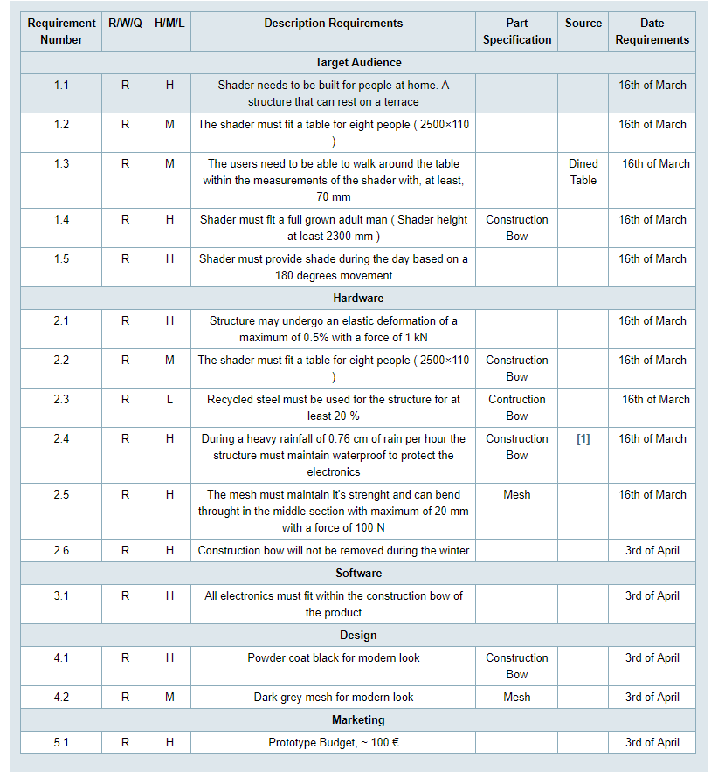

1.6 Functional Tests

We, as a team, need to evaluate if the product we are designing for our project is well done, and for that we are going to do a few functional tests. The main objective of these tests is to find problems not detected during the theoretical part of the project so we can correct them and have a functional product, ready to be placed on the market. The tests we are going to do are:
- Motor torque - Check if the motor has enough capacity to provide the amount of force needed to move the shader
- Delay - Check the delay between the controller order and the actuator response
- Gear Functionality - Capacity of the gear to keep up with the movement
- Structure safety - This test needs to be done in a simulation software, because the prototype material is different from the one we are going to use in the actual product, and for that reason we can't do these tests in a real model
- Sensor - Check if the sensor works as it is supposed to work, and if the cloth chosen is detected by the sensors

1.7 Project Planning
Table 2 shows the different tasks the team needs to perform, as well as the person/people responsible for it.

Table 2: Task identification and allocation

Task | Responsible (s)
Initial Planning
Task Identification and Allocation | Manuel/Sven
Gantt Chart | Manuel
Technical Research | Christopher/Melanie
Market Research | Marta
Initial Budget Planning | Marta
Purpose Definition | All
Specific Planning
System Diagrams | Melanie/Christopher
Structural Drafts | Manuel/Sven
Design | Sven
List of Materials and Budget Re-planning | Marta
Interim
Eco-Efficiency Measures for Sustainability | Sven
Ethical and Deontological Concerns | Melanie
Project Management | Manuel
Upload Interim Report and Presentation | Christopher
Interim presentation | All
Upload Refined Interim Report | Marta
Complete List of Materials | Marta
Construction
Construction Hardware | Manuel/Sven
Construction Software | Christopher/Melanie
Testing
Product Testing and Corrections | Christopher/Manuel/Sven
Upload Functional Test Results | Marta/Melanie
Final
Upload the Final Report and Presentation | Christopher
Upload the Movie, Poster, Manual and Leaflet | Melanie
Final Presentation, Individual Discussion and Assessment | All
Upload the Wiki with all Correction Suggestions | Marta

1.8 Report Structure
Table 3 shows the structure of the report from team 4.
Table 3: Report structure
Section | Title | Description
1 | Introduction | Brief description about the project, the objectives and requirements
2 | State of Art | Technological and market research. All the information that might help us decide how to do our project
3 | Project Management | The task and time allocation. How the team manage our time and tasks considering the resources the team has
4 | Marketing Plan | Who's our target audience
5 | Eco-efficiency Measures for Sustainability | All the concerns the Team needs to take care in order to have a sustainable product
6 | Ethical and Deontological Concerns | All ethical concerns regarding the project
7 | Project Development | Development of the project, problems faced and how the team solved them
8 | Conclusions | A brief summary about the project and main conclusion

2 State of the Art

2.1 Introduction
The existing products, as well as the electronics that are available in the market and can be used in our project, are going to be presented in this chapter. It will serve to get new ideas that we may, or may not, implement in our product. The research concerning the existing products includes intelligent and non-intelligent shaders, because the intelligent shaders market is still very small, and does not provide many solutions.

2.2 Existing Solutions
In this part, we are going to unveil some solutions that already exist in this field of study, taking in to account that only one of the solutions is intelligent.
2.2.1 Parasol
Purpose:
The actual purpose of a parasol, is to provide shadow to offer some comfort, and to prevent people from catching sunburns that could result in serious health problems. There are two main kinds of parasols, the ordinary beach parasol, as presented in Figure 3, are seen usually at beaches and pools. There are also commercial parasols, as shown in Figure 4, normally used by restaurants, cafes, hotels, etc. The purpose is the same for both, what changes is the panorama where they are inserted.


Figure 3: Ordinary Beach Parasol [2]
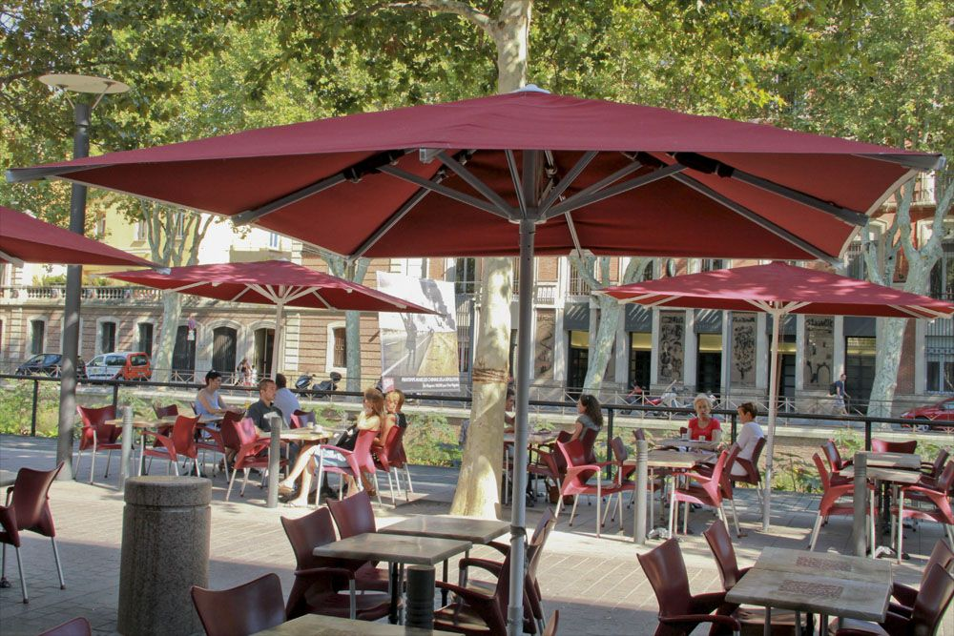

Figure 4: Commercial Parasol [3]
Structure:
In this section, we need to split these two types of parasols because they are built with different kind of objectives, and so the way their structure is projected is different. The ordinary beach parasols are normally made with very cheap and weak materials, such as plastics with some cloth on top. This type of parasol is lightweight, so is very easy to transport. There are also some parasols made with iron, those are a little bit heavier, but the possibility of disassembling the parasol means these parasols are also very easy to transport. The commercial parasols are usually made with better materials, are more resistant, because they are made to businesses, which means the security and sturdiness of the parasol needs to be way higher than in the ordinary parasol. This differences are perceptible if we compare Figure 3 and Figure 4.
Table 4 includes the pros and cons of beach parasol, and Table 5 includes the pros and cons of a commercial parasol.
Table 4: Ordinary Beach Parasol Pros and Cons
Pros | Cons
Cheap product | Weak materials
Easy to transport | Need to be adjusted by hand
Effective in its purpose | Short life cycle

Table 5: Commercial Parasol Pros and Cons
Pros | Cons
Effective in its purpose | Expensive product
Strong materials | Need to be adjusted by hand
Longer lifecycle | Hard to transport

2.2.2 Canopy
Purpose:
A canopy is an overhead structure able to provide shade or shelter, so it does the same thing as parasol but is more robust and usually is a fixed structure, it is used normally in terraces and public spaces. A canopy can be made of various materials, such as, vinyl, acrylic, polyester or canvas [4].
Structure:
This type of product is usually very steady, robust and strong, as shown in Figure 5 . The modern ones have very high strength-to-weight ratio, and the fabric used to do the ceiling of the canopy has some important characteristics when it comes to human security, such as flame retardant and strength.
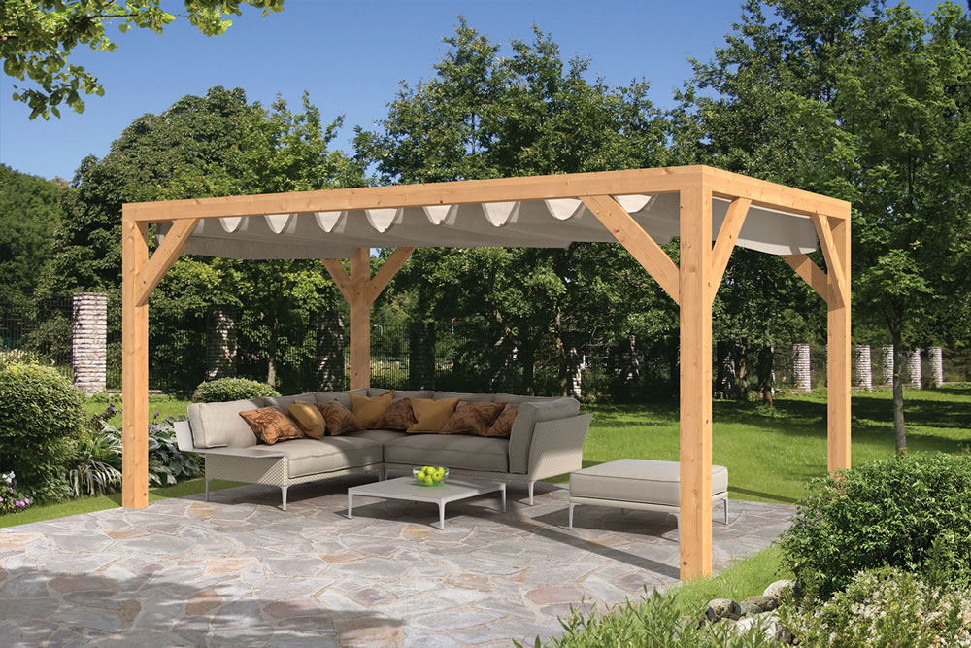

Figure 5: Garden Canopy [5]

Table 6 considers the pros and cons of this structure.
Table 6: Canopy's Pros and Cons
Pros | Cons
Strong structure | Fixed structure
Long life cycle | Not moving by itself

2.2.3 Awning
Purpose:
An awning is a sort of a supplemental cover that helps control intense sun exposure and heat. This kind of structure can be stationary, as presented in Figure 6, retractable, as shown in Figure 7, or a mixture of both, like in Figure 8, usually, awnings are made of materials like aluminium, cloth, vinyl, or wood. They are placed on the outside of a building, usually supported by a wall. Once this type of structure prevents that the full spectre of heat enters the building, it helps to save some money because it decreases the need for air conditioning [6]

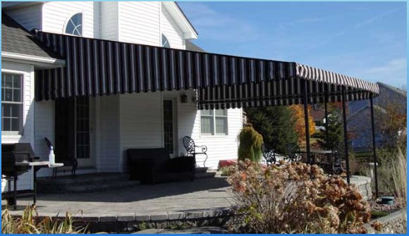

Figure 6: Stationary Awning [7]
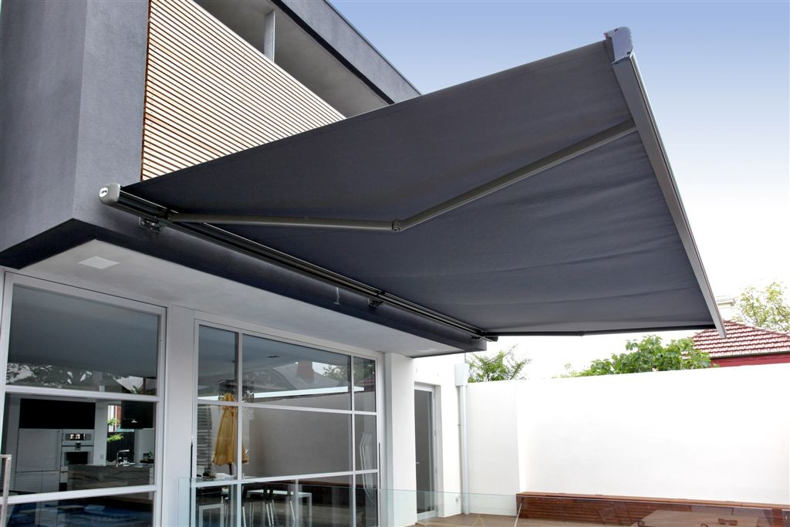

Figure 7: Retractable Awning [8]
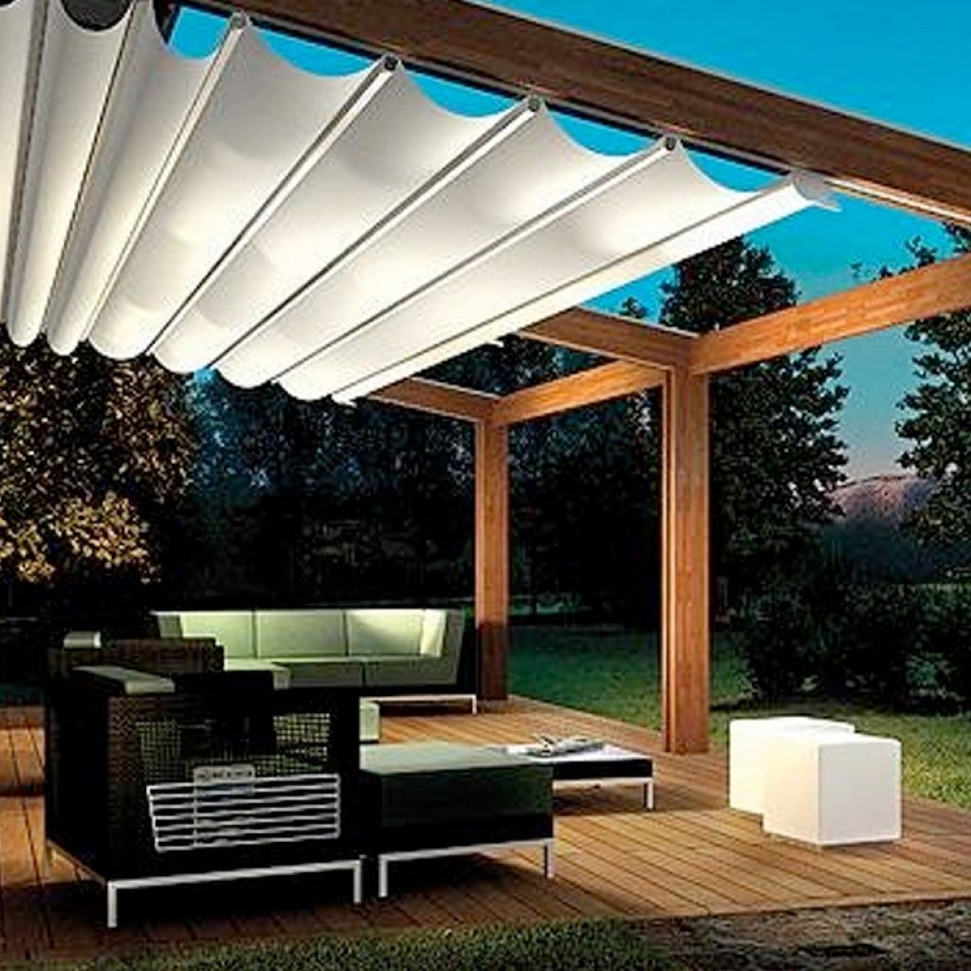

Figure 8: Mixed between a fixed and retractable awning [9]
Structure:
Since it can be stationary, retractable or mixed, the sturdiness depends on the type of awning selected. The retractable ones are usually less resistant and more fragile than the fixed ones, however they offer the possibility to choose between catching sun and have some shade, the mixed options represents, in our opinion, an upgrade, because it has strong material as the stationary ones but provide to the user the possibility to choose between catching sun or have some shade.
Table 7 includes the pros and cons of stationary awnings, Table 8 includes the pros and cons of a retractable awnings and Table 9includes the pros and cons of mixed awnings.

Table 7: Stationary Awnings Pros and Cons
Pros | Cons
Not too expensive | Fixed structure
Helps to save money on energy | Non-intelligent structure
Effective in its purpose | Short life cycle due to weather tear

Table 8: Retractable Awnings Pros and Cons[10]
Pros | Cons
Helps to save money on energy | Big initial investment
Possibility to choose between catching sun or have shade | If motorized, need to replace the motors periodically
Longer lifecycle | Hard to clean

Table 9: Mixed Awnings Pros and Cons
Pros | Cons
Helps to save money on energy | Impurities can stop the path of the canvas
Possibility to choose between catching sun or have shade | If motorized, need to replace the motors periodically
Sturdy as the fixed ones | Big initial investment

2.4 ShadeCraft Sunflower
Purpose:
This product follows the sun to provide a consistent shade, as well as comfort with some high-end features, such as built in speakers, Wi-Fi, Bluetooth, HD camera to take selfies, it has also its own source of energy powered by some solar panels [11].
Structure:
In order to provide the best for their costumers, ShadeCraft installed some high-end features in their product, shown in Figure 9. Such as, wind sensors, that will measure the velocity of the wind so if the wind is too strong the structure can closes by it self, a proximity sensor, used to protect the costumer, it works by calculating the distance between the Sunflower and the obstacle in question to make sure it doesn’t hit anything when is opening, environmental sensors, such as, temperature, humidity, UV radiation, air quality, this sensors are there to provide information to users, it also as an app that is directly connected to the ShadeCraft Sunflower and displays all the information measured by the sensors [12].
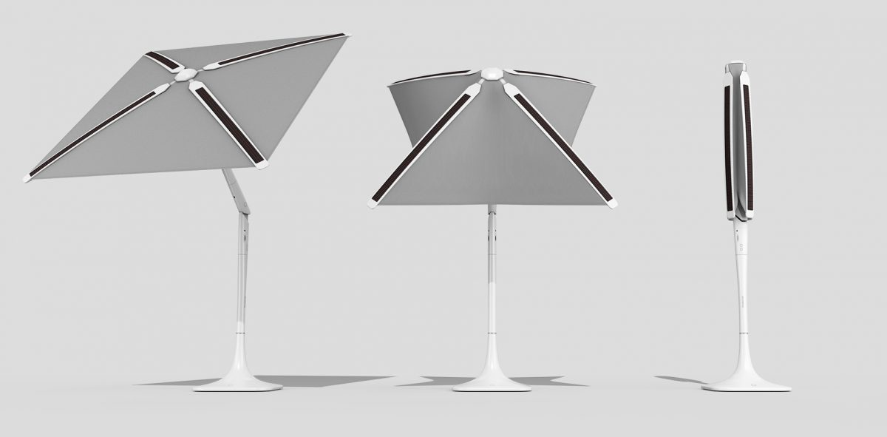

Figure 9: ShadeCraft Sunflower [13]

Table 10 contains the pros and cons of this product.
Table 10: Shadecraft Sunflower Pros and Cons
Pros | Cons
High tech instruments | You need a garden with space
Provide comfort | Very expensive
Follows the movement of the sun (intelligent)

2.3 Electronics/Technology

Sun Tracking
There are two different ways of following the route of the sun during the day. The first possibility is to use sensors that measure the intensity of the sun. TSL45315 for example, as presented in Figure 10, is a digital ambient light sensor. It gives back measured values in Lux. With these values it would be very easy to give the command to move the motors to get the shade in the right position. It is also easier to find different sources for certain components of coding which are needed for our shader. On the other hand it is very complex to choose the right position of the sensors and also the cabling could be difficult.
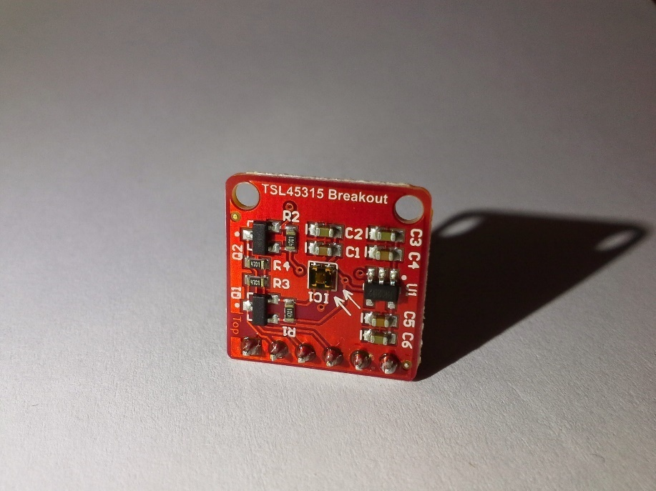

Figure 10: Light sensor TSL45315 [14]
The second option is to programme a real time clock that already knows the apparent movement of the sun. Here it is necessary to set the date, the time and the geographocal location. Then the position of the sun has to be calculated. There already exists a code of Solar Position Algorithm for Solar Radiation Applications which is useful for our sunshader because it is very precisely. The advantage of this option is that the sensors are not needed and the cabling is much easier.
Controller
A controller will give the possibility to choose where the shader should stay. Probably the consumer doesn’t want to cover the spot with the shader even if there is sun. So he has the option to move it wherever he wants. It is planned to programm a controller for the phone. The consumer can just press two buttons (one for activating the manual movement, one for choosing the direction) and this sends an impulse to the motors to move in the desired direction.

2.4 Conclusion
After the research in the state of art, our team decided to combine some features from different types of structures. We want to build a fixed structure, semi-deployable, which means that some parts of the structure can be easily disassembled in order to have a longer life cycle and to clean easier. We want to provide shade and comfort to people, with a structure that can be used in terraces and gardens. The main objective of our project is to provide a consistent shadow over a table. We believe there is a gap in the market that we can explore.

3 Project Management

3.1 Scope
The scope shows in Figure 11 of the a chart that explains how the project is structured.
In this way is managed to work according a structural way.
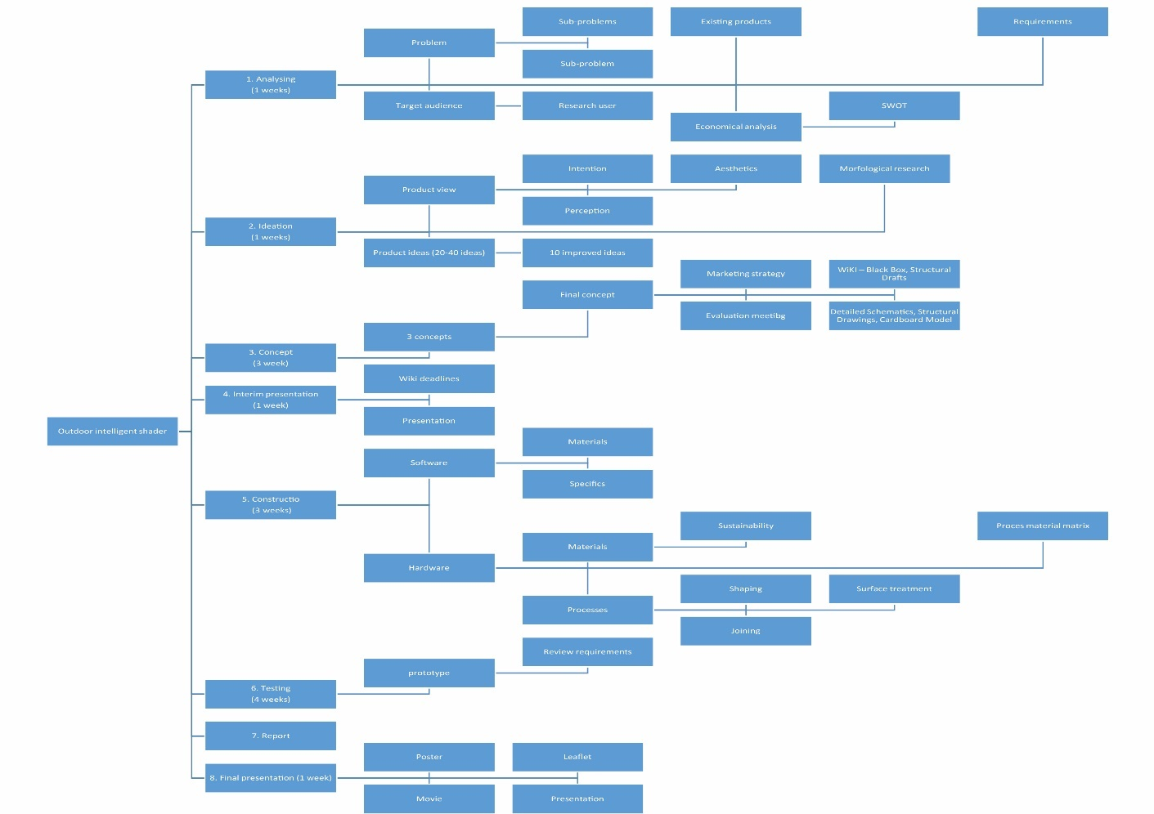

Figure 11: Scope
3.2 Time
In order to help the team to manage time, we used a gantt chart, as presented in the Figure 12 and Figure 13.
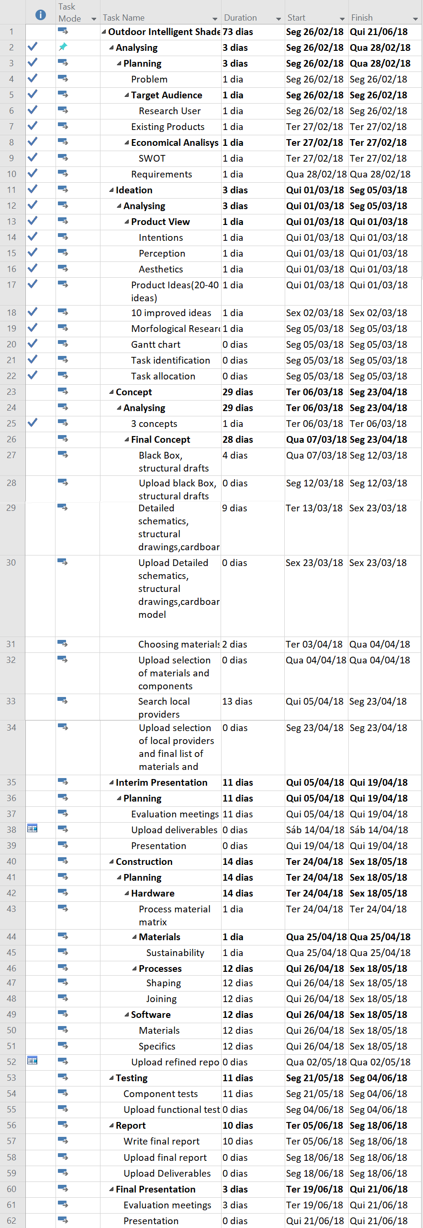
Figure 12: Gantt Chart
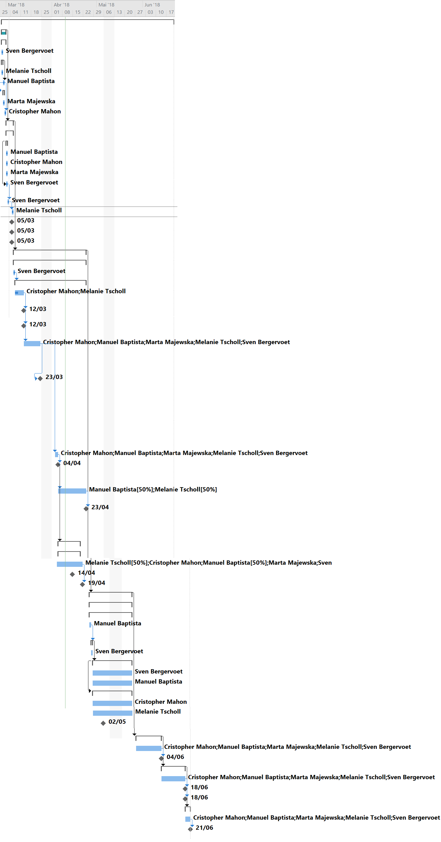
Figure 13: Gantt Chart

3.3 Cost
Cost management is really important in any project, it allows us to manage the budget in a conscious way. This project had a budget limit of 100.00 €. There are two types of costs: work resources costs and material resources costs.
Work resource costs depends on time, and quantity of work of each one of the people involved in the project. This budget is calculated on the cost by hour and the duration of the work any of the team members has assigned. The hipothetical work resources costs of our team are expressed in Figure 14 and Table 11.
Table 11: Working Cost Table

Name | Work load (h) | TotalCost (€) | €/h
Marta | 328 | 2460 | 7,50
Melanie | 464 | 3480 | 7,50
Sven | 448 | 3360 | 7,50
Christopher | 456 | 3420 | 7,50
Manuel | 440 | 3300 | 7,50

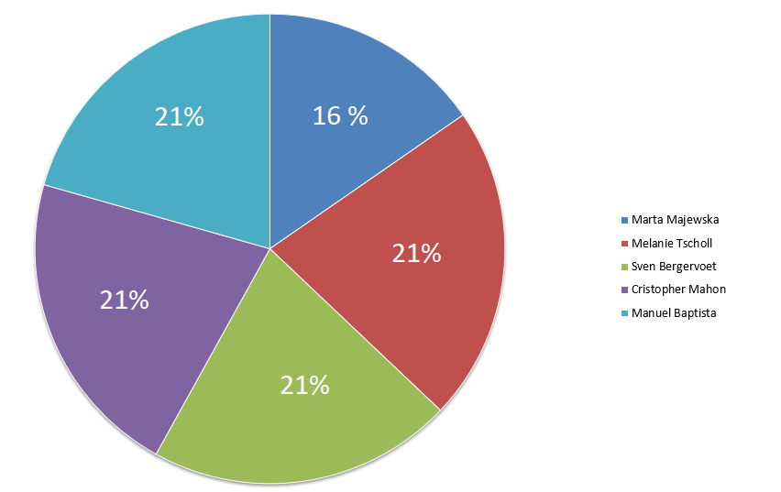

Figure 14: Working Load

Material resources costs are based on the price of each component and its quantity. Figure 15 shows the percentage each component took from the budget and Table 12 displays the list of materials and their respective prices. In order to do this, the Team ordered the necessary material from different suppliers and reused some materials from ISEP.

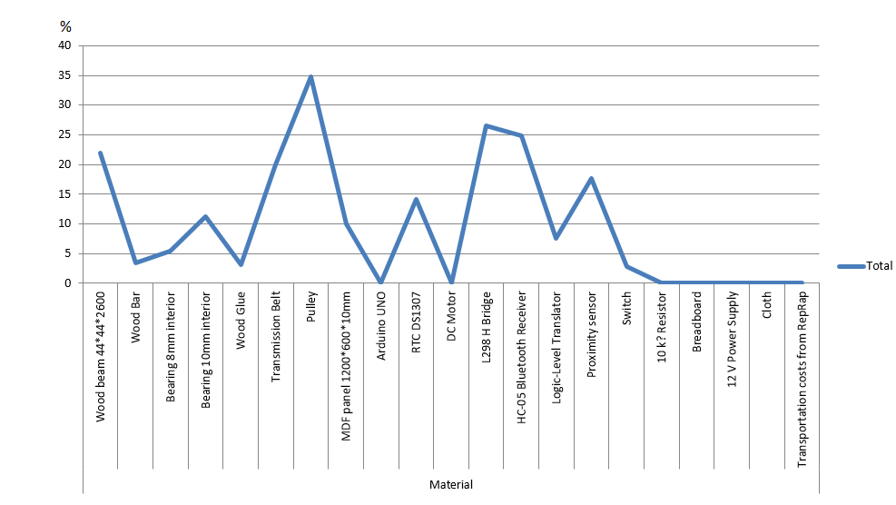

Figure 15: Materials Cost Percentages

Table 12: Materials Cost Table

Material ​ | Quantity ​ | Unitary price | Final price
Wood Beam 44*44*2400 | 2 | 5.49 € | 10.98 €
Wood Bar ø10*2400 | 1 | 1.69 € | 1.69 €
Panel 1200*600*10 | 1 | 4.99 € | 4.99 €
Woodglue | 1 | 1.59 € | 1.59 €
Bearing ø8mm | 3 | 0.90 € | 2.70 €
Transmission Belt | 5 | 2.00 € | 10.00 €
Pulley | 6 | 2.90 € | 17.40 €
Bearing ø10mm | 4 | 1.40 € | 5.60 €
Cloth | 1 | 0.00 € | 0.00 €
RTC DS1307 | 1 | 4.70 € | 4.70 €
HC-05 Bluetooth Receiver | 1 | 8.30 € | 8.30 €
Proximity Sensor | 2 | 2.95 € | 5.90 €
Switch | 1 | 0.95 € | 0.95 €
L298 H Bridge | 1 | 8.85 € | 8.85 €
Logic-Level Translator | 1 | 2.50 € | 2.50 €
Arduino UNO | 1 | 0.00 € | 0.00 €
DC Motor | 1 | 0.00 € | 0.00 €
10 kΩ Resistor | 1 | 0.00 € | 0.00 €
BreadBoard | 1 | 0.00 € | 0.00 €
12 V Power Supply | 1 | 0.00 € | 0.00 €
 |  | Total ​ | 86.15 €

3.4 Quality
Quality management is defined as the practice of making sure that outcomes, benefits and processes of any particular project meet the requirements that were set forth by the stakeholders and that the final product is fit for purpose [15].
Broadly speaking quality management as interpreted by our group can be broken down into seven sub-groups of project management ideologies.

These seven sub-groups are as follows:
- Customer Focus
Throughout the process of our project we must be constantly aware of what our customers are most likely to value in their product and to ensure that our product does simply not emulate the exact same functions and aesthetics as other products on the present consumer market we will be competing against. Also, it is important to uphold a good, healthy customer relationship to do what we can to ensure loyalty from our current customers and to increase good word-of-mouth promotion to let potential customers know we are a good choice.
- Leadership
In undertaking this project, we initially had to set out clear milestones that we wish to achieve as an organization to ensure that we create not only the product we want to but an effective working environment in which we are able to as productive as possible within our group. This means establishing clear leadership when facing certain obstacles and ensuring that we can meet targets as successfully as possible by empowering the most qualified members of our team to be in charge of the most relevant sections of this project based on their individual experience. As well as taking charge of each section of the project at the beginning of the project, it is also important to ensure that contributions of each team member are made clear to others so that they get the credit they deserve and if any part of the project needs changing that individual is most qualified to do so. This is particularly important in our project to ensure that each team member is given an appropriate level of trust to make sure that they can complete individual sections of the project/report.
- Engagement of people
Whilst it is important to ensure the most qualified people lead specific parts of the project it is also important to ensure that where possible, the more people we can put on a section of the project the better to ensure the quality of the work is as good as it can be and to give as many team members as possible the chance to offer their personal insight to the project to improve it in any way we can. This also allows as a group to take note of just how well each individual team member is doing in the project and allows to have more open discussions as a group about any problems we may be facing.
- Process approach
By taking what is called a process approach it allows us to view activities as processes so that we can better break them down in to manageable pieces of work for each team member and to measure just how difficult or attainable each task is and see how each task can lead to another. This also allows us the opportunity to prioritise any chances we get to make our work better and to better ourselves as students and team members throughout the project and to also give us the chance to use our team resources more effectively.
- Improvement
This sub-group applies to us in the respect that we as a team are constantly looking for new ways to improve our efficiency and are always talking about how we have improved on our past weeks of work. We like to acknowledge and congratulate individuals who make particularly big strides in improving their work ethic and contributions to the project.
- Evidence-based decision-making
Our team is constantly updating and changing parts of our project to try to make the best product we can and we make these changes based on evidence-based decision-making. We always look for the cheapest or more effective components and materials to work with and compare them to the current set of materials we have to reduce our costs and to do all that we can to make our product as good as we can within our budget and still keeping within our requirements for what we need our product to do.
- Relationship management
To ensure we keep as good of a relationship as possible with our stakeholders and suppliers we must consider exactly what we want from them and do what we can to not waste their time, effort or money. Where possible we should consult with out stakeholders to ensure that if there are any issues within our ideas/designs that they are given the chance to offer their opinion on how we can best improve our design or construction process. At all times we should be able to share information with them whenever they request it so they can make informed decisions based on the most up-to-date facts [16].

3.5 Human Resources
One of the most important factors during a multi-disciplinary project is the the way the different specialties are bring together, if well managed, it can lead a team to success and if the management is not the best , it can reflect in the project. Since we are in a academic environment, we have supervisors that helps us providing feedback which allow us to improve our project.
In order to work with other persons on a project we divided the work to be more efective. In Table 13, each task was assigned to different roles. As a team, we decided to use the Responsibility Assignment Matrix, also known as RAM or RACI matrix, because it is an appropriate tool for assigning roles.
The Responsibility Assignment Matrix is composed by the following roles:
Responsible (R): Who is assigned to work on the area.
Acountable (A): Who makes the final decision.
Consulted (C): Who can help with technical information.
Informed (I): Who must be informed when a decision is made.

Table 13: Responsibility Assignment Matrix

Task\People | Christopher | Manuel | Marta | Melanie | Sven | Supervisors | Subject Teacher
Task Identification and Allocation | R | R | R | R | A | I | C
Gantt Chart | I | A | I | I | I | I | C
Technical research | A | R | R | R | R | I/C
Market research | R | R | A | R | R | I | C
Initial Budget Planning | I | I | A | I | I | I | C
Purpose Definition | R | R | R | R | A | I
System Diagram | R | R | I | A | R | I
Structural Drafts | I | A | I | I | R | I/C
Design | I | R | I | I | A | I/C
List of Materials and Budget Planning | R | R | A | R | R | I/C | C
Interim Presentation | R | R | R | A | R | I | I
Interim Report | R | R | R | A | R | I/C | C
Construction Hardware | I | A | I | I | R | I/C
Construction Software | A | I | I | R | I | I/C
Product Testing and Corrections | R | R | I | I | A | I/C
Upload Functional Test Results | I | I | R | A | I | I/C | C
Upload the Final Report and Presentation | A | R | R | R | R | I/C | C
Upload the Movie, Poster, Manual and Leaflet | I | I | I | A | I | I/C | C
Final Presentation, Individual Discussion and Assessment | R | R | R | R | R | I/C
Upload the Wiki with all Correction Suggestions | R | R | A | R | R | I/C | C

3.6 Communications
The main objective of communication management is to guarantee a respectable teamwork and a good working environment. In short words communication is delivering and receiving messages. It can be done in words but also in electronical ways like emails, giving advices to machines etc. For this project communication is one of the most important things and it is also kind of a big challenge because the team consists of people from different countries with other languages and cultures. No one of the team members has worked together before and so it is very important to get to know the strengths and weaknesses of the others.
To have a good communication strategy a plan called key of strategies has to be worked out.
Table 10 shows the components which have to be communicated, from whom, when, why and how. Encoding and decoding means to translate a message in an easy way. Decoding a message is extracting the meaning of a message in ways that make sense for the receiver.
Table 14: Communication Table
What | Who | When | Why | How
Meetings with supervisors | Team members and supervisors | Every Thursday | Get feedback on the project, going to the right way | Presenting the status of the project, getting spoken and written feedback (Email)
Project planning | Team members | Few times a week | Setting intern deadlines for the project | Talk about the project after the lessons, writing on the facebook group
Team meetings | Team members | Depending on the work which has to be done | To discuss what are the next steps | Talk together in different locations (class, others houses), make suggestions, discuss
Deliverables | Team members | Depending on the deadlines | To be on time | Divide the work, every team member gets a part to do, in the end the work will be put together and discussed

3.7 Risk
A risk can be defined as an event that occurs throughout the duration of the project that has unforeseen consequences that can affect: Cost/Budgeting, Time/Scheduling and beginning of next steps (bringing the whole project to a standstill). As with most things that are beyond human control we can say that some risks are more likely happen during our course than others.
In our project management classes, we have been taught about risk management and how the process of risks can occur. These stages of risk creation/effects are illustrated in the Table 16.
Table 16: Explanation Table

Trigger | Cause | Event | Consequence
This is the event that begins to put things in place that will eventually start the risk process | This is incident that will directly result in the event that causes a change in our design / decision making process (otherwise known as the event) | This is what will happen to our project development process as a direct result of the cause of the risk | This is how our development process has been changed and how it has affected our project as it continues into the future

For example, it is far more likely that a delivery of our materials will be delayed than a natural disaster will happen to destroy the building we are in. Due to this reasoning it is entirely feasible and indeed possible to construct a table to illustrate and better identify which risks are more likely to occur than others whilst also addressing the cause behind the risks, the impact they will have on the project's completion and the proposed strategy we should undertake in order to solve or prevent the issues these risks could result in. This is presented in Table 17.

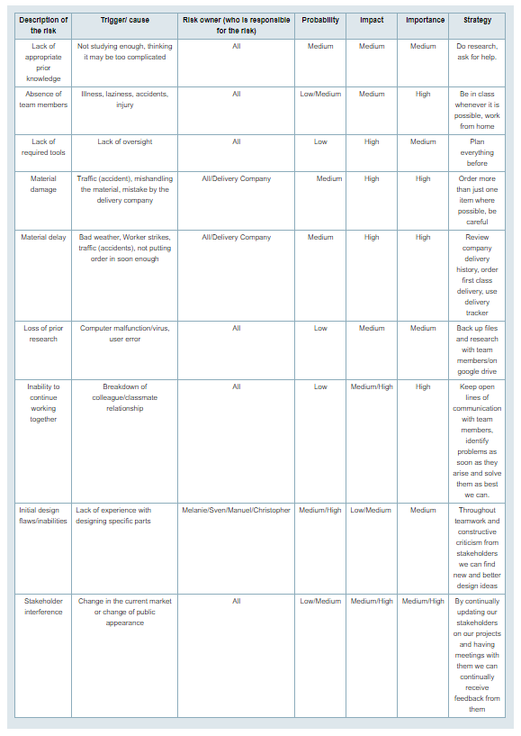
Table 17: Risk Table
As with any project conducted under these circumstances we must realise that there are certain risks to our projects successful completion and accept that these risks are a possible eventuality that we may not be able to control. So, instead of trying to control whether or not they will happen, we instead look at ways in which we can control the outcomes that arise as a result of these risks. As can be expected certain risks will affect the project more than others. Throughout the course of completing our project we are able to adopt certain strategies to the risks we are likely to encounter these are as follows:
- Accept that the risk is going to happen (if unavoidable) and work through it taking on board any lessons that were learned throughout the process of facing the issue
- Transfer the risk to someone more capable of resolving the issue removing work from your workload and ensuring it is dealt with my someone more qualified to fix the problem and this in turn removes the possibility of it being detrimental to your work
- Avoid the risk altogether by changing the process currently being undertaken to one where this risk will no longer be an issue meaning that you must be able to change your creative or planning process to no longer use whatever tools/resources had to be used when dealing with the issue
- Mitigate the risk to decrease the impact of said issue and to lower the probability of the risk ever becoming an issue in the first place. This is a classic example of many hands making light work and ensuring that the problem is not a large issue that consumes too much time/manpower/resources etc.

3.8 Procurement
Procurement is the act of obtaining goods and services. The process of procurement includes some preparation and processing of a demand as well as the receipt emition and approval of payment [17]. This is a vital part of any business, because it is impossible to a company to survive if the price of procurement is bigger than the profit made by the product.
Since we have a budget of 100,00 € and the restrain of only be able to buy products from portuguese suppliers, the team needs to be agile in order to find the best options to our project, some of the things we need to take in mind are:
- Compare the quality-price ratio from the available suppliers
- Take the maximum advantage of the material we have at our disposal
- Look for suppliers located in Porto to decrease the shipping cost

3.9 Stakeholders management
One of the most important parts of a successful project is the ability to manage all the stakeholders expectations and power. A stakeholder is a person or entity that has influence on the team or is influenced by the team. In order to manage properly the stakeholders we must take in mind the role, expectations, power and interest of the stakeholders, measuring their influnce in this topics. First of all, is necessary to identify all the stakeholders connected to the project, and those are:
- Team Members
- EPS Coordinators
- Teachers
- Suppliers
- ISEP
- Final Consumer
In order to organize all the information, the team built Table 18.
Table 18: Stakeholders Analysis
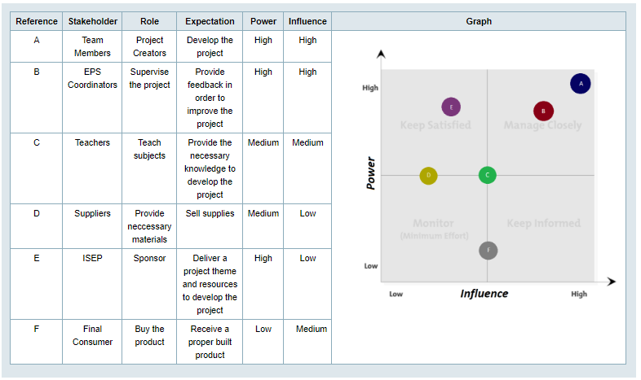

3.10 Conclusion
In conclusion, Project Management has been one of the most important parts of our project as it clearly sets out exactly what logistical, economic and personal issues or obstacles we are likely to have to overcome. It reminds us to constantly monitor; our costs and ensure we stay within budget throughout the semester, our communication and risk awareness to do all that we can to avoid any delays or derailments to our project and it also reminds us to keep track of our attention to time management to ensure that we stay as on time as we can to meet any deadlines in our schedules for the semester.
As our Project Management section reviewed how we organised our project development process throughout the course of the semester so to will our Marketing section lay out the plan we have for organising the future process for releasing our product to the wider community/global market.

4 Marketing Plan

4.1 Introduction
This chapter of the report will contain all important information about our target demographic, the promotion of our product and comparative analysis of other products. Below you will also find information about: SWOT analysis, strategic objectives, segmentation and adapted marketing mix. Furthermore, we will attach information about budget and strategy control.

4.2 Market Analysis
Each business, regardless of the size and area of activity, in order to be able to function smoothly and constantly should monitor what is happening in their environment. Especially in the case of starting a new business/launching a new product on the market, it is necessary to conduct a thorough analysis of the surroundings around. The final conclusions should help us to recognize our chances, threats and limitations inherent in the environment, which should help to prepare the right strategy to present our product to the market.
Answers to basic questions about the company's environment are very important in order to verify the potential market and recipients.
- Under what economic conditions does the enterprise function?
- What are the potential trends of the development of the product?
- What solutions should be used to achieve success in a given competitive situation (eg product promotion among potential recipients)?
We divide the enterprise's environment into microenvironment and macro-environment. The analysis must always concern the whole enterprise environment.

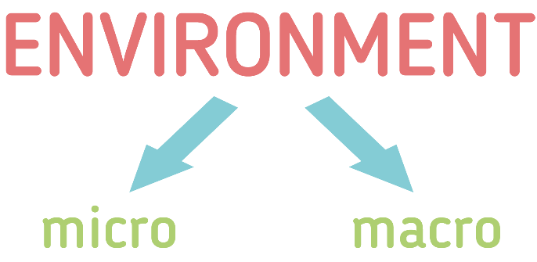

Figure 16: Market environment [18]
- Micro-environment: Affects the working of a particular company only, to which they relate to. In addition it has a direct impact on the business activities.
- Macro-environment: Affects the functioning of all the company entities, operating in the economy. It has a big influence to all business groups.

Specific division into environmental sections:
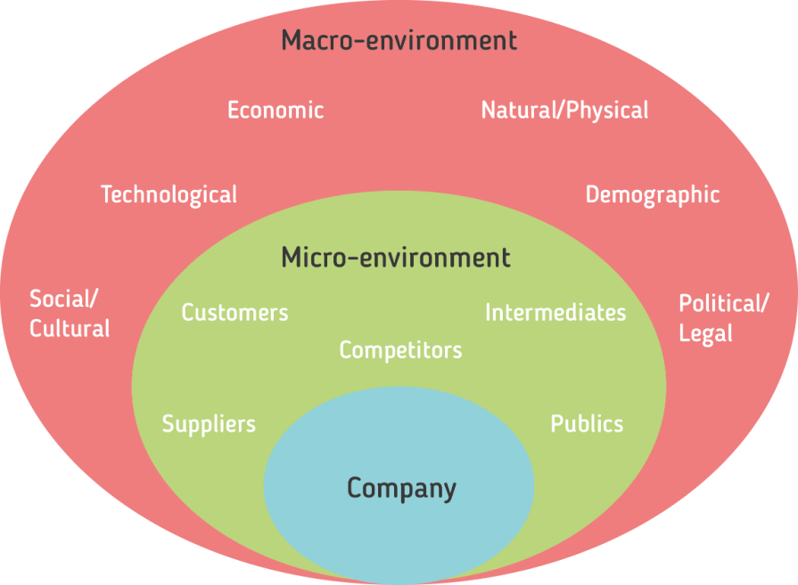

Figure 17: Micro and macro environment [19]

4.2.1 Micro environment
The micro environment of a company is also called a closer environment. In economic terms, these are all economic entities that affect the company, but the impact of which can also affect the company. This micro environment determines the conditions for the company's development and operation in its industry and geographically defined market.
The microenvironment mainly includes:
- customers
- raw material suppliers
- competitors
- producers of substitute goods
- producers of complementary goods
- workforce
- shareholders
- market regulators
- strategic allies

The easiest way is to divide the micro-environment into 5 categories ([20]) :

Suppliers
Individuals and business entities that provide the enterprise with the resources needed. It's all about negotiating prices, quality and delivery times. The quality of the relationship between the entrepreneur and the suppliers often determines the quality company's functioning and its market position.
It is worth mentioning many examples of active participation of suppliers in building the company's success:
- participation in the promotion of goods and services
- offering favorable delivery terms (eg extended deadlines payments)
- the possibility of obtaining rebates or other financial benefits
- short delivery periods

Especially in the case of small units having an idea for a business (like our team's idea) and not having adequate resources, the importance of favorable terms of purchase grows.
Our product contains some electrical components like a stepper motor, power supply and also building materials. All of these products can be bought here in Portugal. However, the final selection of all materials (for a product in original dimensions) at the suppliers can only be approved after testing the prototype. Becouse than we can know if all the intended goals have been done and if there is no need for making some improvements.
Customers
It answers the question of who is our buyer/our client (B2B or B2C, local or international, etc.) and what is the reason for buying our product. What can make a person buy our product, why someone wants to spend money on our product and not some other competitive one.
Our goal is private individuals purchasing goods and services for the purpose satisfying individual needs like typical families who live in houses with gardens. Our product, due to the technology contained inside, will not be for the poorest people. It will definitely cost more than the ordinary Sunshade umbrella. But it does not change the fact that our product will be able to buy for people equally at the average level of life, as well as those who earn a lot. Furthermore our product has no competition on the market, because no one has ever created this type of product. The only threat can be ordinary conopy, which are already built in some homes and people will not destroy the already created constellations to buy ours.

Intermediaries
They support the company in the distribution of products and services and support the company in the promotion. The most common are wholesalers, retailers, transport and courier companies, research and advertising agencies, banks, and insurance institutions.
SetSun would be mainly sold business to consumer (B2C) but can also be sold in the futher business to business (B2B). Our goal is to get to the customer as quickly as possible and that's why we think that the best strategy is to promote our products on the internet. Both individual customers and companies will be able to purchase the product thanks to the online store.
Competition
Defines the conditions for the functioning and development of a company in a given sector or market segment. The competitive environment consists of all business entities that directly cooperate with the company or compete in the process of satisfying the needs of consumers. However, it should be remembered that the competitive advantage is not static, it changes with increasing volatility in the environment. It competes for the future, not for the present moment.
Everyone who consider the competition should pay attention to the following elements:
- the number of competitors on the potential market and their strategies
- industry development phase
- size and market shares
- costs of withdrawal from the market
- strategic alliances (groups)

Our product is one of a kind, because it combines with shape something similar to the shape of conopy but with technique, electricity, system inside and also modern/stylish look. There are several products on the market that work similarly, but no product reacts to the sun and does not change its position depending on the position of the sun in the sky. Therefore, we think that we are able to find our niche and gather a group of recipients who may be interested to buy SetSun.

Publics
Every company has the responsibility to please the public. All activities of each company should be considered in terms of public opinion and their impact. Society has the power to help us achieve our goals, and it can also knock out our chances of success. However, satisfying the needs of all recipients is practically impossible. Each person has his own view, opinions on the subject and it is hard to hit the tastes of each person. Therefore, it is very important that the company (from the beginning of its activity) has their own target market - in other words a group of people to whom the company will want to reach.
In the case of our product, the target group are families with houses with gardens. In our opinion, the basic principles that our product must fulfill are:
- have a modern look (so that the product in the garden looks good - a modern, fashionable look)
- it was useful (so that the buyer knew why he bought the item)
- fulfilled the application of following the sun (the argument that distinguishes our product from the others)
- SetSun was friendly to the environment
4.2.2 Macro environment
The company's macro environment is all factors that have a direct impact on the company, but they can not be regulated by them themselves. So macro environment creates favorable conditions for the functioning of the company and the factors that create these conditions, the company called the surroundings of the company.
The surroundings that occur in macroenvironment are as follows ([21]) :
Demographic forces
Phenomena involving population fluctuations, natural increase, age of buyers, etc. This determinant is not so important for our product, because our target are families or families in children. In fact, our product can be purchased by anyone who owns a house with a garden. Fluctuations in population or population growth will not change the needs of people who want to settle in beautiful areas, preferably with their own home. More and more people are moving out of the city center due to the emission of dangerous toxins in the city. They settle on the outskirts of cities or in the countryside. We believe that this need of people to have a piece of their place on earth will not change that's why our product can be in constant circulation regardless of demographic fluctuations.
Economic factors
These are phenomena related to the economy, which may facilitate or hinder the functioning of the enterprise. In the case of our product, the economic situation may affect the number of products sold or the price of materials that we will need to create SetSun.
Natural/physical forces
This is an area that draws attention to renewable energy sources and natural resources, such as forests, agricultural products, marine products, etc. There are also natural non-renewable resources, such as oil, coal, minerals, etc. During production planning, our team pays a lot of attention to choose the best materials for production, and also to not harm the environment.
Technological factors
The skills and knowledge applied to the production associated with technologies and techniques. Thanks to the skills acquired in previous projects of our team members, we are able to better plan the production process and the choice of materials. In this field, we use much of Sven Bergervoet's knowledge and experience in Industrial Product Design as well as the experience of Manuel Baptista in Mechanical Engineering and Christopher Mahon in areas such as: Electric, Electronic and Energy Engineering.
Political and legal forces
Laws and the influence of political elites are included in them. We assume that our product will be environmentally friendly, so we should not have any legal problems with introducing it to the market. When designing the product, we wanted to meet as many standards as possible, which our product should fulfill.
Social and cultural forces
They include social factors, such as social behavior, current trends, lifestyle, etc. Our product is designed to use the most environmentally friendly materials as possible. We want to show that although our invention has electronics and technologies in it, it can be also eco-friendly. We want to use this as the main argument in our sale of the product on the market, so that people know for what they pay money and that do not contribute to the deterioration of global environmental conditions. What's more, we hope that the popularity of the product will increase thanks to people defending the environment. Thanks to this, we hope that it will gain publicity about our product, which will make it fashionable and a larger group of customers will be interested in buying our product.

4.3 SWOT Analysis
SWOT analysis (or SWOT matrix) leads to an understanding of strengths and weaknesses enterprises and to identify opportunities and threats that flow from the outside environment. From the entrepreneur's point of view, the most important element of this analysis is assessment of strengths and weaknesses of the company, generating from the environment opportunities - favorable circumstances and the risks and preventing the development of activities of the entity [22].
Table 19: Explanation of the SWOT analysis
Letter | Explication | Description
S | Strengths | Company's activity aimed at increasing the efficiency of its operation or gaining a competitive advantage. Everything that is an advantage over others.
W | Weaknesses | Company's activity that reduces its efficiency or prevents competitive advantage. Everything that is weakness, barrier, defect relative to others.
O | Opportunities | “Attractive” area for potential activity an enterprise on which a competitive advantage can be achieved. Everything that creates a chance for a positive change.
T | Threats | The emergence of an unfavorable phenomenon in the environment, which may lead to a weakening of the company's position in the absence of an appropriate response. Everything that creates the danger of adverse change.
However, it is worth remembering that in the SWOT analysis it is not necessary to systematically isolate all points and describe all factors, but to identify key factors that can have a decisive impact on the future of the company or the success of a specific project.
Below we present our swot analysis with our strengths and weaknesses as well as opportunities and threats for our project.
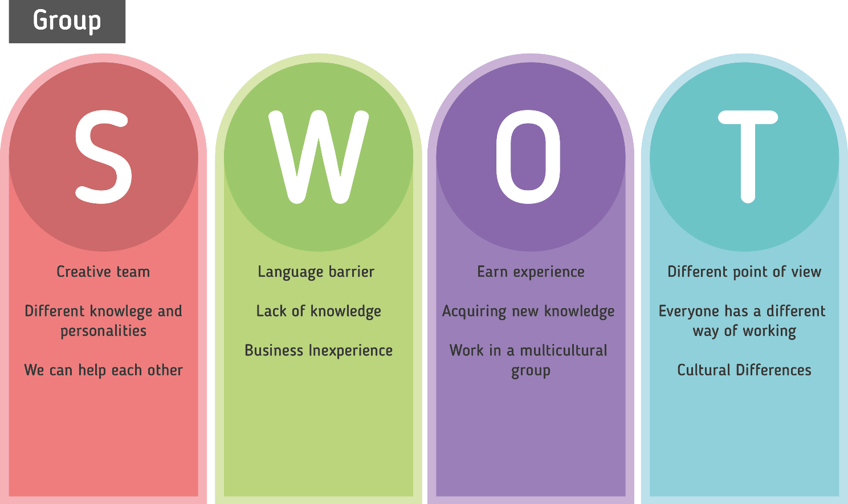

Figure 18: SWOT Group
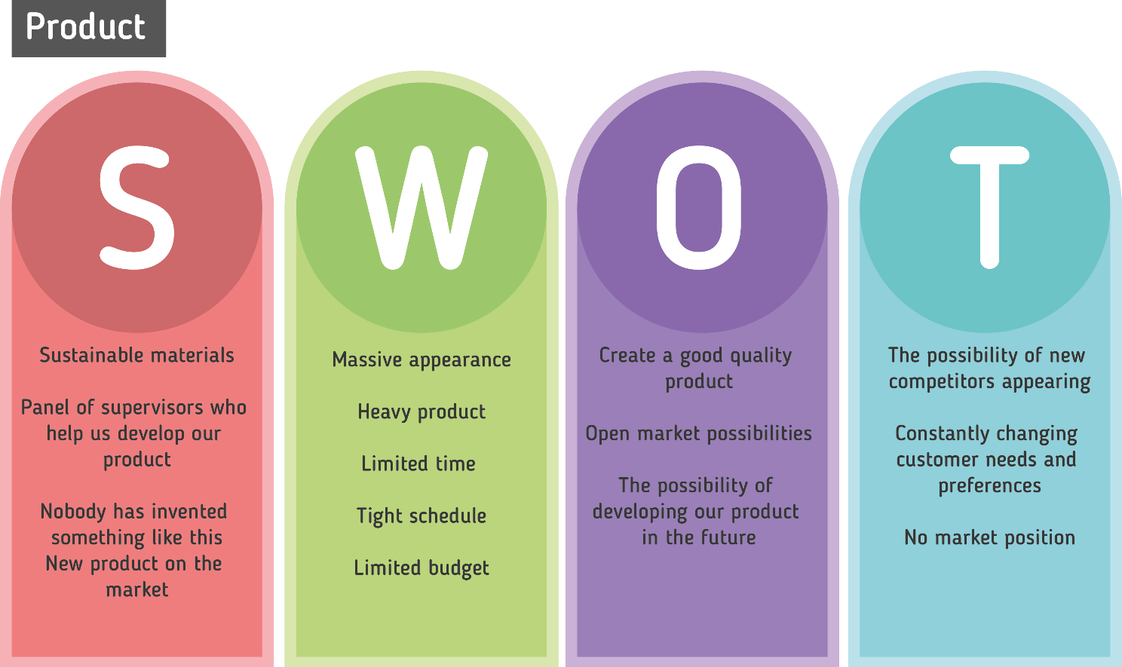

Figure 19: SWOT Product

As you can see in our swot analysis, strengths and weaknesses are mostly internal factors, while opportunities and threats are external factors. It is also possible to interpret it in a different way as strengths and weaknesses are the features of the current state, and opportunities and threats are expected future phenomena. However, the best summary is the statement that strengths and weaknesses are factors depending on us (those on which we have a planning and management influence), and opportunities and threats are objective factors on which we have no direct causative influence. For example, our weakness is lack of knowledge and possible mistakes in understanding each other. That's why it's up to us how much time and effort we will put in the project so that every member of the team knows all the details and progress of work and in critical situations even to use a dictionary so that all words used in the project are known and understood by all team members. However, looking at our threats, we have no influence that they are already some existing products on the market with similar using or that the needs and preferences of customes are still constantly changing. Our motto is to be creative and positive, which is why we focus on our strengths. We believe in our opportunities of success. We try to fight with our weaknesses and also observe the changing market, to know what threats can wait for us.

4.4 Strategic Objectives
In order to be able to successfully accomplish goals, both life and work goals, first of all, goals should be properly determined. This is what the SMART method has been created for. SMART is an acronym for 5 words: specific, measurable, achievable, relevant, timely defined [23].
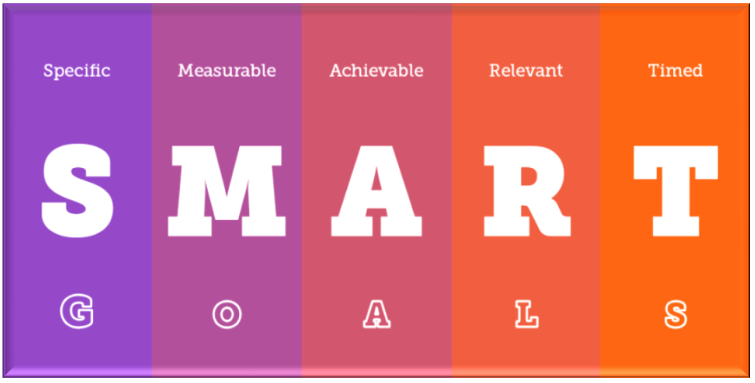

Figure 20: SMART method [24]

According to this method, a correctly set goal should have the following characteristics:
- SPECIFIC = simple, concrete message
The goal can not be vague. It should be easy to determine exactly what we want to achieve in a simple and detailed way. How often have we heard when someone is talking to a child: “start learning”. This is a typical mistake. When we want a child to really learned something, we should show some commitment and after that be sure that the child has understood what we mean. Issue a specific command. For example: “do tasks 28 to 36” or “read the text on pages 49 and 53”. The same principle will applies in companies. The wrongly formulated goal will look like this: “increase customer satisfaction”, “increase sales”. But: “increasing the sales of time management training by 10% compared to 2012” - this is a full compliance with the first letter of the SMART principle.
- Measurable = computable, calculable
It is a goal formulated in such a way that we can express or at least measure the degree of its implementation numerically. The target should have strictly defined parameters. We need to know when to start, what stages to go through and when to finish. We also should determine and after that we should know that the stage has been completed.

- Achievable = available, attainable
In other words, realistic. A too ambitious goal undermines faith in its achievement and motivation to implement it. You always have to consider whether the task is possible to achieve at all? It is very important to remember that all goals should always be adapted to the currently owned resources: time, adequate technological resources, financial resources and staff.

- Relevant = important, meaningful
The goal should be an important step forward and at the same time it must be a definite value for who will carry it out. Example: A specific goal should be chosen so that the employees who will implement it can identify with it. Only when they recognize that the goal is right and makes sense, will they effectively strive to achieve it. A good way to do this is to simply reconcile the tasks together with the employees in an active manner so that the employee is aware that he / she participates in their appointment.
- Timed = timely defined, specified in time
The goal should have a precise time horizon in which we intend to achieve it. Everyone should have a schedule where can find the date of the beginning and end of the main objective as well as its individual stages - than everyone knows what to do. Then the action and time management is effective. In this situation everything it's just under control.
S.M.A.R.T. or S.M.A.R.T.E.R ? Over the years, the “smart” method in some enterprises has evolved to the “smarter” method. Two letters “E” and “R” are added [25].
The letter “E” comes from the word: Evaluate. This method consists in checking whether our goals are being evaluated. Assessing our goals every day is much easier to achieve. Why? Because long-term goals (for example: several months) we can easily ignore if we are responsible for many tasks at the same time. Each time, we should make sure that we have set up the system to assess our goals and make an objective assessment.
The letter “R” comes from the word: Readjust. The last step of this method is to check whether all our goals we have set before are correctly formulated. It may turn out that we are pursuing to some goal, but we do not achieve good results or see improvement in our actions. Readjust does not mean that we need to throw away your goals and start everything all over again. This means that we should try a different approaches until we get closer to your goals. That's why constant assessment is so important every day. If we do not rate, we can not measure our progress.
Our next goals will be:
- Create a working prototype before 4 June 2018
- Complete the entire WIKI website before 15 June 2018
- Create an official website where people can buy our product - by the end of September 2018
- Create a database of people interested in purchasing our product from Portugal- by the end of November 2018
- Popularize and promote our product in other countries thanks to strong advertising (such as Spain, Italy, Greece - in warmer European countries) - between February and May 2019. So that for the holiday season, people could get your product.

4.5 Segmentation
Market segmentation is the procedure of dividing the market into relatively homogeneous groups of consumers, which due to similarity of features reveal a similar demand, in order to prepare a product that meets their needs and, as a consequence, gain a market advantage. It consists in dividing it into smaller parts called segments, which differ from each other in terms of customer expectations with regard to the product, purchase method or other criteria. After segmentation, the company must choose the segment in which it wants to sell its products. The main purpose of segmentation is to analyze the structure of the market, i.e. the needs of customers that make up the market [26].
We can distinguish the following parts:
* Geographic
* Demographic
* Behavioral
* Psychographic
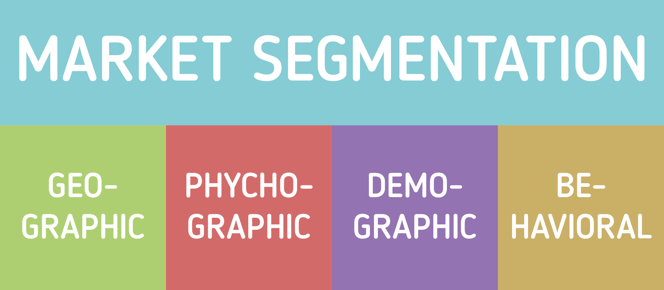

Figure 21: Market Segmentation [27]
4.5.1 Geographic Segmentation
The basic use of our product is when the sun is shining that is why on the map below you can see the level of insolation in the world. It is obvious that Africa is the most sunny continent. Unfortunately, the living standards and income of the population are too low to sell our product there [28].
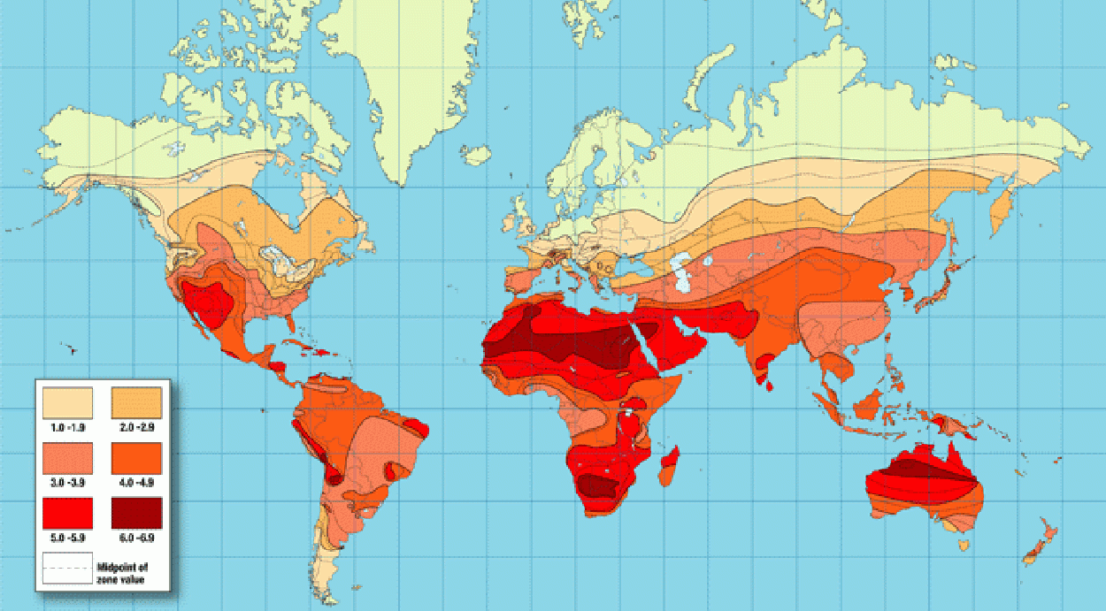

Figure 22: The level of insolation in the world [29]
That's why we decided to focus on europe. First of all, because our product is created in Portugal from local stores but also because all team members come from europe. We know more or less what we can expect in specific countries and we have knowledge about our competitors from our own experience.

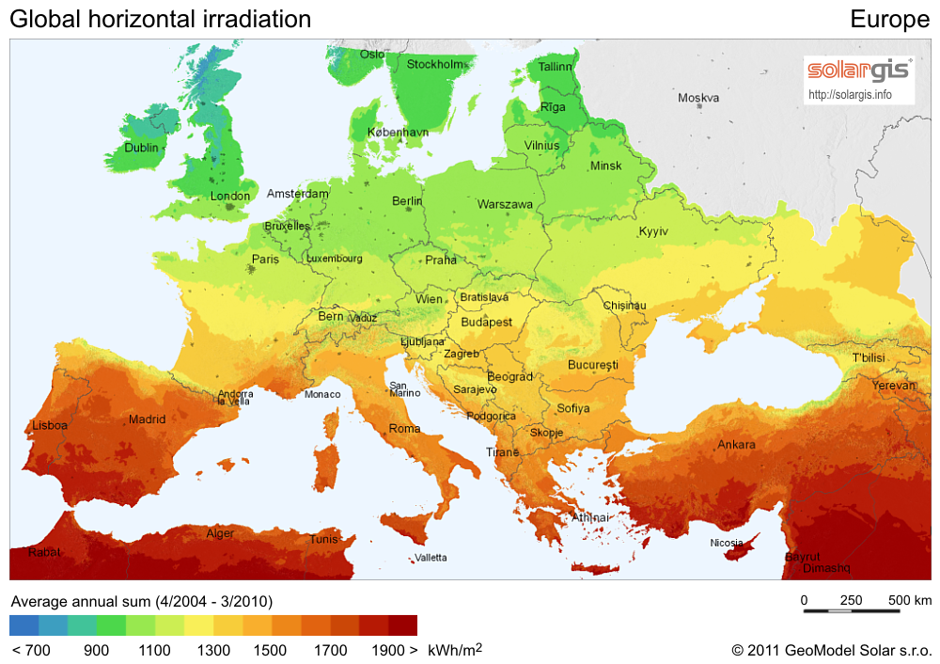

Figure 23: The level of insolation in Europe [30]

As we can see on the map above, the sunniest and warmest is in the countries of the southern part of Europe. Most of the sun is in Portugal, Spain, France, Italy and Greece. That's why we think it's a good idea to start popularizing our product in Portugal and then try it in nearby countries such as Spain or France.

Each year, research is conducted on the number of sunny hours during each month and summarizing the annual total. On the list below, we have selected 5 cities with the highest level of sunny days a year. Most of the sun appeared from Rome in Italy, then in Malta, the third place is occupied by Athens in Greece, followed by Marseille in France and in the fifth place the capital of Portugal - Lisbon. On the sixth and seventh place there are two cities from Spain - Madrid and Barcelona. Interestingly, this combination of data shows that there are several cities in which the sun shines all year round. Countries with these cities are our ideal target, because then our product could be used throughout the year - not only seasonally.
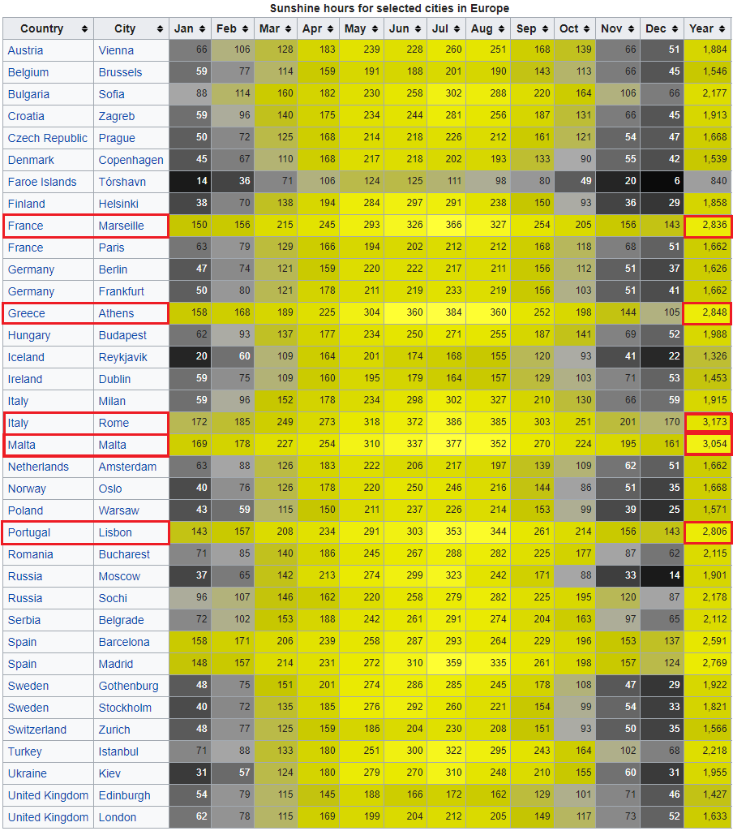

Figure 24: Sunshine hours for selected cities in Europe [31]

By suggesting a list of countries with the sunniest cities and countries in which we were, we chose our future target. Assuming the development of our product and popularity, our goal will be to countries like Portugal (first country) and then: Spain, France, Italy and Greece.
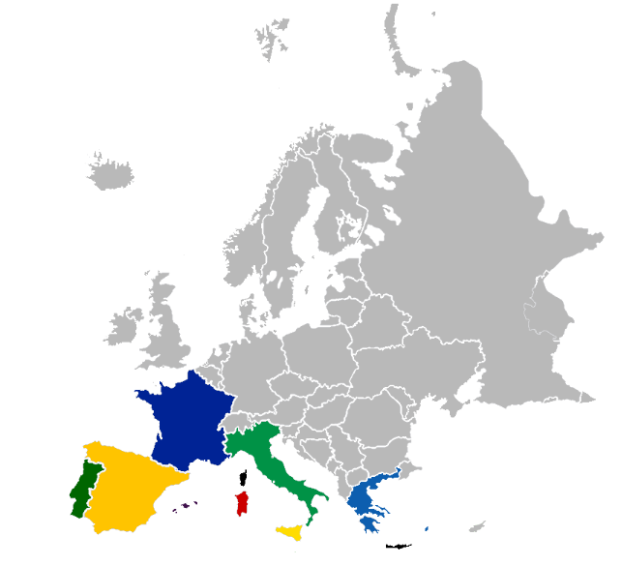

Figure 25: Future target of the countries [32]
At the moment we want to focus only on one country - on Portugal. This is where we develop our idea and we think that Portugal is the right country to present our product. Below is a map of the whole country with sunshine level. As you can see, most of the sun falls in the southern part, but also almost the entire wharf with big cities like Lisbon and Porto.
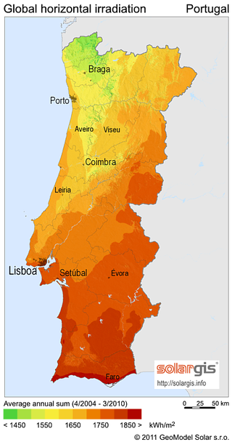

Figure 26: The level of sunshine in Portugal [33]

4.5.2 Demographic Segmentation
As you can see on the map below, the most inhabitants live in the capital city - Lisbon, than in Porto and in the neighborhood of this city, as well as in the south of the country. That's why we want to focus on the largest cities. The more people live in this area, the more potential customers who could choose our product. Based on the current UN estimates, the 2018 population of Portugal is 10.29 million [34].
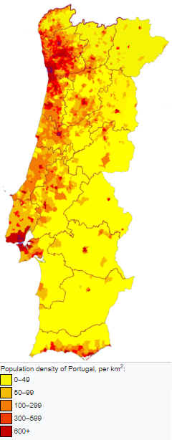

Figure 27: Population density of Portugal [35]

Our target is people in the range of 25 - 70 who have their own house or summer house, with a large garden where they could set up our shader. Our potential clients are women and men alike. They can live alone, be married or have the whole family with children. In the case of the sale of our product, the civil status of potential customers is irrelevant. Occupation, education, religion, race or nationality are also irrelevant.
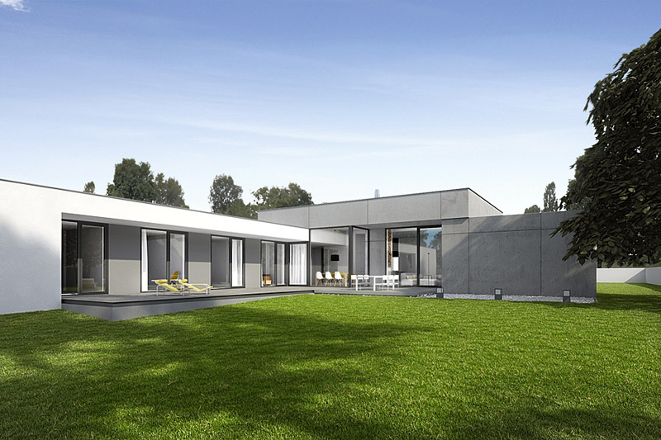

Figure 28: A house with a large garden [36]
As you can see on the map below, the color red means the countries in which you earn the most, while the blue indicates the countries in which the salary is the lowest. Portugal is half of this scale. This means that it will be possible to sell our product in the country chosen by us. However, this does not mean that it will be the cheapest item. Due to the electronics and the entire system inside, it certainly will not be an object for the poorest people. Our goal are more affluent families who value convenience and new products on the market.
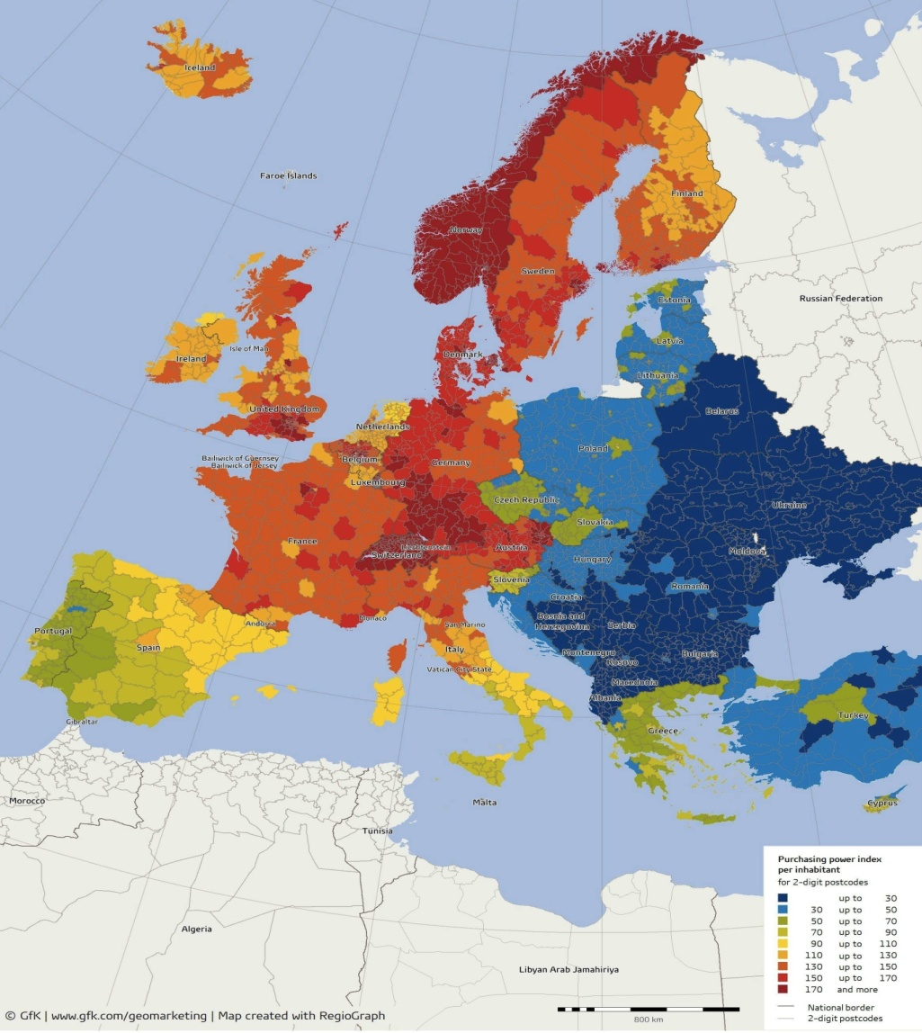

Figure 29: Level of income in Europe [37]

4.5.3 Behavioral Segmentation
An important criterion for segmentation is also the needs and motivations of consumers and factors motivating them to buy. Aspects that allow the market to be divided in this respect are most often the opportunities and place of use of the product, reasons for its purchase, perception of the image of brands or the status / image that the user gains through the purchase. We can distinguish several important factors: user index, degree of loyalty, buyer's phase of readiness. Unfortunately, by introducing a completely new product to the market, our company has no opinion on the market, so we can not count on the popularity of the product or the recognition of the brand. Which does not mean that we are not able to sell our product. We meet the expectations of the application, because our product is modern and it impresses with the whole system that is hidden inside. In addition, people who are under our product in the shade do not have to think about moving it. We hope that this type of comfort will make people interested in our product.

4.5.4 Psychographic Segmentation
Referring to the information contained on websites, we can find out that: There are more houses in Portugal than the total population of 10 million individuals, since half of the Portuguese families own a country or holiday house, as well as many Europeans who choose to regularly spend their holidays in this Southern European country. Large projects of holiday housing featuring private beaches and golf resorts are very common in the South of the country [38]. Therefore, we can say that many people value their lifestyle and comfort by investing money in additional properties so that they have a place to rest and relax. Exactly such people are our “goal”. Thanks to our product, this kind of a houses may seem more stylish and modern. It is a privilege to have our smart object instead of the usual umbrella or conopy.
It is also worth mentioning that not only Portuguese people are our goal. In 2016, Lisbon was voted one of the 42 cities in the world with the best quality of life, by the Worldwide Quality of Living Survey 2016 [39]. This has contributed to increasing the interest of Europeans and people from outside Europe to buy land and property in Portugal, especially in the south of the country. Thanks to the good location of the country, ideal atmospheric conditions and low costs of living in the country, many nationalities became interested in living in Portugal. From the statistics we can get information that many nationalities bought their properties in 2017. Investors from the United Kingdom achieved the highest score of about 45%, then 24% went to Swedish, 15% to French and the remaining 16% of other nationalities also from outside Europe [40]. Such a big interest shows only that the majority of people buying a house in Portugal, especially in the Algarve, values a high standard of living. Also because of the high prices of the property they are people of high social class who value luxury and exclusive items. The interest in Portugal and this type of home buyers only reinforces our conviction that Portugal is a good country to start selling and popularizing our product.

4.6 Strategy/Positioning
After the above analyzes and the choice of our customers, it's time to choose the strategy of the competition. In 1980 Michael Porter described the concept of “Porter's generic strategies” where he describe how a company pursues competitive advantage across its chosen market scope [41].
There are three types of competition strategies:
- Cost leadership strategy
- Differentiation strategy
- Focus strategy

Our product will be promoted and sold in relation to the concentration approach to the competition. This strategy is based on the assumption that a company in this way can serve its narrow strategic segment in a more efficient and effective manner than its competitors operating on a larger scale. As a result, the company achieves differentiation as a result of better meeting the needs of its segment. In connection with our product, we want to reach rich people who will treat our product as something unusual and stylish. It is a narrow group of recipients, which is why we believe that this type of strategy will pay off.
OUR GOAL
In connection with our strategy, we set a target for the next year on the approximate number of products sold and the place where they were sold it. We want to focus on three places: first the south of Portugal - the Algarve area, and then the two largest tourist cities of Lisbon and Porto. We want to sell between 1500 and 2000 products. We think that such a result would be satisfactory. Below is an example distribution of product sales. Of course, during the sale, it may turn out that we will only sell the planned amount in the south of Portugal, but we also want to reach typical Portuguese cities with family houses.
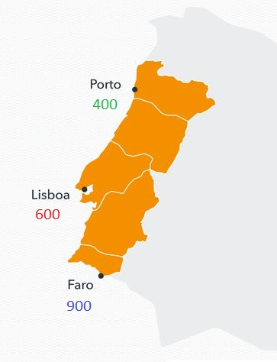

Figure 30: Example of product sale [42]
Below we present again a map with the countries selected for further development for our product. It includes Spain, France, Italy and Greece.

Figure 31: Future target of the countries [43]
In connection with the selection of the following countries, below we present an approximate plan of development and “opening” our bussines for other countries. The plan assumes development over the next five years until the next goals are set, the statistics are looked at, and thoughts about whether the company is prospering and whether it is going in the right direction.

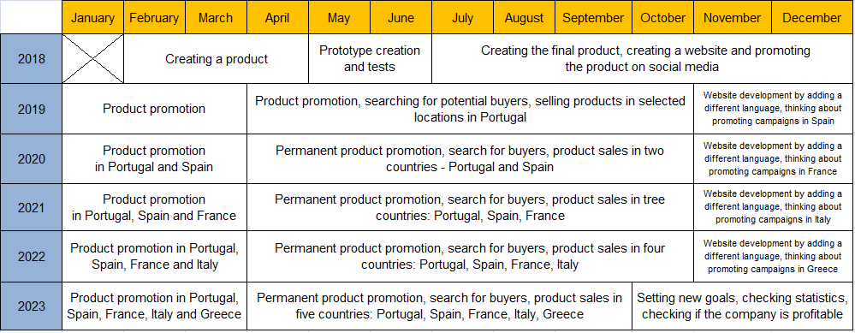

Figure 32: Future plan for the development in other countries

4.7 Adapted Marketing-Mix
“Marketing mix” - otherwise known as “4p” meaning product, price, place, promotion. The marketing composition is a broad category of interrelated elements (activities, processes, methods and techniques) used in the enterprise and creating a jointly integrated system of impact on the market environment of the company (clients, competitors) [44].
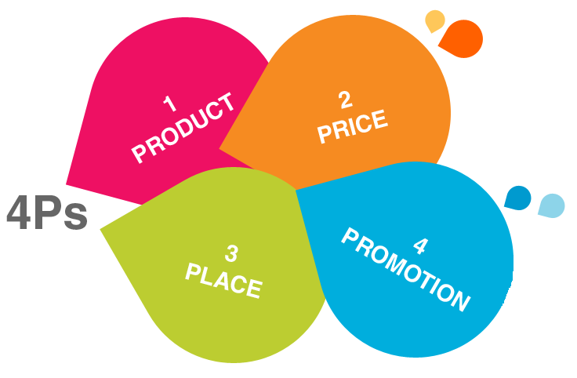

Figure 33: 4P picture [45]
Product
Below we present a comparison of our product in relation to other currently operating products on the market. Unfortunately, at this moment of the project we are not able to reliably assess all points, we can only assume that something in the future can be improved.
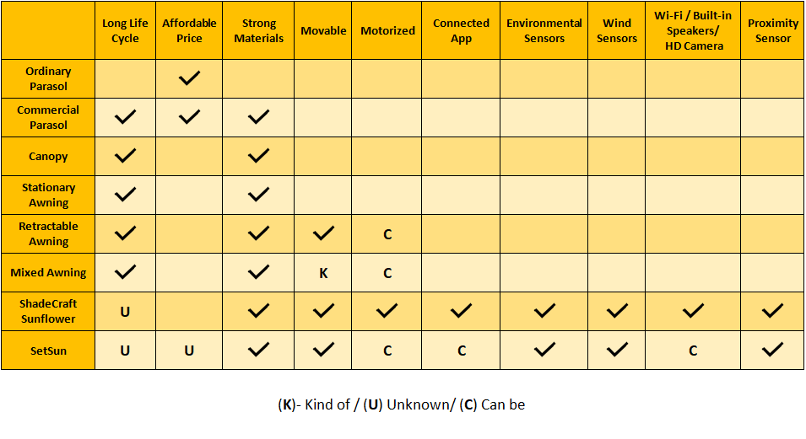

Figure 34: Comparing our product with the competition
Price
Due to the many elements of the construction at this moment, we do not know exactly what the price will be. The price estimate indicates that it will be between 550 and 750 euros.
Place
Our product will be available for purchase through the official website. At the beginning we want to focus on sales in Portugal - the first country we have chosen as our target destination. Then we will promote SetSun in Spain, France, Italy and Greece. It is also important to remember about the proper preparation of shipping equipment, because our product is relatively heavy, which does not change the fact that shipping will be possible everywhere.
Promotion
When it comes to the promotions of our product, the most important thing is our official Webside with an additional store service. This is really valid because it will be the main source through which we will communicate with the buyers. The next idea we want to implement is installing a large advertising banner at the airport in Faro. This is to interest arrivals and departing tourists from Portugal. Another obligatory task is to promote our company and SetSun in social media advertising like Facebook, Instagram, Twitter or Snapchat. In addition, we want to invest in posters, leaflets, advertisement in newspaper and magazines and internal mail system to better communicate with interested, potential buyers.

4.8 Budget
When it comes to putting the product on the market, the most important thing is having a good start. We believe that we are able to find a company that will support our project and invest money in it. In addition, each of us will bring its own capital to promote a new product on the market, as well as a new brand / company that we want to create.

Table 20: Detailed budget for product promotions

Incomes | Cost ( € )
Cash contribution of group members | + 4000 €
Influence from outside (sponsors) | + 1500 €
Expenses | Cost (€)
Official Webside with an additional store service | - 1500 €
Posters (10 000) | - 500 €
Leaflets (5000) | - 300 €
Radio advertisement during summer seasion | - 250 €
A large advertising banner at the airport in Faro | - 850 €
Newspaper and magazines advertisement | - 800 €
Social media advertising (Facebook, Instagram, Twitter, Snapchat) | - 1000 €
Internal mail system and buying trello.com platform for communication | - 300 €
Balance | 0 €

4.9 Strategy Control
The best method of control strategy is to use the Deming Cycle also referred to as the PDCA cycle Plan-Do-Check-Act or the PDSA cycle Plan-Do-Study-Act or Deming). This is a diagram illustrating the basic principle of continuous improvement created by William Edwards Deming [46].
P-D-C-A disseminated by the circles associated with management by quality and ISO standards regarding quality management. According to this version, the Deming cycle consists of:
- PLAN: Plan a good way of working, a better method.
- DO: Complete the plan for the test.
- CHECK: Investigate whether a new way of doing things works better.
- ACT: If the new way of working brings better results, consider it as a standard (applicable procedure), standardize and monitor its use.
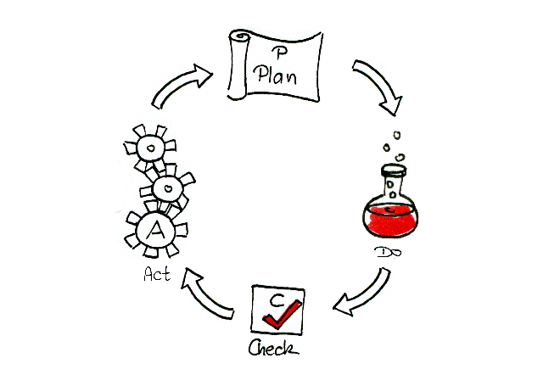
Figure 35: PDCA [47]

4.10 Conclusion
Based on this market and economic analysis, our team decided to create Outdoor Intelligent Shader - SetSun intended for for people with a high standard of living because we think that this type of product is missing on the market. Our product follows the sun, which means that the person at SetSun can relax, chill-out or simply go to sleep without any stress or burns on the skin. Our object is made of the most environmentally friendly materials. Our main goal was to create a eco-friendly product that can make the lives of many recipients more enjoyable and comfortable. Analysis and all searches have shown that with good promotion, we are able to sell it ona large scale even in other counties in Europe which is our main goal.

5 Eco-efficiency Measures for Sustainability

5.1 Introduction
During the past decades Eco-efficiency and Sustainability are subjects that became really important. During the past 100 years we already used 50% of all our natural resources while the homo-sapiens are already existing for more then 40.000 years. This means that during the 0,0025% that humans exist we used an incredible amount of our earths resources. We're destroying our forests, taking all our natural resources out of the ground, in the near future ecological refugees is going to be the topic of the day. This is just an example of a big amount of problems that we are facing when it comes to saving our planet. The average footprint of all the people of the world is 1,5. this means that we need 1,5 earths to maintain our way of living. And compare that of the footprint of Europe that is an average of 4,5. We consume so many products that if this continues we are not able to maintain our way of living. That our way of living in this moment is not Sustainable does not mean that it will be like that in the future. We people have the ability to change the world. Which is going to take a long time, but eventually we will get there. With designing and constructing this product we will look carefully at the eco-efficiency and the sustainability. That the outdoor intelligent shader will match all the pillars of sustainability, shown in Figure 36.
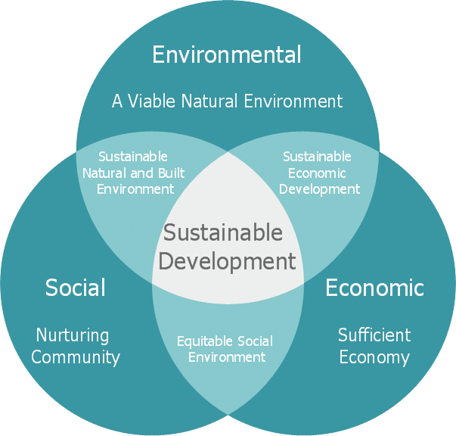
Figure 36: Economic, Social and Environmental sustainability [48]

5.2 Environmental
One of the ideas the current society has, although all the information that already exists, is that the natural resources avilable in our planet are unlimited and we can exploit it without any kind of repercussion, when in fact the things are not like this. In order to achieve an environmental cleaner planet, we need to find a way to protect our resources from those who want to earn money at any cost, such as gready corporations. The path we must follow is to support a different type of behaviour, where we should focus in things like:
- Reducing fossil fuel consumption
- Recycling and better waste management
- Use of renewable energy
- Organic Farming
- Protect the forests

5.2.1 Materials
On all levels of materials, impacts on the environment will occur. From the collection, processing to raw material till the production of the parts from the specific material. During the construction of this product the environmental impact should always be taking in to consideration at all times. The use of renewable materials and recycled materials will be used as much as possible.
These following materials will be used:
- Low Carbon steel
- Stainless steel
- Copper
For every material the amount that can be recycled or that is successfully recycled on a large base is really different. At this moment large amount of metals are recycled compared to plastics (Figure 37). Also for making the product recycled materials can be used in two ways:
- Use recycled materials for the product.
- Use materials that can be recycled at the end of its life cycle.

For our product it is really important to always keep sustainability in are minds and focus on what's good for our earth.
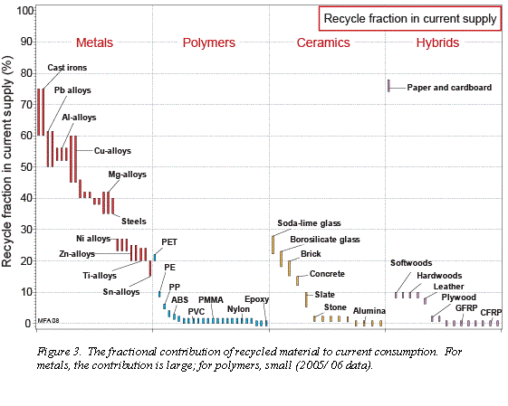
Figure 37: Recycle fraction in current supply
Not only is it important for a material to be able to be recycled but also the amount of effort it takes to process a material. In this case we talk about a carbon intensity. This intensity is measured in the amount of CO₂ that is produced for one Kg of material. In this graph (Figure 38) are two lines shown that say 'recycled' and 'virgin'. The recycled line shows the amount of CO₂ that is produced when the material comes from other products that are been reshaped for its new purpose. The virgin line shows the amount of CO₂ produced when the material is collected from the earth (the very first stage of winning materials). For every material shown in the graph it is a shocking difference between the virgin and recycled materials. Recycled materials show that it is way better for the environment.
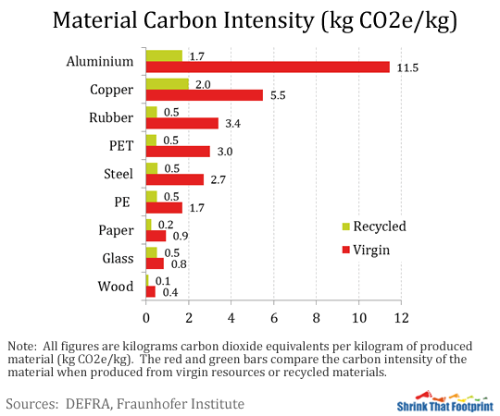
Figure 38: Material emissions [49]

Low Carbon steel
Low Carbon steel is an material that is most common in construction work. This material is an alloy of iron with carbon, often a little manganese, nickel, and silicon. Low in 'low carbon steel' means that the amound of carbon in the material is less than 0,25 %. The metal is at the same time, strong, tough, easily formed and very cheap. What in this chapter is so important is that this is one of the metals that is most likely to be recycled (Figure 37). Low carbon steel is an steel type that is compared to many other materials has a rather low CO₂ intensity than other materials. Although the use of recycled materials will keep the CO₂ intensity even lower (Figure 38).

Stainless steel
Stainless steel is a wide used material that is mostly known for its property that it prevents the steel from corrosion. This is due its oxide layor. Stainless steel alloys are made from iron with chromium, nickel and often four or five other elements. Also with Stainless steel it shows that it is an material that can be easily recycled. (Figure 37). Also for Stainless steel which is also a steel type is also an material with a rather low CO₂ intensity (Figure 38).

Copper
Copper is also a wide used material in our product. This is because of the wiring in the product. The wire will go from the shader to the Powersupply and this can add up a lot of copper wires. Compared to the two types of steel earlier explained copper is a material that is less likely to be recycled (Figure 37). Also for the amount of CO₂ that is released it produces a lot more.

5.3 Economical
Achieve a sustainable economy model is a hard thing to do. A company needs to have in mind, that besides the fact that profit is important, in order to be sustainable, ​the company needs to take care of the social and environmental problems while it has profit. We live in a world where consuption ​is seen as a normal thing and the big corporations take advantage ​of that to run after profit without any kind of social or environmental conciousness. The public in general does not do anything against that because the idea that big corporations pass, is that is impossible to have a confortable life without prescind those things.
The most used economic indicator is the Gross Domestic Product also known as GDP, it is used to measure the economic activity of a region, the main problem about this indicator is that it has some limitations such as [50]:
- It does not distinguish between an investment in good things or in bad things, so an environmental disaster can contribute positively for an economy growth
- It does not take in account ​the distribution ​of growth, which means big corporations can make a lot of money while the ordinary people strugle and can not make a lot of money, and still counts to a positive economic growth
- It does not take in account if there is an excessive use of the ressources, ​for instance, if all the ducks were killed and sold in the space of a year, the economic growth would increase but it would cause a clear crisis in the ducks market.
- It does not take in care of things that helps the society but does not have any kind of commercial value, such as volunteering,​ research, etc.
For the reasons written before GDP can not be considered ​a development indicator
In the following pictures we are going to present some portuguese GDP data, such as Portugal GDP Growth Rate Evolution ​between ​1960-2017 presented in Figure39 , ​the Portugal GDP Annual Per Capita Evolution between 1960-2017 shown in Figure 40 ​and the Portugal GDP between 1960-2017 in Figure 41 .
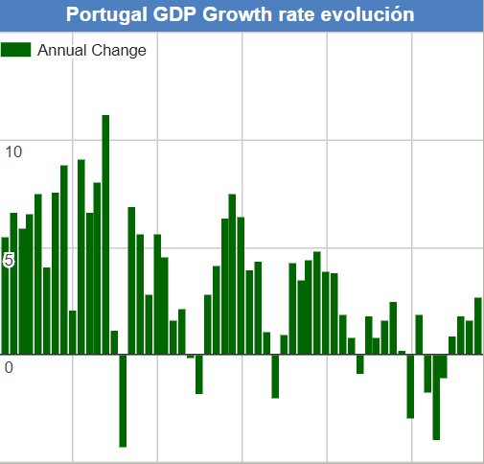

Figure 39: Portugal GDP Growth Rate Evolution ​between ​1960-2017 [51]

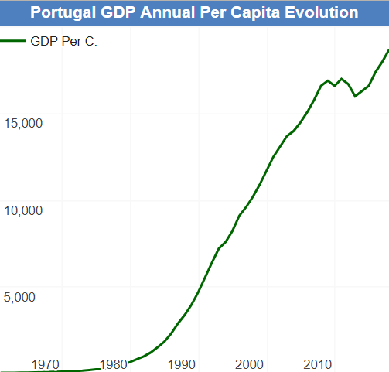

Figure 40: Portugal GDP Annual Per Capita Evolution between 1960-2017 [52]

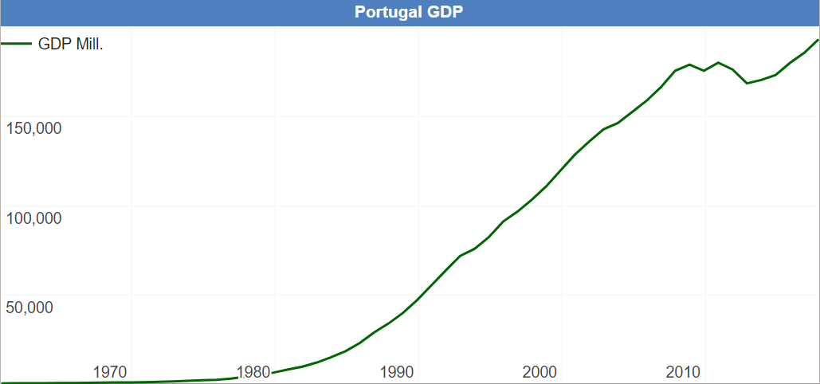

Figure 41: Portugal GDP between 1960-2017 [53]

Our team want to do things ​in the right way and to achieve ​a sustainable model we are going to buy all the products needed ​to our project from local providers, it will certainly help the portuguese economy to prosper and maybe even create some work stations.

5.4 Social
Social sustainability is avoiding changes in the environment which might have bad effects on subsequent generations. In other words, it is an effort to provide the people after our time a green, healthy and liveable place in the world. Thus, social sustainability is also strongly connected with ethics.
Not only by saving the planet can you make a product sustainable it is also about people. People that work for your company or are somehow involved to your product. Of course your costumer needs to be really happy with your product. But what about the people that manufacture your product or do you know if the people that are working in the the iron mines have good working conditions?
Before you choose a company that will deliver materials to the factory it is really important to know where the material is coming from. where the material is made, in which conditions it is made, how do the people get paid and do they need to make long hours a day with little brakes. This is a concern that is very common when talking about materials that come from for instance China.
For all the employers of the factory it is really important that they work in the right conditions. Working with large machines can often be a dangerous job. Every machine will be safe to use to keep the risk of injuries as low as possible. They also will work according a regular working schedule as it is in Portugal. Also the loan of the employees will be leveled with the kind of work they are doing.
In our case successful, social sustainability is to be understood that the team but also the consumers receive satisfaction of human needs in fact in the form, that the Environment has still the possibility to reproduce itself and that it does not have to endure damages and losses over a long period of time. Social justice, say and human dignity are also a big part of social sustainability.
Social sustainability is very important, if several people have to work together. That’s why it has to be ensured that every team member feels good and involved. To provide a good climate within the group following points are respected:
- Every team member should be sure in his part of work. If this is not possible, it should be taken advantage of help in online forums, of other students or experts.
- Sustainability and efficiency are a very important point and should have a high priority for the team.
- Every team member should stick to the developed code of ethics without exception.
Even if all of the involved stick to the plan, it could nevertheless come to certain issues such as overwork, accidents, disputes related to the work and so on. Then it is important to accost these problems quickly and to find a solution as soon as possible. It must be possible to hold a meeting and to discuss at any time. The most important thing is to show honesty and respect for the others. Also, outsides are allowed to complain about the team if security or the environment get endangered. Those problems will be also discussed and solved within the team.

5.5 Life Cycle Analysis
Life Cycle Analysis is a really difficult task to do. Most of the products that are pushed into our society have a linear life cycle. This means that during the process of making a product from collecting the resources till the end of life is not completed. The circle is not round, there is a waist of materials. If it would be a complete circle, this means that during that process there wont be a waist of energy or materials. This is called durability.
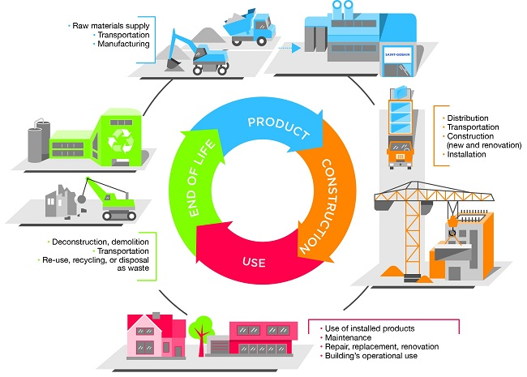

Figure 42: Life Cycle Analysis [54]

5.5.1 Product

Raw materials supply
Just as all other products, materials need to be collected. For producing a material the environmental impacts are enormous. material analyse. As shown in the previous chapter the materials in this product have a big impact on environment. Even with the use of recycled materials.

Transportation
All kinds of materials are been collected or made all over the world. This means that with a rather complex product that has a lot of different parts from each different materials the only options are to use materials that come from all over the world. These transportation methods that are most common are:
- Boat
- Plane
- Truck
This amount of material that are used in this product come by boat and are taking with trucks to its final destination.

Manufacturing
Manufacturing can be done by local providers here in Portugal, but that will not say that the product will be produced here in Portugal. Big manufacturing countries like China or India are also a option to manufacturing this product, because the labor in these countries are way lower then in comparison with Portugal. As shown in Figure 43, China is one of the countries with the highest industrial output. In this case the parts will be Manufactured here in Portugal. Most of the parts will be made with machines, but it will add extra labor for the assembly. Some Parts will be assembled in the manufacturing factories while others because of transport will be done at the main factory where all products will come together. This is because not all the parts will be made in the factory from this product.

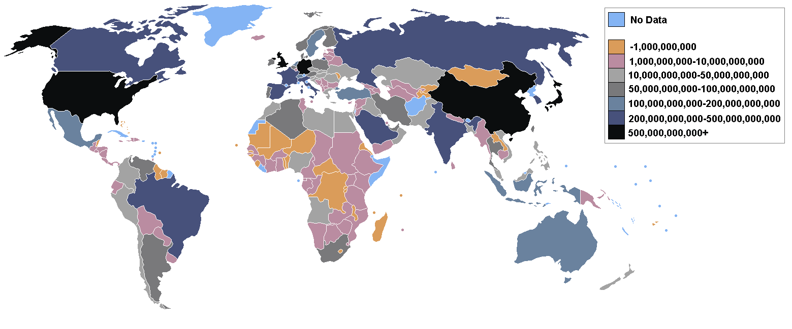

Figure 43: Countries by industrial output [55]

5.5.2 Construction

Distribution
After the product has been assembled at the factory in Portugal, the distribution of the product throughout the whole county can start. The distribution of all the parts will be done by truck

Transportation
Concerned the transportation of the product, each truck will carry up to a maximum of three products. The trucks will be specified to only carry this product. The product will not be delivered fully assembled. This saves a lot of space on the truck. Also for the transportation from truck to the standing place on the terrace can be done more efficient if not fully assembled. The parts will be transported from the truck to the standing place by a forklift truck or a crane.

Construction (new and renovation)
When the parts of the whole product arrive at it's destination the construction of the part on the spot can start. the most efficient way to do that is to let the construction-workers be on the sport at the same time as the product arrives. Sharing a forklift truck to not only put it on the spot, but also position it the correct way to assembly the product. For the renovation or service on the product it is possible let a mechanic come of to take a look at the product and replace a part where needed. If bigger parts of the construction will need to be replaced that goes according to the same procedure as when a new part arrives.

Installation
Transportation and installation are in this case really similar. Transportation from the truck to the house is an intense part of the installation. During the installation at the beginning, the forklift truck or the crane are needed to place the big construction parts on its place. When these parts are on the correct position the work vehicles will not be necessary anymore. The next steps will be done with the help of mechanics that have the knowledge to assemble the product. This can be defined as cabling from the shader to the power source the following processes will be done by small electronic tools like a drill.

5.5.3 Use

Use of installed products
After the whole product is installed and works as it shoot be the users can finally enjoy there new shader. The Setsun will only use electrical power that's been drawn from the house to the product. When in use the power will go to the motors and the CPU in the product.

Maintenance
The Setsun will require little maintenance. The only maintenance required is to clean it ones in a while, just to keep the canopy clean and prevent mechanical parts from breaking if there for instance comes dirt in.

Repair, replacement, renovation
When pieces are broken or basically not work anymore, the product will be turned off until the mechanic that will pass by for service says the product can be turned on. A mechanic will be informed by the costumer the inform about a possible problem. the mechanic will drive to the location and will try to solve the problem on the spot. a Service vehicle will provide him with the needed materials to solve most of the problems. If structure is damaged or broken the use of work vehicles is needed.

Products's operational use
During the operational use of the product it will only cost Electrical power to keep the Motor and CPU working.

End of life

Deconstruction, demolition
The Setsun is easily deconstructed as most of the parts are bolted together and can be Deconstructed in the exact opposite way as it is installed. For the demolition of the product, most of the parts can be recycled.

Transportation
After the product is disassembled, there is an possibility that parts from the Setsun can re-used in new Setsun products. We give the option to take in old parts to renew them.

Re-use, recycling, or disposal as waste
All electronics can be screwed out of the product so the leftover parts can be recycled. Most of the parts are build out of the exact same material which causes parts to be easily recycled as well.

5.6 Conclusion
Looking at Eco-efficiency Measures for Sustainability to sum everything up, the biggest part comes down on the materials, with the manufacturing and the surrounding elements as labor and economical growth. By keeping track of where the materials are coming from, in which conditions the materials are produced and what the environmental impact is for these materials is a quick explanation of a Sustainable approach. Mostly recycled materials, collected and produces by hard working men and women that earn a fair price for their work with materials that have a low CO2/Kg. Whilst considering the Environmental and Sustainability factors in our project we must also be concerned with the Ethical and Deontological aspects of the work we will be doing as part of our European Project Semester which the next section of this report will focus on.

6 Ethical and Deontological Concerns

6.1 Introduction
Ethics is a very important but also a difficult topic. It doesn’t decide what is right or what is wrong, it is kind of a system for moral principles. These principles show how to make decisions and how to lead the life. It is very important that the team analyses different ways to find the best solution whilst making sure that we do not breach any of the ethical issues and concerns we considered. The project and also the interaction with the team members has to be good for every individual and the society. The topics which the team has to deal with are:
- How to live a good life?
- What is right and what is wrong?
- Moral decisions
- Responsibilities and rights
Since every country has a regulation about ethical correctness the team created an ethical code of conduct during the work for the project. If there arise any problems, the team has to counteract those issues.
Code of ethics (Team 4):
- Respect is paramount
- Every team member has the same rights
- Decisions will be discussed and decided together
- Everybody has to be honest and say his or her opinion
- The developed product should not impair the consumer/ environment

6.2 Engineering Ethics
The project team consists of five members from different countries with different engineering backgrounds and experience. For this reason, it is very important to find out the strengths and weaknesses of every member. Everyone has other opinions, knowledge and experiences when talking about ethical issues. When developing the product there are a lot of ethical hurdles which the team has to handle with. Licensed software and open sourced projects are essential for ethical correct engineering. On this way, safety and also legal problems can be prevented. The team canot assure that ethically incorrect behaviour is impossible because, as mentioned in the introduction, ethics do not decide what is right and what is wrong, it just gives us an idea of moral principles.

6.3 Sales and Marketing Ethics
The special thing of Setsun is that it is truly honest and transparent to its customers. Also in the marketing of the product it was very important for the team to not make false claims or promises. The key is to offer neither more nor less depending on costs, quality and value.

6.4 Environmental Ethics
Environmental ethics are also a very important part of the project. Nowadays peoples’ consummation is extremely high. Most of the time it is not their fault. It all starts with the companies. A lot of firms are not caring about sustainability or the future environment. They try to hide their bad treat of the environment and to sell everything in a way to get the most profit. On the other hand, sustainability and environmental caring can be used as a good marketing tool. These days people are more enlightened in what happens to our environment and how our consummation affects our world. For our group it is very important to be a good model for others. As we set sustainability as one of our objectives it is necessary to think about efficiency, renewability and a greener world in general. With a budget of 100€ our team tried to figure out the most effective and best material to provide these requirements. The materials are purchased locally to avoid a long, environmentally damaging path but also to support Portuguese companies.

6.5 Liability
The team has the moral obligation to present a liable product to the costumers, so it has to work properly and the inside components have to be obtained from certified suppliers.
The product will be accompained by a product manual. In this manual there will be instruction on how to use the product and all the features that the product offers.
The EU has some requirements regarding the machinery and electronics that needs to be followed. This requirements are:
- Machinery Directive - 2006/42/CE 2006-05-17 [56]
- Electromagnetic Compatibility Directive - 2004/108/EC 2004-12-15 [57]
- The Low Voltage Directive - 2014/35/EU 2016-04-20 [58]
- Radio and Telecommunication Terminal Equipment Directive - 2014/53/EU 2014-04-16 [59]
- ROHS (Restriction of Hazardous Substances in Electrical and Electronic Equipment) - 2017/2102/EU 2017-11-15 [60]
Some of this directives don't apply to our project, however, the team believes they should be mentioned. For instance, Setsun does not have any type of radio or telecommunication, so this directive does not apply to our product.

6.6 Conclusion
During this project there could come up many ethical problems. Within the group the code of ethics can help to avoid these issues. Since we have done a lot of research in engineering ethics, we found out that it is very important to use licensed software and open sourced projects to not violate the copyrights. In terms of marketing it is essential to be transparent and honest to the costumers. It is of huge importance that the environment will not be damaged because of our product. This is why our team was dealing with sustainability and environmental ethics. In the end we will provide a liable product to our customers. It will work properly and we will get the inside components from certified suppliers to provide best quality and safety. Due to the implicit focus of providing a product that is ethically sound we are focusing on providing a quality product that solves a particular problem in our current society and as such in our next section this report will aim to show exactly how we propose to do so. The next chapter will give an overview about the development process of Setsun.

7 Project Development

7.1 Introduction
This section of the report details the different sections of product development of our outdoor intelligent shader, the development of which can be split up into different more detailed sections. It includes individual sub-sections relating to; the initial structural design, the electronic configuration, control systems and black box diagrams, software development and mechanical components.

7.2 Architecture

7.2.1 concept choosing
The following chapter is about the design, construction and the electronics of the shader. During this phase we faced a lot of difficulties with the design. There are so many different solutions with all its advantages and disadvantages. Eventually we end up making a chart that shows which design will come out best.
As shown in the Figure 44 there are 6 different concepts shown:
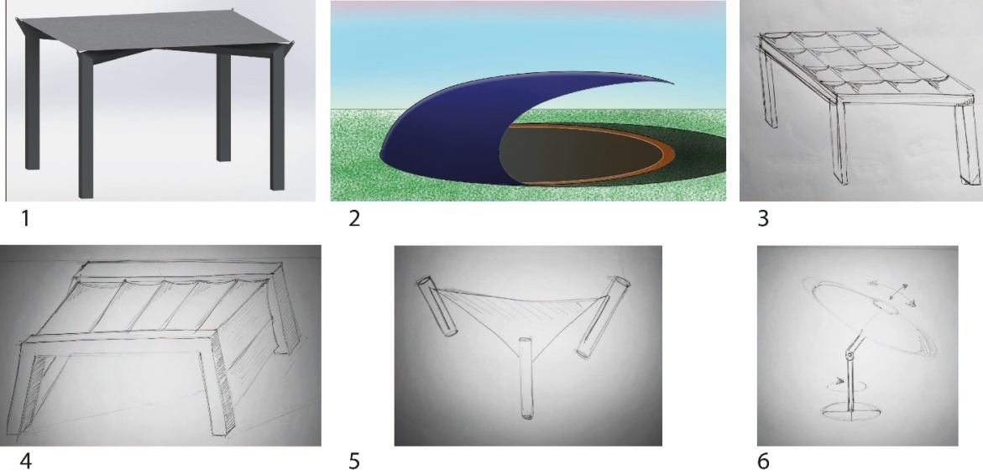

Figure 44: Design concepts
Here a quick explanation of every design:
- Canopy: this canopy has a fixed roof with on the 4 sides individual shaders that can go down.
- Ball design: this shows an ball shaped structure that turns during the day over a rails.
- Individual shaders: this shader has multiple individual small shaders that can open an close to provide a pattern of shade where needed.
- Bow shader: two metal bow structures with a stretched cloth in the middle that moves an 180 degrees during the day.
- Pole structure: a structure where the three poles move up and down to change the position of the sun.
- SMART parasol: this is a regular parasol that moves with the sun to maintain its shadow directly underneath it.
With all that information the concepts were ranked from one to five and eventually the one with the most points is the concept that is going to be further developed.
As shown in the Table 22 below the chosen concept is number 4.

Table 22: Concept Point Chart
 | Design | Electronic | Construction | Cost | Marketing | Total
1 | 2 | 3 | 3 | 2 | 3 | 13
2 | 5 | 3 | 1 | 2 | 4 | 15
3 | 3 | 1 | 4 | 1 | 3 | 12
4 | 4 | 4 | 4 | 3 | 3 | 18
5 | 5 | 4 | 3 | 2 | 3 | 17
6 | 3 | 2 | 4 | 3 | 4 | 14

7.2.2 Morphological chart
This concluded that number 4 is the one that's going to be the base of the development for this product. At the beginning a design is not based on any construction or electronics. It's still a rough idea. To get grip on this the use of a morphological chart is really helpful. This chart shows many possibilities to solve a particular problem. In this case it is to move the cloth from one side to the other. by combining the different ideas it eventually shows a possible solution for the problem.
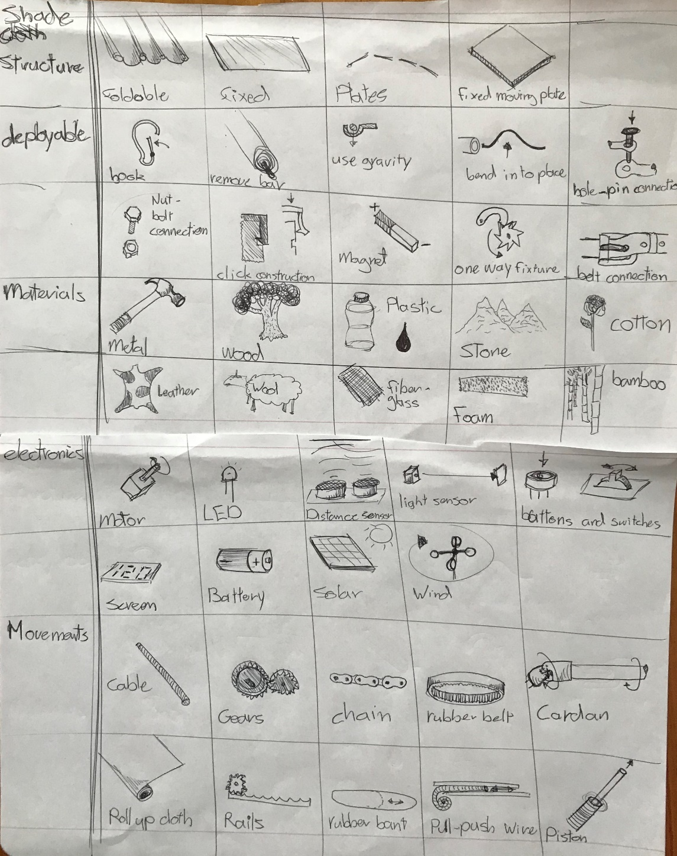
Figure 45: Morfological chart

After everything about what the design would look like with the morphological chart the final design the idea was to use a roll-up system at both sides of the shader. There are no movement components needed because the strength of the cloth is used. Just like a cable it's very strong in pulling force and not in pushing force. So this means that there's one motor that rolls up the cloth at one side and one on the other side.
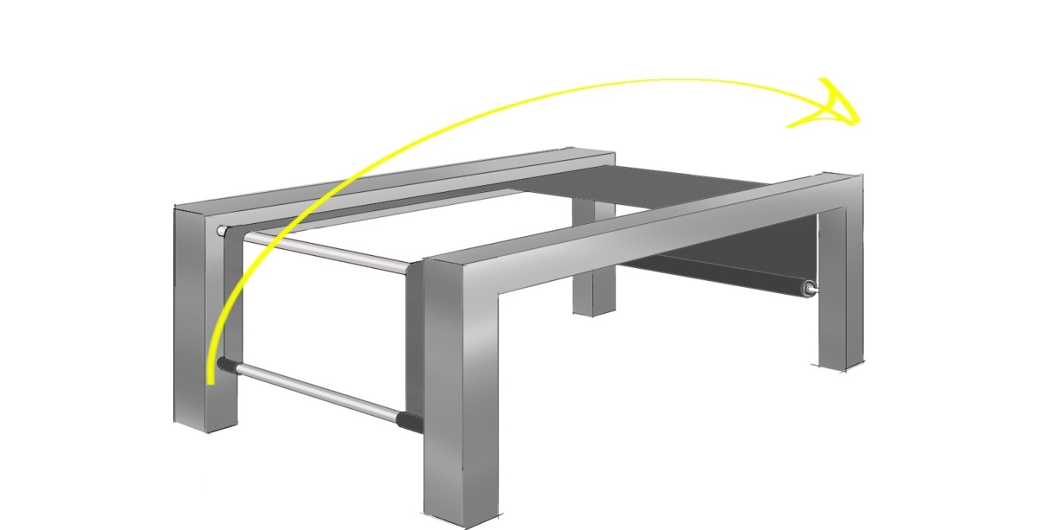

Figure 46: Final design

7.2.3 Aesthetics
The idea of how a product should look like is a very important aspect of designing. The product must have its own special appearance, especially when designing for a luxurious product.
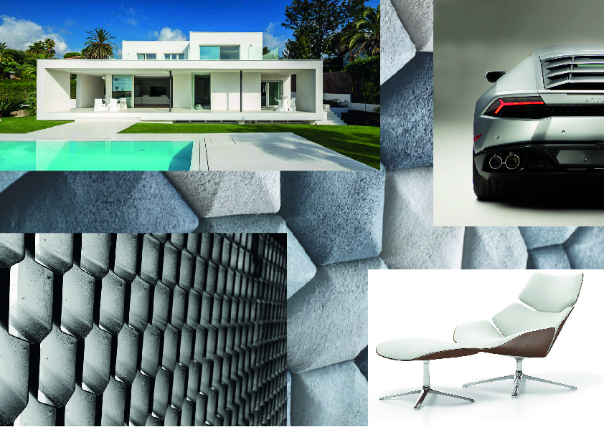
Figure 47: Aesthetics
Figure 48 displays the black box diagram of the system for the shader. It shows the components which are needed for our project. Changes could be made to this because of the development process.
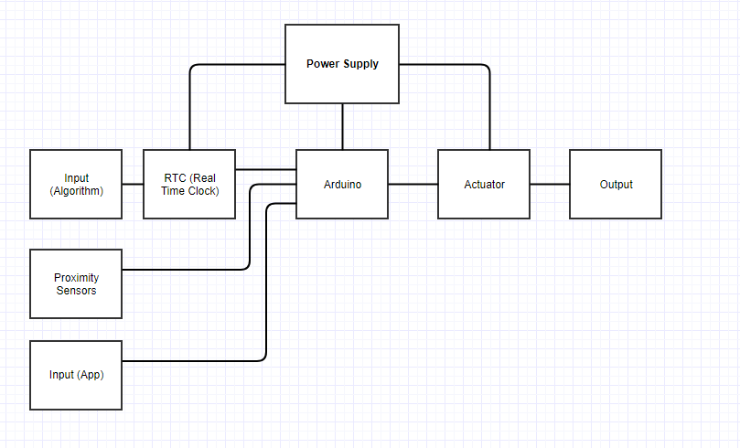
Figure 48: Blackbox diagram
The input signal is either a button or the algorithm which will be used to inform the system where the sun is positioned above the shader at any given point of the day based on the time of day and time of year the shader will be in use.
When the shader's cloth move by itself, the algorithm reads the time in the clock and then gives a signal to the controller (Arduino Uno). The controller activates the electric motor so that the shader can move to the appropriate place to provide comfort and shade to the user.
The process is the same when pushing the button, but in this case the algorithm and the real time clock are not needed. The command to move the shader comes from an external remote control. All lines in this diagram are to be read as if going from the left side of the screen to the right.

7.3 Components Product
In the next chapter there will be a full explanation of all the finished components for the product and for the prototype. ​Every part will be explained with the following infromation:​
- Part appereance
- Part use
- Part material
- Part strenght

Outdoor intelligent shader (head assembly)
At first is the complete product. The shader is based on three big components.
- The construction bow
- The vertical bars
- The mesh

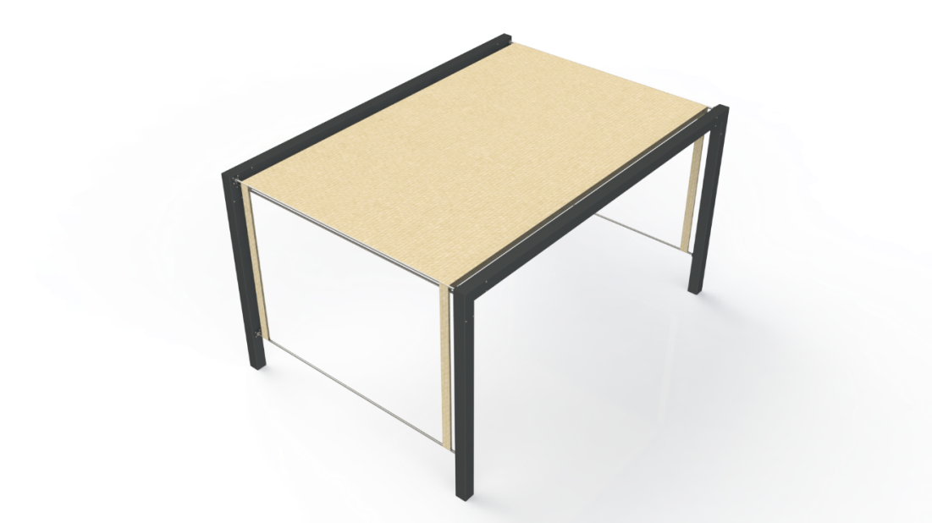

Figure 49: Final design

Construction bow
Appearance
The first assembly forms the basis of the whole structure as presented in Figure 50. This construction will absorb most of it's force because it's used to mount on the floor and all of the other assemblies and parts will be mounted to this construction. It will also form a base for all the electronics that will be fit within the hollow structure.
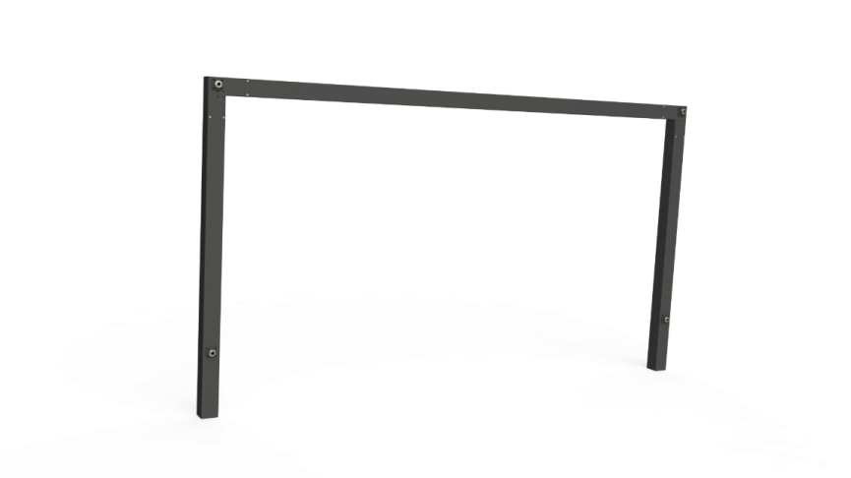
Figure 50: Construction bow
Shaping
The structure is a simple constructed structure which uses compared to other designs less manufacturing processes. Also a square design has the advantage that underneath the shader it gives the maximum amount of space to walk underneath it. To put that into perspective the construction bow exists out of 5 main parts:
- pole for the motor
- 2 regular poles
- top bar
- 2 corner-pieces
The pole for the motor is almost identical to regular poles. The only difference is that the pole for the motor has wholes in them to attach the motor to the pole using bolts. in Figure 51 is shown what the difference is between the regular and the pole for the motor. The regular pole does not have the four holes.


Figure 51: Pole for the motor
To show how all the parts are connected to the pole for the motor a exploded view is shown below. this includes the following features from left to right in the image:
- motor
- coupling
- belt
- gear
- bar
- bearing
- mesh
- screws (regarding the connection of the motor and the bearing)

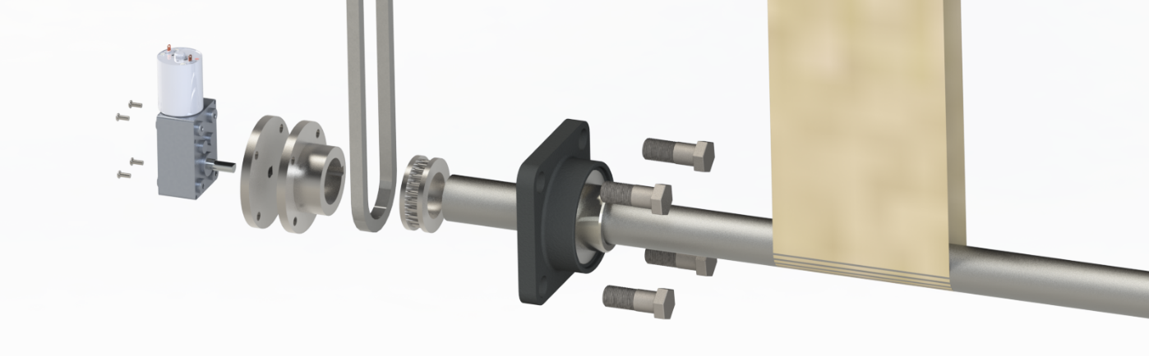

Figure 52: Exploded view motor pole
Because there could be some tolerance in the mesh there are slots added in the back poles to make it possible to move the roll-bar up and down to tighten or loosen the mesh.
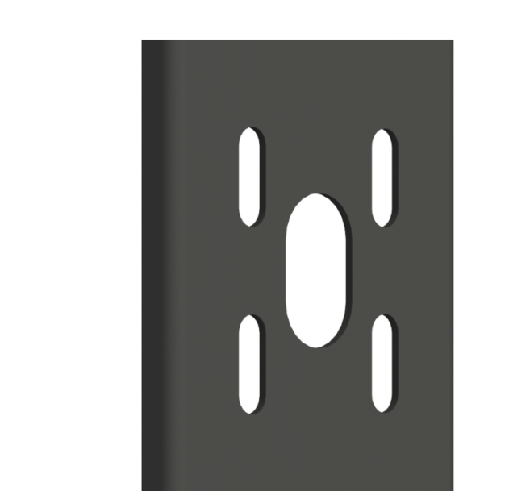

Figure 53: Back bar moveable
The top bar has no specific holes or difficulties. It is a straight forward beam that slides over the corner pieces. The only thing added to the bar are four holes on each side so the corner-piece can be mounted to the top bar.


Figure 54: Corner view top bar
Corner-piece
The corner-pieces of the structure are built to make it easier to assembly the whole structure and to transport all the pieces to the delivery address. The corner-pieces are places with an inside beam that has the exact inner diameter of the outside tubes so they would fit perfectly in the structure. Then they will be bolted on to the structure. While this is done the belts will be put through the structure for easy access. Also will the corner-piece be provided with the right wholes for the bearing and the vertical bar that provides strength to the structure.
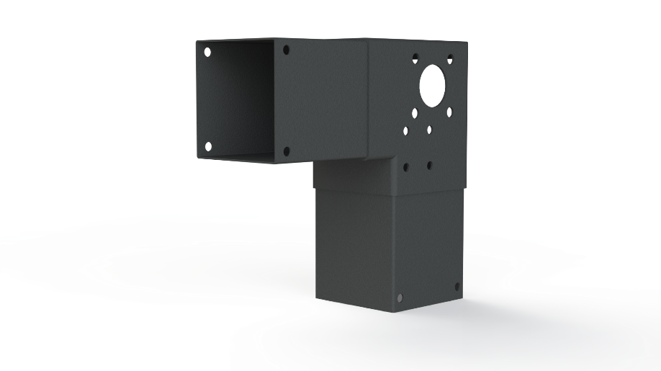

Figure 55: Corner view top bar
Because of a lit it is easy to excess the inside of the structure where all the bolts and gears are fitted. This lit is provided with magnets that prevent the lit from coming off. There are no bolts sticking out because of the magnets so it forms a flat and smooth surface. To make sure the lit is watertight a rubber foam strip is added.
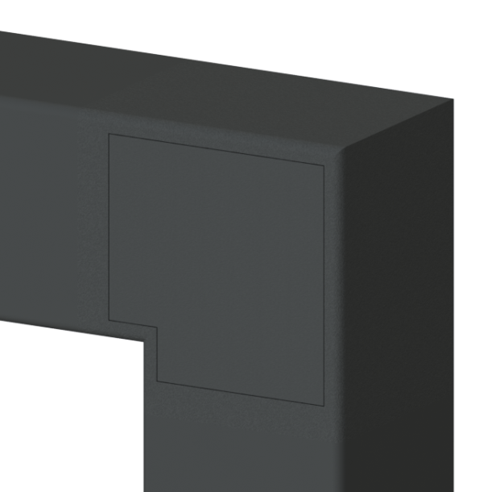

Figure 56: Corner piece with lit
To show how the cornerpiece is connected to the poles is an exploded view added. The exploded view shows the following:
- the bars
- cornerpiece cover
- poles
- screws
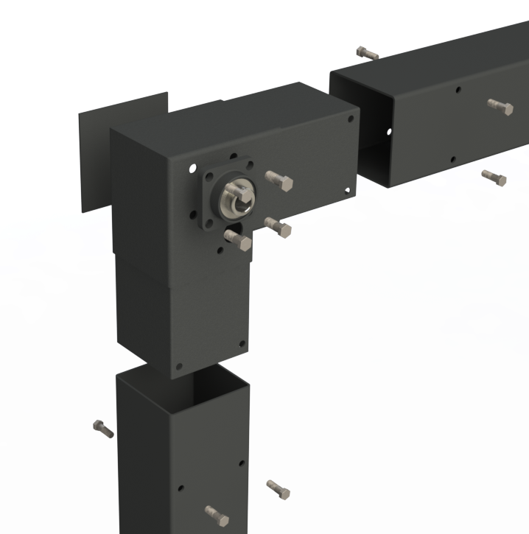

Figure 57: Exploded view cornerpiece

Also to show how all the rest of the parts are connected to the cornerpiece a exploded view is added. Important to take in to account is that this is the part where the belts come together and so it forms one of the more important pieces of the whole structure. The following features are shown in the exploded view:
- belts
- bars
- bearings
- mount plate
- collars
- self-lubricating bearings

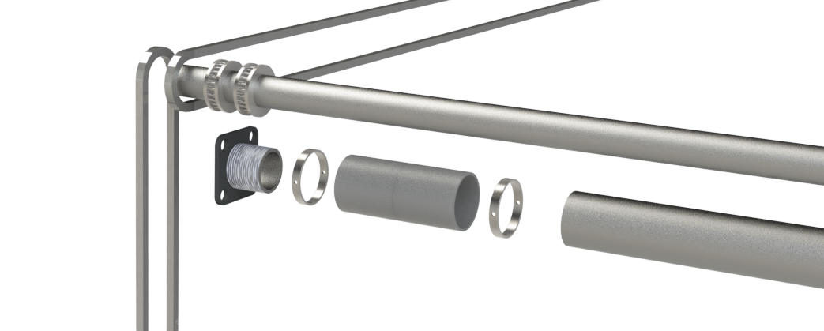

Figure 58: Exploded view cornerpiece
Rubber belt
To provide movement to the rolling-bars the following options where looked at:
- regular chain
- shaft
- rubber belt
- stainless steel cable
To take all the pro's and cons into consideration the solution to provide the movement is the rubber belt. The reason for this is mainly because of the low maintenance and the low sound it produced when it is used. In contradiction with chains of shafts there is no need for lubrication and especially chains produce a lot of sound when in use.
Belt tensioner
There is also a belt tensioner needed to make sure the rubber belt will move properly over gear. This is done by an arm which has a small cylinder with a slot of the width of the belt so the belt will stay between it. The tension is provided by a torsion spring attached between the plate and the arm.
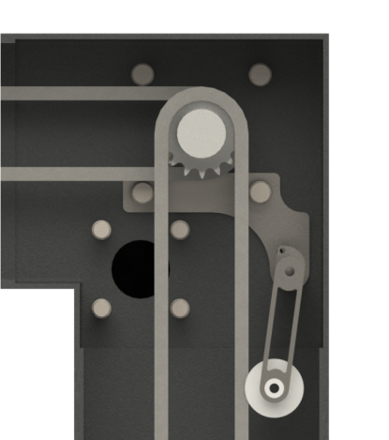

Figure 59: Tensioner cornerpiece
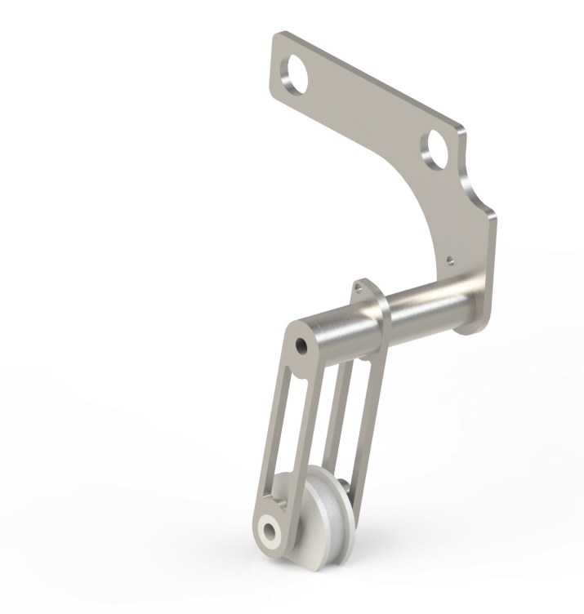
Figure 60: Belt tensioner
Force study
These five pieces gives the advantage to make an easy transported construction that is also easy to assemble at the spot. The two bows that are going to be used are completely identical which saves a lot of manufacturing processes concerning the bath size. To measure if the construction bow is strong enough an complete identical construction bow is constructed in SOLIDWORKS out of one piece to do a force study. The square tubes are made out of 130×130 mm steel with a thickness of 3 mm. This gives the structure enough strength to resist a force in the middle of the structure of 1000 N which causes a deformation of less than 1.4 mm that is considered as acceptable in the List of Requirements (shown in the image below).

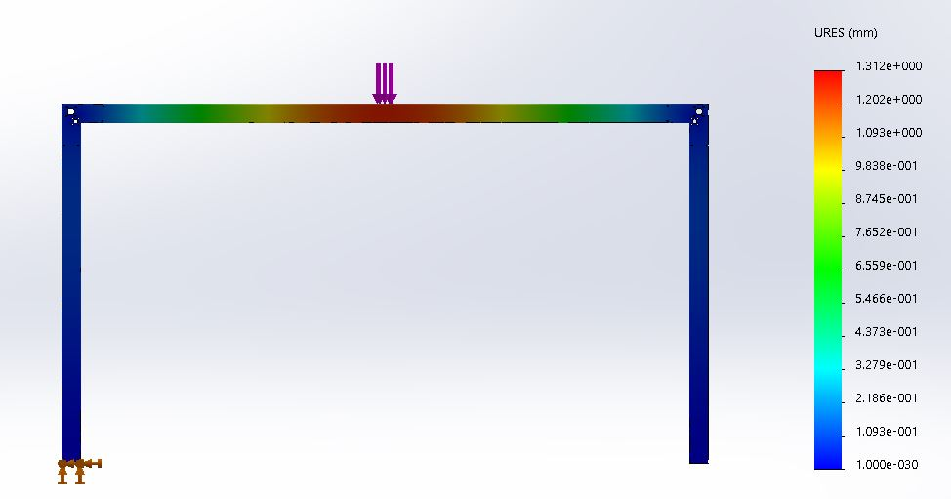

Figure 61: Construction bow

Material
To choose the right material for its purpose the program that’s called CES Edupack is used. This program helps to funnel the materials to a small group of materials to choose from. The understanding information shows the limits we put up to choose the material:
- Material in ‘Bulk Form’
- Price of 2 €/Kg
- Recyclable
- Only Metals and alloys
- Hot metal extrusion as shaping process (because of the hollow square form)
- Graphic that shows Young’s modules (GPa vs. Price (€/Kg)

Now we set all the different limits the next step is to look at the graphic. In the image shown below there are only a couple colored dots. These dots are the only left over materials that can be used for our product (from 3986 to 552 materials).

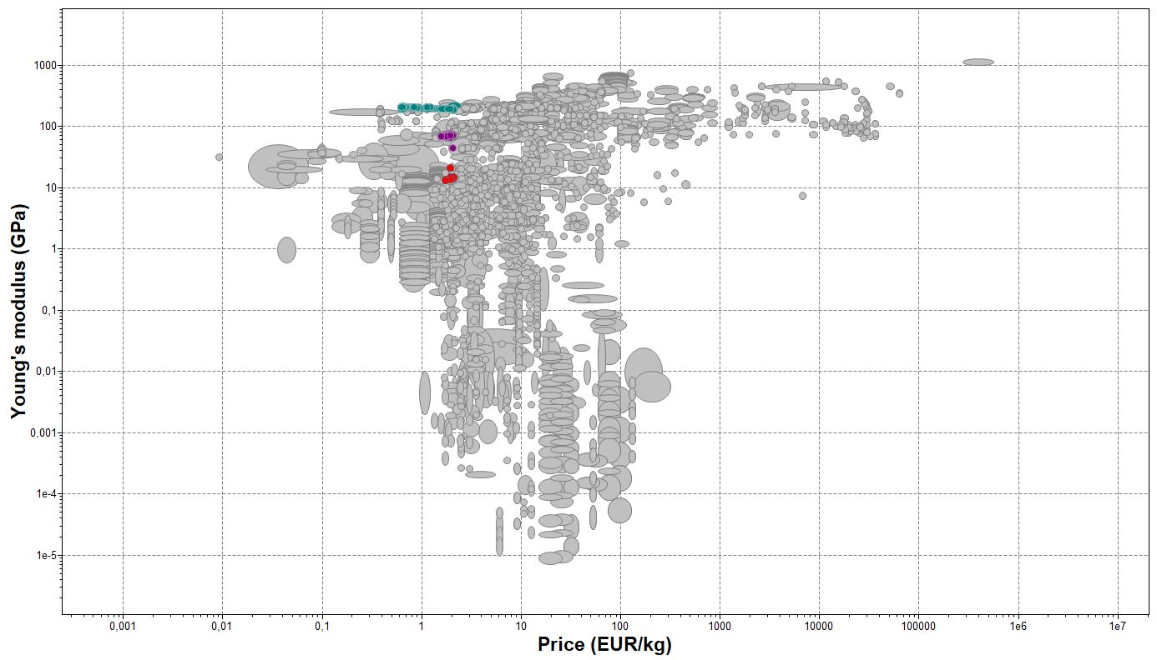
Figure 62: Graphic all materials
After that an index and display line is added. This line shows a balance between the Young’s modules and the price. So the strongest material with the lowest price is shown eventually. In the image shown below is the line with the leftover materials. This line is based on the following formula E^(1/2)ρ. This is the formula for a beam structure (others are for a panel or tie).

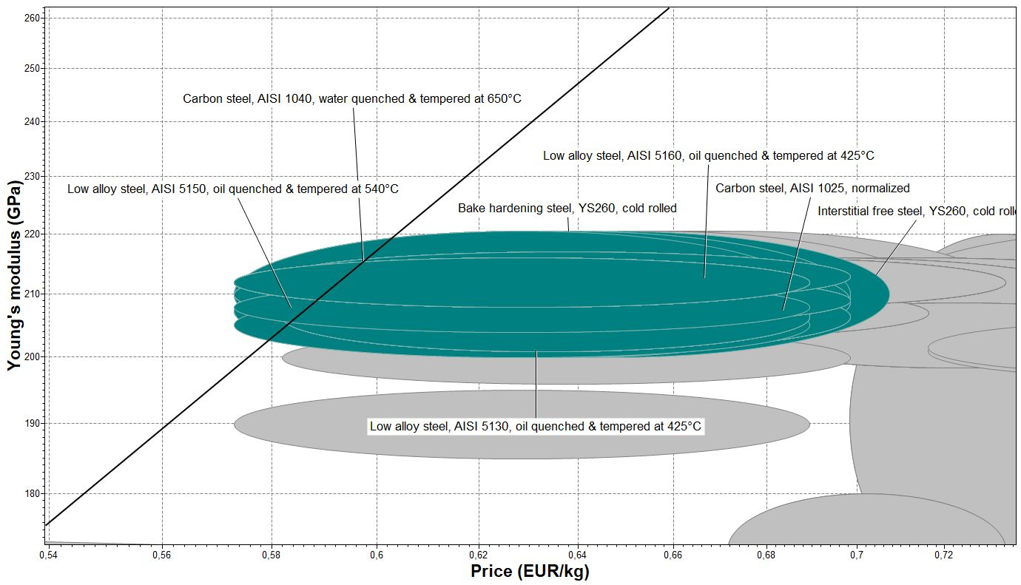
Figure 63: Material chart inzoom
All these types of steel are really close together, but eventually is chosen for a Carbon steel. The specific type of carbon steel is not specified as it depends on the manufacturers possibilities. Carbon steel is the ideal steel for our project as it can be recycled, easily welded, easy to process and very cheap. It’s not stainless witch can be seen as a downside, but the structure is going to be powder coated so the structures steel wont rust.
Joining
First of all the construction bow forms the basis of the complete product. The footpiece, the vertical bars and the rollorbars will be connected to the structure. To join the pieces together stainless steel nuts and bolts will be used. This is done so there is no need to weld anything to the construction bow and it is also easy to remove.
Surface treatment
For the surface treatment of the construction bow are two different types of surface treatments used.
  - Hot-dip galvanizing
  - Spraypaint
Hot-dip galvanizing: This is a surface treatment that is often used to protect metals from corrosion. It is an excellent long-term corrosion projection. Galvanizing is preferred over painting because of a metallurgical bond between the coating and underlying steel. Also because the construction bow uses hollow beams the inside can also be protected from corrosion. In terms of economics, galvanizing is inexpensive, despite being energy intensive. And also the coating has a very good resistance against mechanical damage. But if we look at the environment, it uses some hazardous chemicals for the process.
Spraypaint: As hot-dip galvanizing does not give the construction bow a particular color a final surface treatment is added to match the esthetics of the product.

Horizontal bars
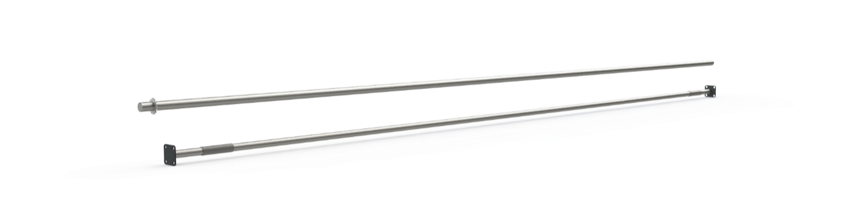
Figure 64: Horizontal roll bars
The horizontal roll-bars are forming the connection between the two construction bows. However this is not their only purpose. On the roll-bars are gears attached which are connected to three belts in total. These belts form a connection between all the roll-bars so they would rotate at the same speed. The mesh is going to be attached to two of these bars at the bottom of the structure.
In total there are 4 different roll-bars:
- roll-bar 1 gear
- roll-bar 2 gears
- roll-bar 1 gear motor
- horizontal force bar

Roll-bar 1 gear
Roll-bar 1 gear will be used at the bottom of the structure at the back. It rotates between the two bearings and there is only one gear attached to it with a belt that moves to the top.
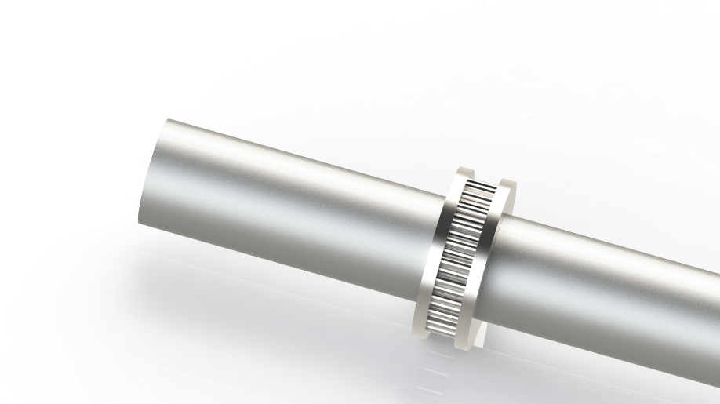
Figure 65: Roll-bar 1 gear
Roll-bar 2 gears
In the structure there will be two of these assemblies and will be placed at the top of the structure in the corners. they rotate between the bearings and connect the belts with two gears. One gear for the horizontal belt that follows the topbar and the other gear that follows the vertical belt to the bottom of the structure.
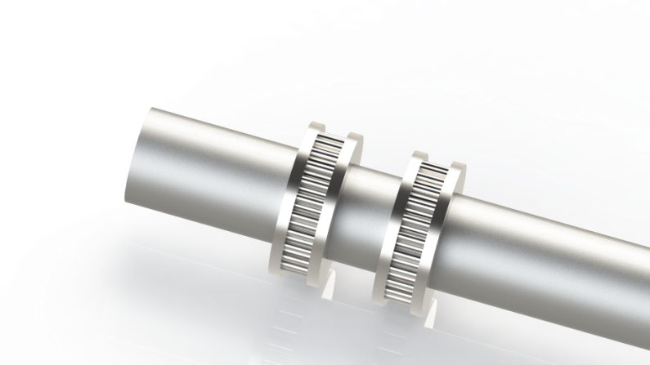

Figure 66: Roll-bar 2 gears
Roll-bar 1 gear motor
This is the roll-bar that will be driven by the motor. This is done by a key hole in the bar which is used for the flange coupling.
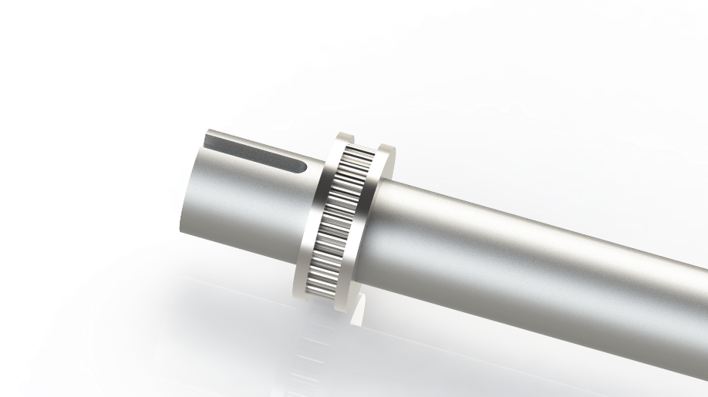
Figure 67: Roll-bar 1 gear motor
The roll-bar 1 gear motor is going to be attached to the motor and this is done by a flange coupling. In this way it is easy to place the roll-bar over the drive shaft from the motor and screw it in place.
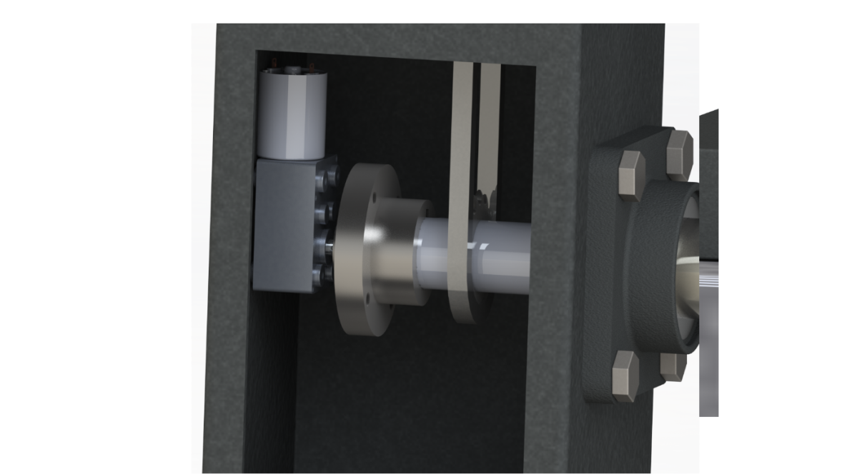
Figure 68: motor roll-bar connection outside view
Horizontal force bar
This bar will go all the way across the structure to make the structure stronger. They are placed in the two corners. For the attachment of the vertical bar to the construction bow there is an small plate added so the bar can be screwed together.To make this possible there are 4 holes in the corner of the plate where bolts can fit through. There is also a fifth hole that makes it able for the cable to go through that goes to the sensor in the bar.
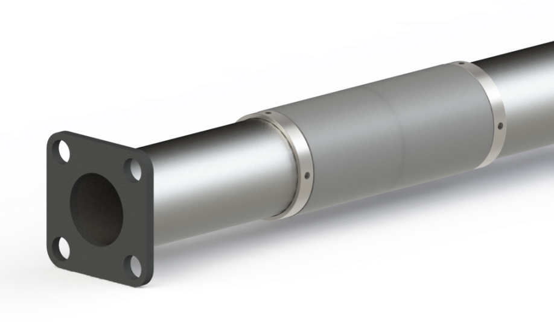
Figure 69: Horizontal force bar
On top of the bar is an small tube added with on the outside screw thread. This screw thread matches the inner screw thread on the vertical bar. In that way the bar can be screwed to the plate. This is necessary because the collar and the bearings need to be removable from the bar.
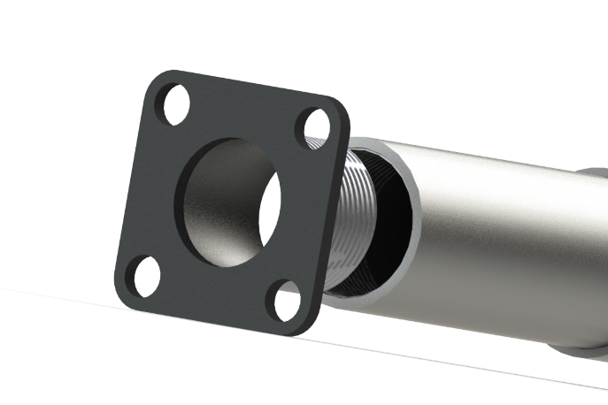
Figure 70: Mounted plate exploded view
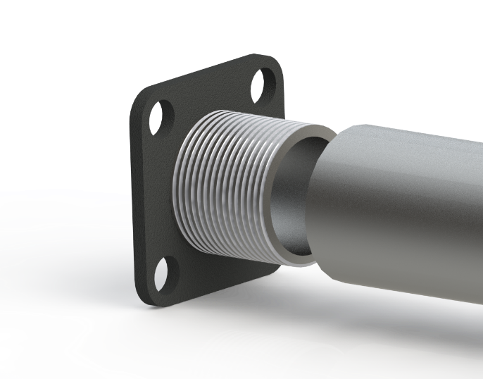
Figure 71: Mounted plate exploded view 2
Looking online for the self-lubricating bearings there are many different kinds of Self-lubricating bearings. These are the following properties needed for the product:
- 40 mm inner diameter
- 100 mm length
- Max of 10 mm thickness
- Outdoor use
- Low-impacts
With these properties in mind a self-lubricating bearing was found online. Unfortunately there is no self-lubricating bearing that provides the length needed. The maximum length available is 50mm, so instead there are two on each side of the bar.
Just as explained the self-lubricating bearing will roll over the vertical bar. But it is still able to move to the sides. The following challenges need to be taking in to account:
- The self-lubricating bearings must be free to roll over the bar.
- The solution to hold the self- lubricating bearings in place may not be bigger than the outer diameter of the bearings (mesh can get stuck).
- The attachment must be removable if self-lubricating bearings need to be replaced.

The biggest challenge was to be able to come up with a solution that was smaller than the outer diameter of the bearing and would not stick out. One of the possibilities that were looked at were circlips. In this case there will be a groove in the bar and with a tong the circlip will be placed in the groove. Unfortunately there are no circlips available online that will fit over the bar of 40mm and not stick out. Another simple solution would be to just use small screws and screw them in next to the bearings. But if the bearing would touch the screw and turn it will likely turn the screw out of its place and eventually fall out.
The final solution is to use shaft collars. This is a common solution to keep bearings in place. There are only no collars available that provide this diameter with such a small thickness. So they would need to be produced. In the collar will be 4 small socket screws that can be screwed to the bar to hold the bearings in place.
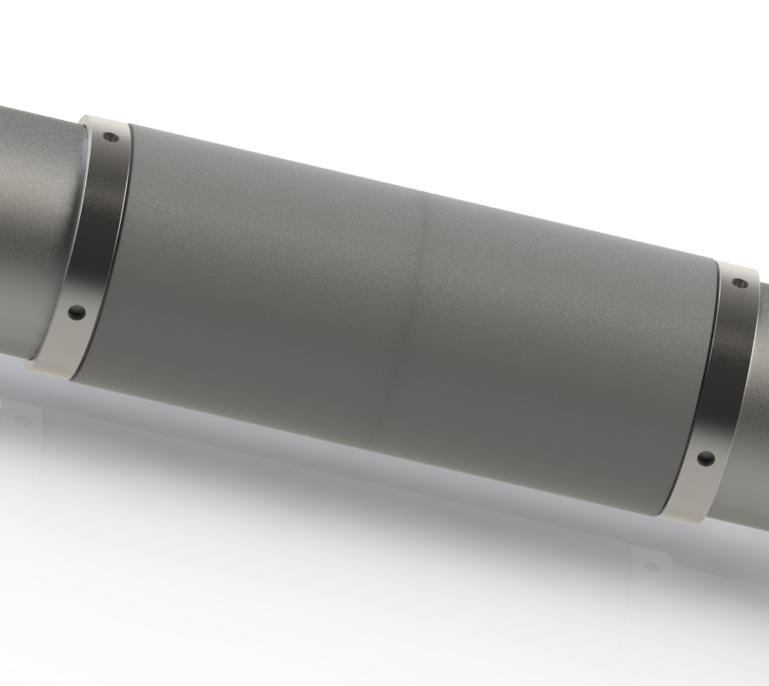
Figure 72: Collar with self-lubricating bearings

Mesh
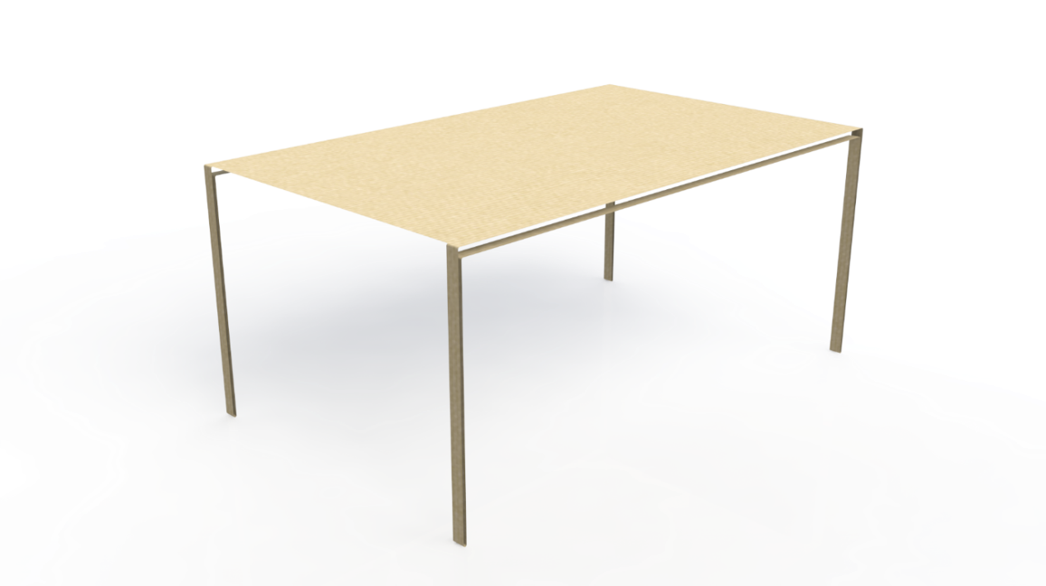
Figure 73: Mesh
For the last part of the Setsun will the mesh be places over the horizontal bars. The cloth will form a closed loop that is stretched over the six bars. To give a quick review of the way the mesh moves take a look at the image shown below.
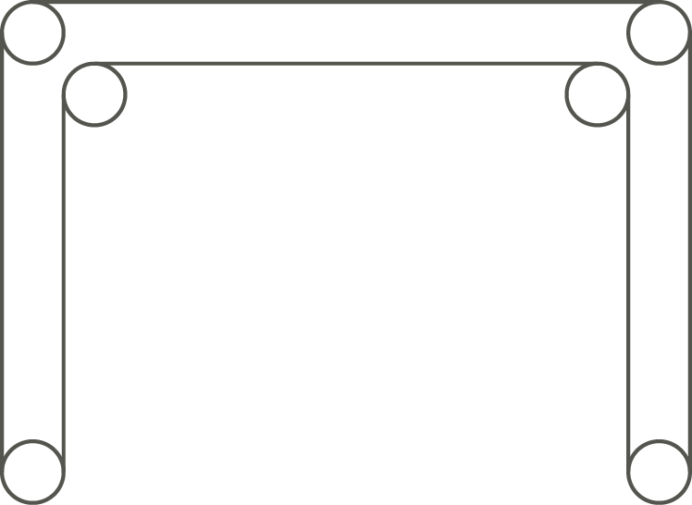
Figure 74: Movement mesh
Shaping The shaping of the mesh is one of the most important parts of the whole product. The mesh will eventually provide the shape and place of the shade on the ground. This is solved by using a closed loop shaped mesh. this is so the cloth will never get stuck and is free to move to all sides.
Joining one thing to keep in mind is mostly the order of assembling the mesh. Since it is a closed loop the horizontal bars must be placed through the mesh first because elders the mesh will not form in the correct position.
Surface treatment There is no specific surface treatment for this part except the fact that the colour or the mesh has to do with the type of material of the mesh.
Material There are plenty of different materials for mesh. To get a grip of what kind of material can be used, looking at the state of the art can be helpful for the solution. In this case looking at the purpose of the mesh is most important. That is why looking at the materials that are uses for an awning is a good start. The cloth will be exposed to sunlight, it is able to outstand rain and most important is that the mesh can be rolled up. These properties are shared with the Sunset. Eventually there are 2 different kinds of materials that are possible to use:
- Acrylic
- Polyester
When looking at these two materials for the mesh in its environment the following properties are important to take in to account:
- Breathability
- UV resistance
- Water resistance
- Colour fastness
- Abrasion resistance
- Cleanability
By looking at all the different properties of the two materials eventually is acrylic the fabric that is chosen for the mesh. the main reason is because of the UV resistance properties. Acrylic forms a better resistance to discoloration.

Footpiece
On the bottom of the structure is going to be placed a footpiece, to stuck the construction bow to the ground. The footpiec will go inside the construction bow in order to avoid a non esthetic element in the structure, it will be locked by a pin as shown in Figures 75 and 76.
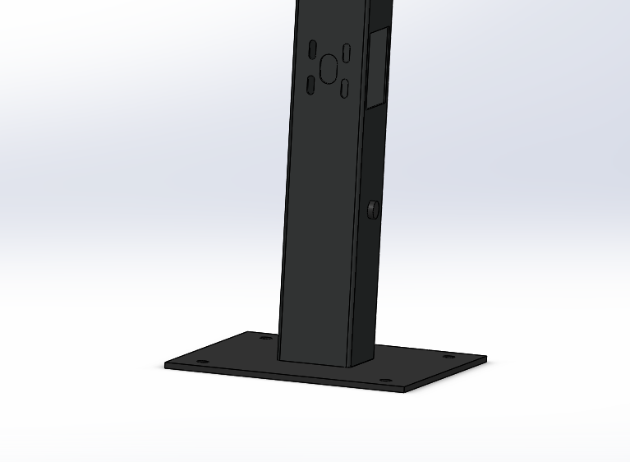
Figure 75: Footpiece
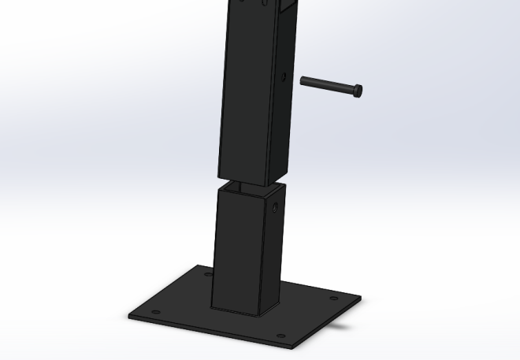
Figure 76: Exploded view Footpiece

Technical drawings
For detailed information the technical drawings are added and shown below:
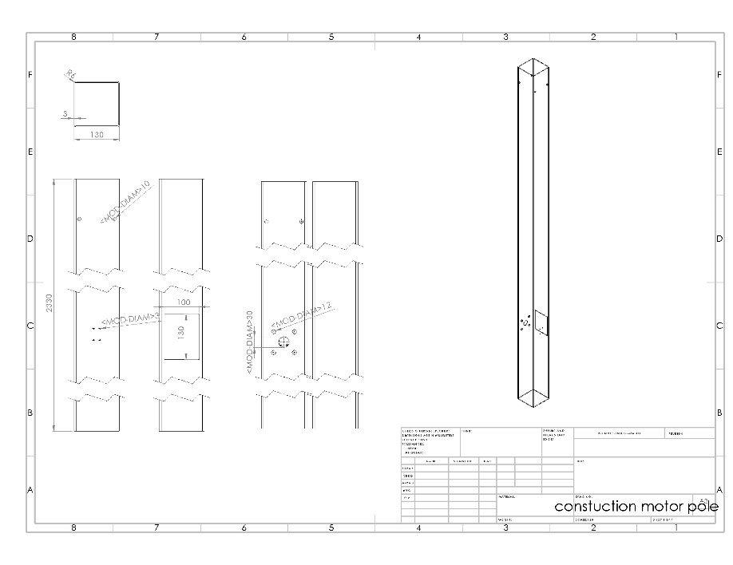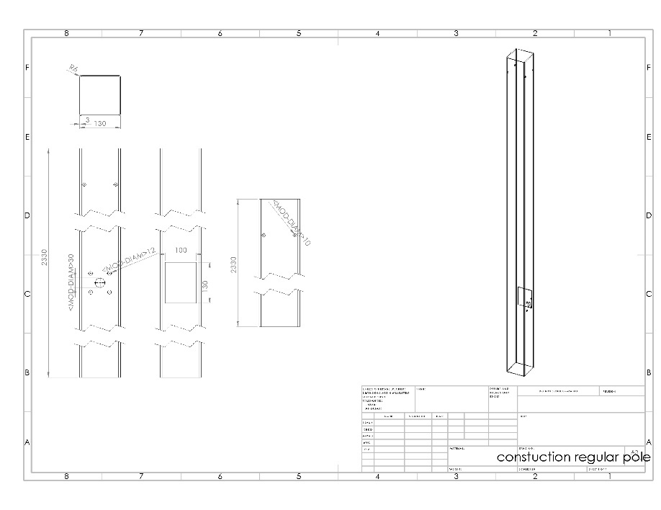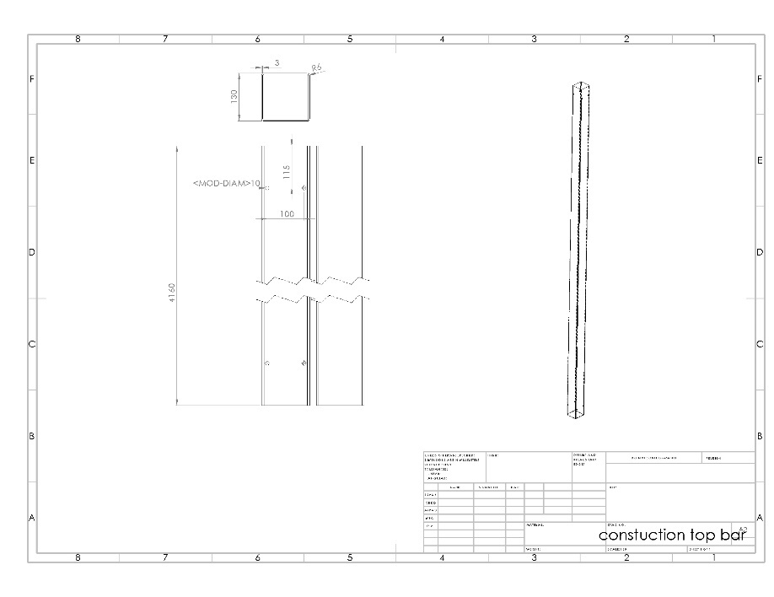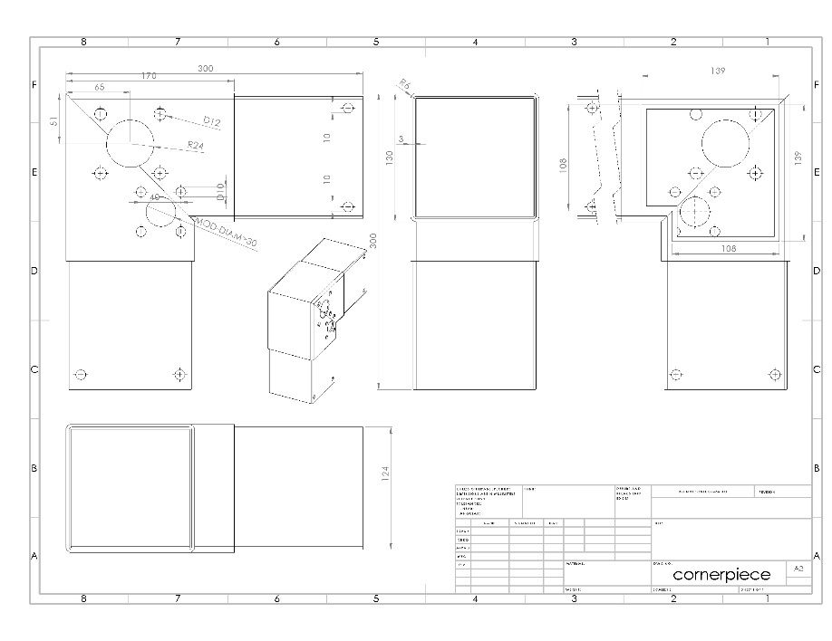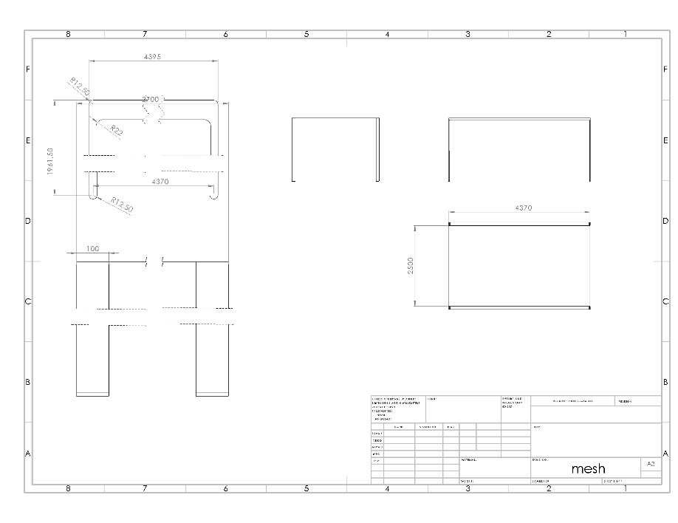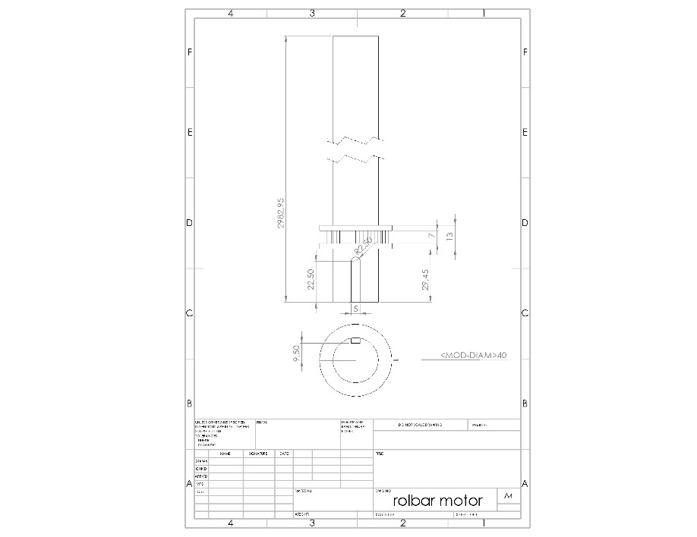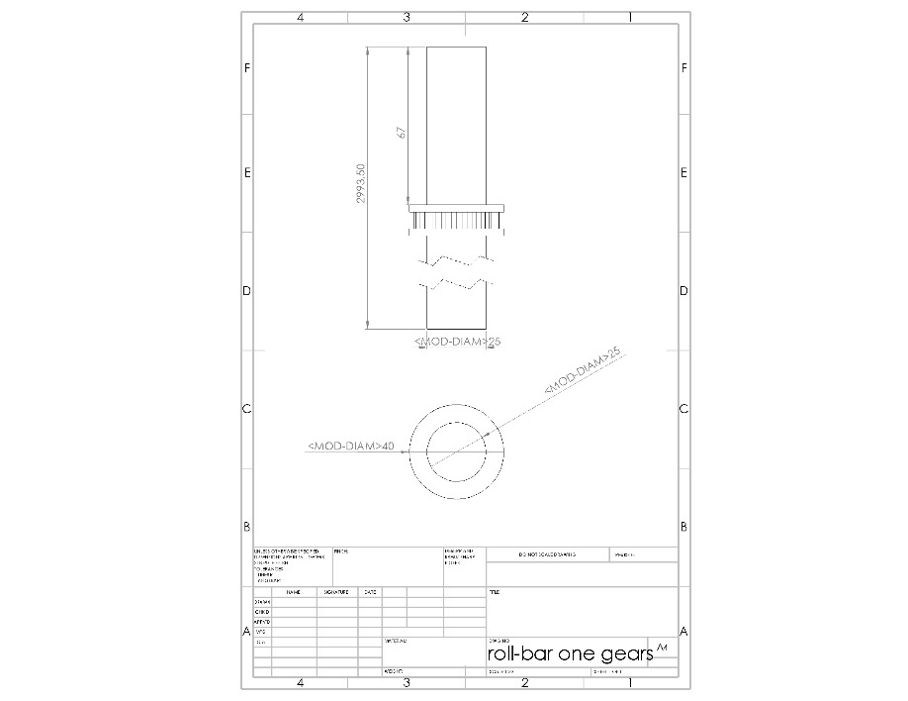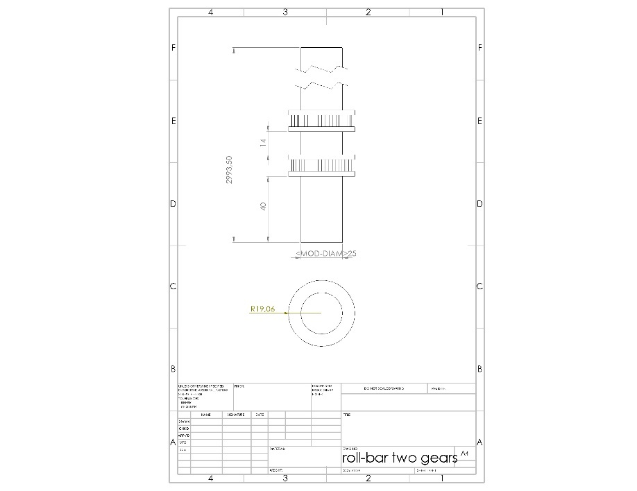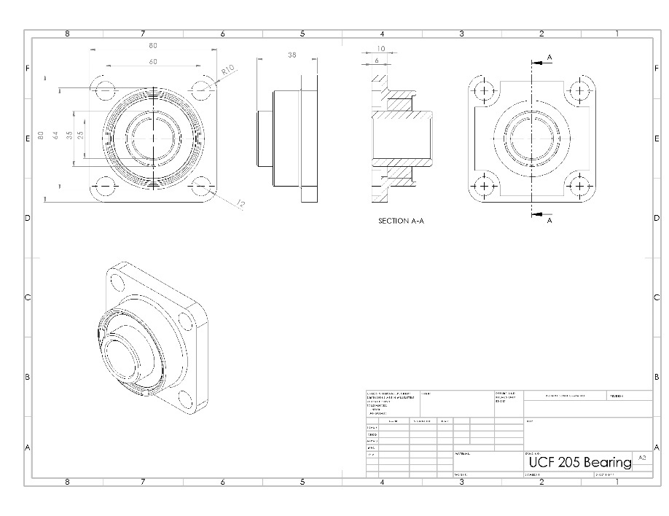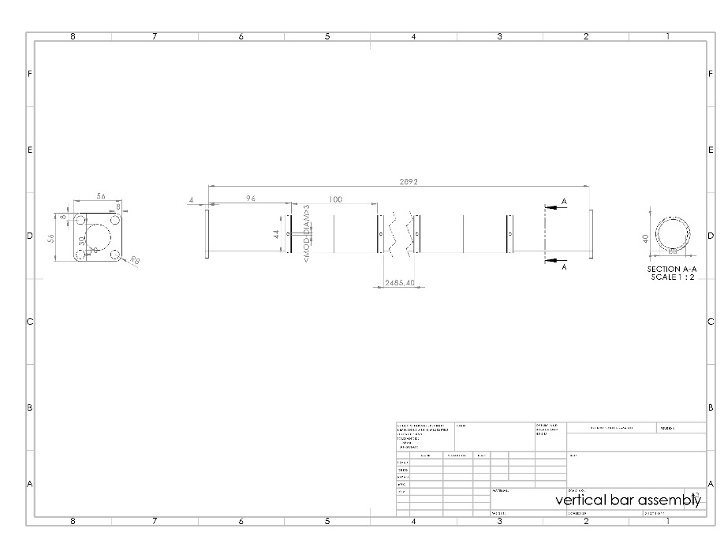

7.4 Components Prototype ​

The prototype will be having a totally different approach than the original product. It will function like the final product, but it will be 1/5 of the original size. Also it will be made out of wood which is an material that can be easily processed for prototypes. All the electronics will be put underneath the base plate. This is done because the construction bow is made out of wood so it won't fit in the structure.

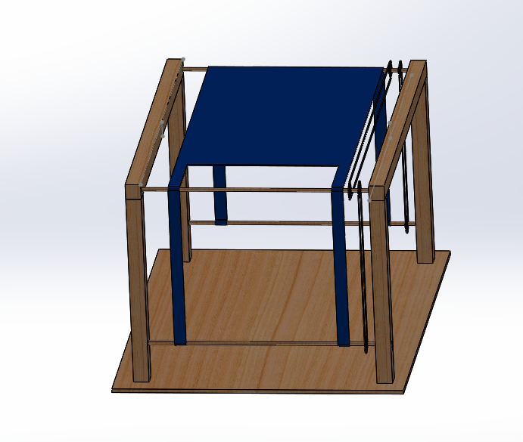
Figure 77: Prototype

Prototype Materials
Table 24: List of Materials
Number | Description | Material | Supplier | Component reference | Quantity | Unitary price | Final price
1 | Wood Beam 44*44*2400 | Spruce | Leroy Merlin | 14126196 | 2 | 5.49 € | 10.98 €
2 | Wood Bar ø10*2400 | Pine | Leroy Merlin | 16909900 | 1 | 1.69 € | 1.69 €
3 | Panel 1200*600*10 | MDF | Leroy Merlin | 11034310 | 1 | 4.99 € | 4.99 €
4 | Woodglue | Epoxi | Leroy Merlin | 16715384 | 1 | 1.59 € | 1.59 €
5 | Bearing ø8mm | Bearing Steel | RepRap | 688zz | 3 | 0.90 € | 2.70 €
6 | Transmission Belt | Rubber | RepRap | correiaGT2 | 5 | 2.00 € | 10.00 €
7 | Pulley | Alluminium | RepRap | poliagt28mm | 6 | 2.90 € | 17.40 €
8 | Bearing ø10mm | Chrome Steel | Aquario | 6200 2RS | 4 | 1.40 € | 5.60 €
9 | Cloth | Cloth | Team Member | Donation@001 | 1 | 0.00 € | 0.00 €
10 | RTC DS1307 |  | Electrofun | ef16b0025 | 1 | 4.70 € | 4.70 €
11 | HC-05 Bluetooth Receiver |  | Electrofun | ef16a0010ok | 1 | 8.30 € | 8.30 €
12 | Proximity Sensor |  | Electrofun | ef17a0167ok | 2 | 2.95 € | 5.90 €
13 | Switch |  | Electrofun | ef17p0183ok | 1 | 0.95 € | 0.95 €
14 | L298 H Bridge |  | Electrofun | ef16b0006ok | 1 | 8.85 € | 8.85 €
15 | Logic-Level Translator |  | Botnroll | CNV01000 | 1 | 2.50 € | 2.50 €
16 | Arduino UNO |  | ISEP | ISEP@001 | 1 | 0.00 € | 0.00 €
17 | DC Motor |  | ISEP | ISEP@002 | 1 | 0.00 € | 0.00 €
18 | 10 kΩ Resistor |  | ISEP | ISEP@003 | 1 | 0.00 € | 0.00 €
19 | BreadBoard |  | ISEP | ISEP@004 | 1 | 0.00 € | 0.00 €
20 | 12 V Power Supply |  | ISEP | ISEP@005 | 1 | 0.00 € | 0.00 €
 |  |  |  |  |  | Total | 86.15 €

Electrical Schematics

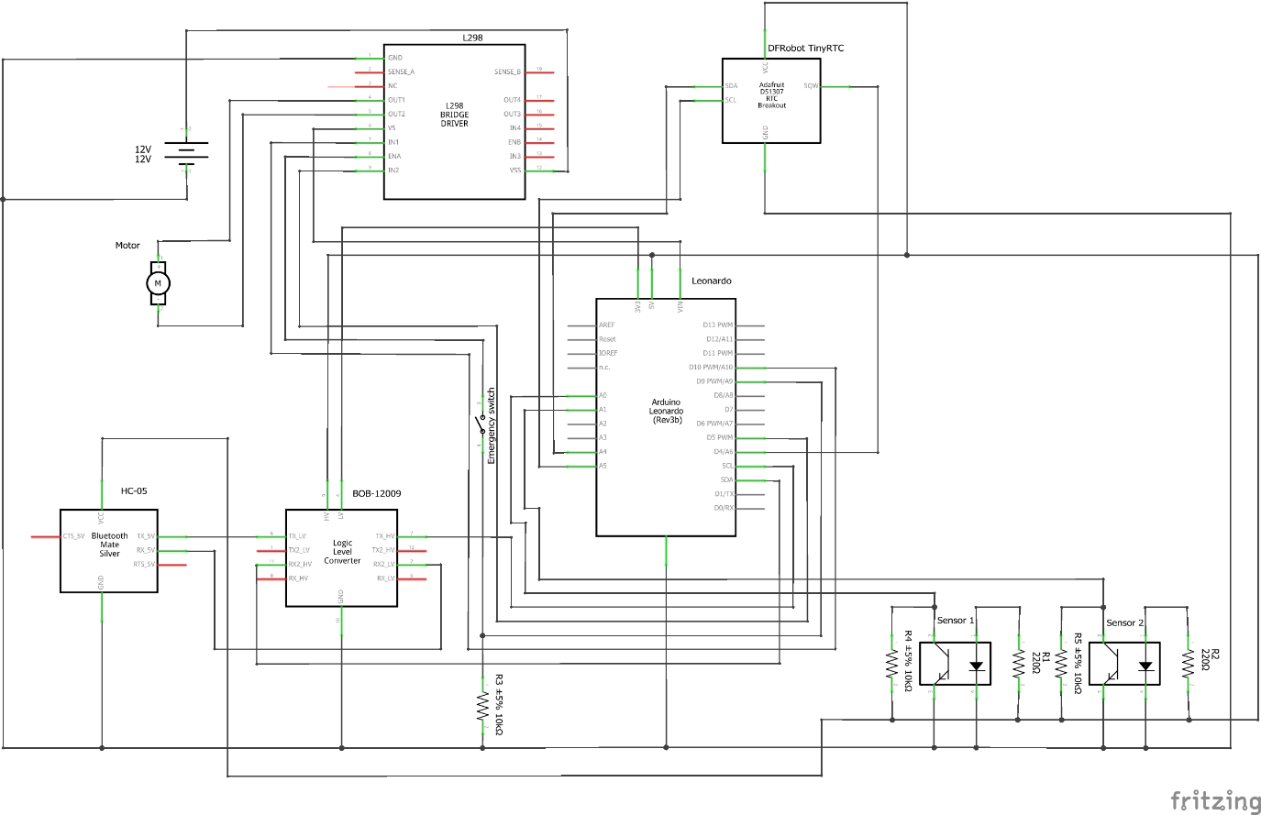
Figure 78: Electrical Schematics

Figure 78 shows the electronics and presents a 12V power supply connected to the H bridge module, that is there to assure the motor rotates for both sides.The H Bridge then is providing power to the Arduino microprocessor, and is connected to the motor and 3 digital PWM entries on the Arduino. The connection done with enable entry in the H bridge has an emergency switch with a pull down resistor. We have then a RTC real time clock, is there to provide the time to read the algorithm wrote with the solar positions, the power supply is a 3V battery, and is connected to the Arduino by 3 analog entries. We use 2 sensors to define the zero-point, also known as the cloth original position. Each sensor is connected to an analog entry. The power for this modules is provided by the 5V output of Arduino. For last, we have a bluetooth receiver for future development. This bluetooth receiver has the function of receive the orders from the phone. The power is supplied by a logic level translator, that is there because the bluetooth devices works on a difference logic level than the rest of the system. This logic level translator is connected to the Arduino by 2 analog entries, and is connected as well with the 5V and 3V3 outputs, to do the level translation. The Bluetooth device is then connected to the respective entry in the logic level translator.

Power Budget
Table 25: Power Budget

Component | Voltage (V) | Current (mA) | Power (W)
H - Bridge | 5 | 0 – 36 | 0.180
12 V DC Motor | 12 | 42 | 0.504
RTC DS1307 | 5 | 1.5 | 0.008
HC-05 Bluetooth Receiver | 3.3 | 30 | 0.099
Proximity Sensor 1 | 5 | 25 | 0.125
Proximity Sensor 2 | 5 | 25 | 0.125
Total |  | 159.5 | 1.041

7.5 Functionalities

Automatic sun shader: We are going to use an algorithm that calculates where the sun is positioned in relation ​with the geographical point where the shader is placed. The values provided by the algorithm are going to insert ​data into the controller and that data will be sent to the actuator. This is a very reliable way to locate ​the sun because there are some factors that can't affect ​the data collecting, such as weather conditions or any kind of external influence, these problems can be found when a light sensor is used. The data will be provided ​to the Arduino board from time to time.

Basis of how it works:
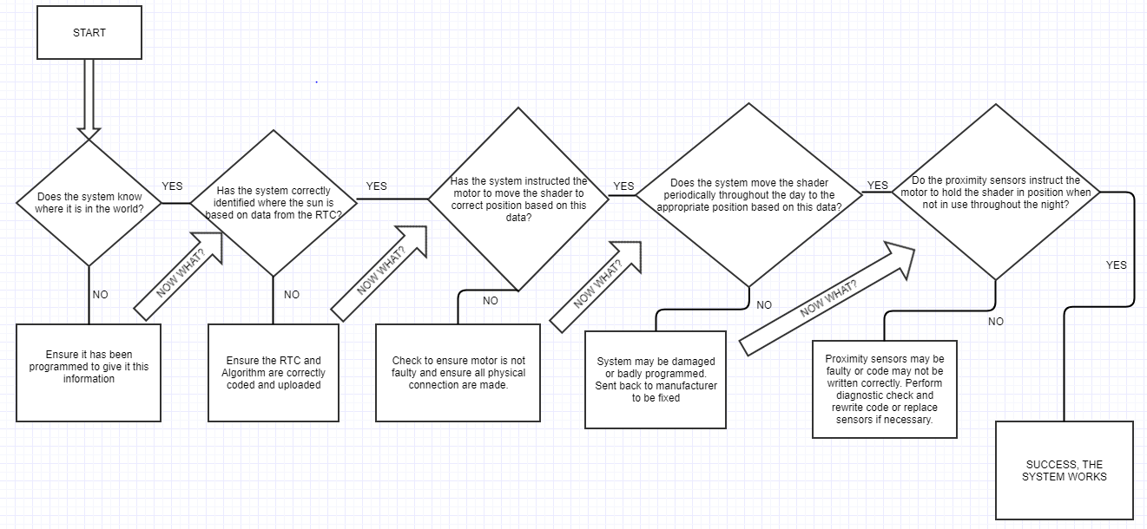

Figure 79: Flowchart of the algorithm

After plugging in the SetSun shader the system will calculate where the cloth part of the shader should move to over the structure based on the time of day and the physical placement of the SetSun in the world. The NREL's Solar Position Algorithm (SPA) calculates the position of the sun given the correct time of day which is given by the Real Time Clock and by the correct position of the SetSun shader (inputted as latitude and longitude by team member at time of programming) at this point the controller, after receiving this information, then sends a signal to the motor in order to position the shader in the correct place.
The time of day is provided to the system by the Real Time Clock that is connected up to the Arduino and whilst this continuously updates throughout the day and even if the SETSUN is unplugged or moved at any point there is a backup battery plugged into the Real Time Clock to keep accurate time in the system.
The placement of the cloth over the structure is determined by; the location of the structure in the world (which country/city/time-zone it is in) and also, which position the sun would be in above the given country/city depending on the time of year or time of day. This information is provided by the algorithm that will be uploaded to our prototype/product by our team. Each day when the sun is rising, the algorithm informs the system as to which position the cloth section of the shader should be in and in turn sends a signal to the motor to spin for a certain amount of time to move the cloth into the correct position in order to shade the people sitting underneath it. After a relevant portion of time has passed and the code has calculated a new position of the sun the controller will again instruct the motor to move for a set time to move the shader to a new position. This process will repeat a few times throughout the day to provide continuous shade to the user’s underneath.
At the end of the day we place in the code an instruction that informs the motor to turn in the correct direction until the cloth returns back to its zero-point (where the sensors meet) throughout the night and wait until the next day to begin again. The proximity sensors which reside in the top corners of the structure are there to ensure that when the cloth moves to its default position at night both proximity sensors are activated and the motor stops turning and the cloth stops moving until the next day when it starts up and moves to the first position at the beginning of the sunrise.

7.6 Tests and Results

It is also essential to evaluate and to test the product to see if it is well done and also to check if there could be safety risks or other issues. For that it is important to make a few functional tests. In these tests the team wants to find out if there are problems which were not detected during the theoretical part of the project. Only in this way the team is able to recognize the malfunctions and to correct them before giving it to the market. The tests will include checking if the motor has enough capacity to provide the amount of force needed to move the shader, making sure that the delay between the controller order and the actuator response, validating the gear functionality and last but most important testing if the structure is safe. This test needs to be done in a simulation software, because the prototype material is different from the one which is used in the actual product. Since the project is quite complex, the team is going to conduct tests during the whole development process and checked some components and behaviours before assembling the prototype. Each electrical component and related code is going to be tested individually before the final version of the software.
PROXIMITY SENSORS: The range sensors indicate when the canvas is in the 0 position, it is also important to define the end of the cycle. It is expected that triggering an end of range sensor will signalize the software.
The test went well, without any circumstances. The sensors recognized the presence of nearby objects from a distance of about 5 cm. This is less than expected but still enough for our outdoor intelligent shader, since the distance will be only around 3 cm.
BLUETOOTH RECEIVER: To test the Bluetooth receiver a device, like a laptop or a mobile phone will be connected to the Bluetooth receiver that is set to work as a slave receiver. It is expected that the device will properly find the Bluetooth connection and will connect without complications.
The first testing of the Bluetooth receiver failed. The LED on the receiver was lightening and also on the coding it said that there is a connection but it was not possible to find the Bluetooth receiver on the Bluetooth terminal of the phone and so it was not possible to communicate.
MOTOR: The motor is quite essential for the automatic movement of the shader. To ensure that the system is capable of adjusting the canvas to the expected position, motor tests are going to be performed. These tests will involve the creation of a dedicated program which will rotate the motor 12 steps in both forward and backward directions.
It is expected that the motor will rotate accordingly, leading to the conclusion that both the circuit and the software driving the motors are working correctly. At the first try the motor was not moving. After some testing we realised, that the cabling was not right connected. After changing this the motor started to rotate properly in both ways, but it did not change the speed as expected. We checked everything again and recognized that there was an other mistake with the cabling connection. Afterwards the motor worked as expected. Also, the L298N bridge works as it provided power to the motor.
REAL TIME CLOCK: The RTC keeps the date and time of the system. To check the battery mode, the power is going to be cut off. It is expected that the correct time and date values will be printed several times after power off and restart, indicating that the set-up, reading functions and RTC are working correctly.
On the first try the Real time clock worked as expected. It is around 15 seconds behind real time but this is accurate enough for our purposes, since the cloth is just moving very slowly.
CLOCK AND SUN POSITION: To test the clock and Sun position determination algorithms, the geographic coordinates will be set before and the time is going to be provided by the RTC. The results we expect are that the calculated date as well as the azimuth and altitude of the Sun will match the values available on the Internet.
INDEPENDENT REPOSITIONING: To test the independent repositioning of the system the team needs to define the time for the polling mode and program the system to print these values, and rotate the motor whenever the variation of the Sun angle corresponds to the next motor step. It is expected that the desired angle will update every time frame and when the desired step value changes the motor will rotate one step.

7.7 Conclusion
Now everything has been taking into account and with all the changes and developments till the last moment, the Setsun is fully constructed. From the aesthetics, perception and intention to the shaping, joining and materialization to it's final product. The Setsun is now a Smart outdoor intelligent shader that will provide shade during the whole day.

8 Conclusions

8.1 Discussion
On the one hand, the goal of this project was to design, develop and build an outdoor intelligent shader, i.e., one which moves automatically the blind according to the position of the Sun. The scientific, technical, sustainable and ethical standards followed throughout the project not only make the team proud, but also help promote the image of the product in the market. It can be concluded that developing an outdoor intelligent shader is to protect people from the sun and let them feel comfortable because they don’t have to move their shader. What we wanted to reach is that people will feel more comfortable in a greener planet which cares of sustainability. While working we were confronted with diverse problems which we could mostly solve. We could not add everything we wanted to our project but in the end it is still a product which we can show to others.
On the other hand, the goal of EPS@ISP is to foster a project-based student centered framework was to work well in a team and to learn to cooperate in a multicultural environment. The European project semester was also about to observe deadlines and to take it seriously, in other words to be responsible. This process was not always easy, since at this educational level students are not usually used to collaborate with colleagues from different nationalities and from different engineering backgrounds. Working as a team forced the team to divide tasks and trust in each other. The team members learned from each other and also about themselves.

8.2 Future Development
In terms of future development, the team recognizes two paths that can be followed in terms of mechanical construction.
The first option the team considers to be a good way to continue the development of this project is to build the structure with tapered bars, just like in conveyer belts, it would provide the necessary strenght for the structure with better looking and smoothest cloth movement.
The other option is to use self lubricated bearings in every bar, so we wouldn't need the belts to provide the movement to the cloth.
We believe both of this option could bring value to the product.
Regarding the electronics, we planned to have an app controlling the shader manually during the project, however, because of some time constraints we weren't able to develop it on time. Hereupon, we believe that this feature is really important when it comes to the desirability of the market to acquire the product, so we had to include it in this chapter.
Bibliography

[1] http://www.dictionary.com/browse/heavy-rain|16th of March
[2] http://ak4.picdn.net/shutterstock/videos/966274/thumb/1.jpg| 13th of March
[3] https://zone-iaso-europe-bafpz4jcbcpku.netdna-ssl.com/img/products/hd/IBIZA%20D%201.jpg| 13th of March
[4] http://www.americanprefabricatedstructures.com/metal-canopy-benefits|13th of March
[5] https://www.tuin.co.uk/images/D/larch-awning-structure.jpg| 13th of March
[6] https://www.thespruce.com/what-is-an-awning-2736960| 25th of March
[7] http://canopyerectors.com/images/stationary%20awning%20fx.jpg| 25th of March
[8] https://5.imimg.com/data5/FU/IR/MY-26985666/retractable-awning-canopy-500x500.jpg| 25th of March
[9] https://i.pinimg.com/originals/95/9a/f7/959af78821e5b85d2ec592bd64218403.jpg| 25th of March
[10] https://www.angieslist.com/articles/pros-and-cons-retractable-deck-awnings.htm| 25th of March
[11] https://www.shadecraft.com/product| 13th of March
[12] https://www.shadecraft.com/product| 13th of March
[13] http://www.jetsetmag.com/wp-content/uploads/2017/05/slider01-4--e1494257972564.jpg| 13th of March
[14] https://www.hackerspace-ffm.de/wiki/images/240_Color_sensor_TSL45315_20140501_134233.jpg | 10th of April
[15] https://www.apm.org.uk/body-of-knowledge/delivery/quality-management/
[16] http://asq.org/learn-about-quality/iso-9000/overview/quality-management-principles.html
[17] http://www.businessdictionary.com/definition/procurement.html | 12th of April
[18] https://en.wikipedia.org/wiki/Market_environment
[19] https://keydifferences.com/difference-between-micro-internal-and-macro-external-environment.html
[20] https://blog.oxfordcollegeofmarketing.com/2014/11/04/the-impact-of-micro-and-macro-environment-factors-on-marketing/
[21] https://blog.oxfordcollegeofmarketing.com/2014/11/04/the-impact-of-micro-and-macro-environment-factors-on-marketing/
[22] https://en.wikipedia.org/wiki/SWOT_analysis
[23] https://en.wikipedia.org/wiki/SMART_criteria
[24] https://suas24horas.files.wordpress.com/2016/07/smart.png?w=809
[25] https://www.wanderlustworker.com/setting-s-m-a-r-t-e-r-goals-7-steps-to-achieving-any-goal/
[26] https://staceyferreira.com/market-segmentation/
[27] https://staceyferreira.com/wp-content/uploads/2017/02/lead-generation.jpg
[28] https://www.solafuture.co.za/news/south-africas-solar-resource-compared-to-the-rest-of-the-world/
[29] https://i2.wp.com/www.solafuture.co.za/wp-content/uploads/2017/06/world_insolation_map.gif?resize=1250%2C691
[30] http://www.hotspotenergy.com/DC-air-conditioner/Solar-Map-Europe.png
[31] https://en.wikipedia.org/wiki/List_of_cities_by_sunshine_duration#Europe
[32] http://wherehaveibeen.info/index.php
[33] https://upload.wikimedia.org/wikipedia/commons/thumb/4/4a/SolarGIS-Solar-map-Portugal-en.png/320px-SolarGIS-Solar-map-Portugal-en.png
[34] http://worldpopulationreview.com/countries/portugal-population/
[35] https://en.wikipedia.org/wiki/Demographics_of_Portugal
[36] http://archinea.pl/wp-content/uploads/2015/08/conde-dom-plaski-dach-04.jpg
[37] http://i.imgur.com/52xpnlZ.jpg
[38] https://en.wikipedia.org/wiki/Housing_in_Portugal
[39] https://www.livinginportugal.com/en/why-portugal/one-of-the-best-places-to-live/
[40] http://portugalresident.com/2017-property-market-overview
[41] https://en.wikipedia.org/wiki/Porter%27s_generic_strategies
[42] https://viagens.sapo.pt/viajar/viajar-portugal/artigos/os-novos-mapas-de-portugal-e-da-europa
[43] http://wherehaveibeen.info/index.php
[44] https://economictimes.indiatimes.com/definition/marketing-mix
[45] https://www.google.pt/search?q=marketing+mix+pictures&source=lnms&tbm=isch&sa=X&ved=0ahUKEwip_rKE17zbAhXDXRQKHenXCAkQ_AUICigB&biw=1366&bih=672
[46] https://en.wikipedia.org/wiki/PDCA
[47] http://nossacausa.com/wp-content/uploads/2014/07/pdca.png
[48] http://www.hlmssustainability.com/wp-content/uploads/2016/10/sustainable-development.png
[49] http://shrinkthatfootprint.com/wp-content/uploads/2009/08/materialemissions.gif) | 11th of April
[50] https://moodle.isep.ipp.pt/pluginfile.php/209637/mod_resource/content/1/Aula%205_EN.pdf | 11th of april
[51] https://countryeconomy.com/gdp/portugal | 10th of April
[52] https://countryeconomy.com/gdp/portugal | 10th of April
[53] https://countryeconomy.com/gdp/portugal | 10th of April
[54] https://www.saint-gobain.com/sites/sgcom.master/files/p60_acv_gb.jpg
[55] https://upload.wikimedia.org/wikipedia/commons/3/3b/Countries_by_industrial_output.PNG
[56] http://eur-lex.europa.eu/legal-content/EN/TXT/PDF/?uri=CELEX:32006L0042&from=EN | 13th of April
[57] http://eur-lex.europa.eu/legal-content/EN/TXT/PDF/?uri=CELEX:32014L0030&from=EN | 13th of April
[58] http://eur-lex.europa.eu/legal-content/EN/TXT/PDF/?uri=CELEX:32014L0035&from=EN | 13th of April
[59] http://eur-lex.europa.eu/legal-content/EN/TXT/PDF/?uri=CELEX:32014L0053&from=EN | 13th of April
[60] http://eur-lex.europa.eu/legal-content/EN/TXT/PDF/?uri=CELEX:32017L2102&from=EN | 13th April

List of tables

Table 1: Team Requirements

Table 2: Task identification and allocation

Table 3: Report structure

Table 4: Ordinary Beach Parasol Pros and Cons

Table 5: Commercial Parasol Pros and Cons

Table 6: Canopy's Pros and Cons

Table 7: Stationary Awnings Pros and Cons

Table 8: Retractable Awnings Pros and Cons

Table 9: Mixed Awnings Pros and Cons

Table 10: Shadecraft Sunflower Pros and Cons

Table 11: Working Cost Table

Table 12: Materials Cost Table

Table 13: Responsibility Assignment Matrix

Table 14: Communication Table

Table 16: Explanation Table

Table 17: Risk Table

Table 18: Stakeholders Analysis

Table 19: Explanation of the SWOT analysis

Table 20: Detailed budget for product promotions

Table 22: Concept Point Chart

Table 24: List of Materials

Table 25: Power Budget

List of figures

Figure 1: Group photo

Figure 2: Teambuilding day photo

Figure 3: Ordinary Beach Parasol [2]

Figure 4: Commercial Parasol [3]

Figure 5: Garden Canopy [5]

Figure 6: Stationary Awning [7]

Figure 7: Retractable Awning [8]

Figure 8: Mixed between a fixed and retractable awning [9]

Figure 9: ShadeCraft Sunflower [13]

Figure 10: Light sensor TSL45315 [14]

Figure 12: Gantt Chart

Figure 13: Gantt Chart

Figure 14: Working Load

Figure 15: Materials Cost Percentages

Figure 16: Market environment [18]

Figure 17: Micro and macro environment [19]

Figure 18: SWOT Group

Figure 19: SWOT Product

Figure 20: SMART method [24]

Figure 21: Market Segmentation [27]

Figure 22: The level of insolation in the world [29]

Figure 23: The level of insolation in Europe [30]

Figure 24: Sunshine hours for selected cities in Europe [31]

Figure 25: Future target of the countries [32]

Figure 26: The level of sunshine in Portugal [33]

Figure 27: Population density of Portugal [35]

Figure 28: A house with a large garden [36]

Figure 29: Level of income in Europe [37]

Figure 30: Example of product sale [42]

Figure 31: Future target of the countries [43]

Figure 32: Future plan for the development in other countries

Figure 33: 4P picture [45]

Figure 34: Comparing our product with the competition

Figure 35: PDCA [47]

Figure 36: Economic, Social and Environmental sustainability [48]

Figure 37: Recycle fraction in current supply

Figure 38: Material emissions [49]

Figure 39: Portugal GDP Growth Rate Evolution between 1960-2017 [51]

Figure 40: Portugal GDP Annual Per Capita Evolution between 1960-2017 [52]

Figure 41: Portugal GDP between 1960-2017 [53]

Figure 42: Life Cycle Analysis [54]

Figure 43: Countries by industrial output [55]

Figure 44: Design concepts

Figure 45: Morfological chart

Figure 46: Final design

Figure 47: Aesthetics

Figure 48: Blackbox diagram

Figure 49: Final design

Figure 50: Construction bow

Figure 51: Pole for the motor

Figure 52: Exploded view motor pole

Figure 53: Back bar moveable

Figure 54: Corner view top bar

Figure 55: Corner view top bar

Figure 56: Corner piece with lit

Figure 57: Exploded view cornerpiece

Figure 58: Exploded view cornerpiece

Figure 59: Tensioner cornerpiece

Figure 60: Belt tensioner

Figure 61: Construction bow

Figure 62: Graphic all materials

Figure 63: Material chart inzoom

Figure 64: Horizontal roll bars

Figure 65: Roll-bar 1 gear

Figure 66: Roll-bar 2 gears

Figure 67: Roll-bar 1 gear motor

Figure 68: motor roll-bar connection outside view

Figure 69: Horizontal force bar

Figure 70: Mounted plate exploded view

Figure 71: Mounted plate exploded view 2

Figure 72: Collar with self-lubricating bearings

Figure 73: Mesh

Figure 74: Movement mesh

Figure 75: Footpiece

Figure 76: Exploded view Footpiece

Figure 77: Prototype

Figure 78: Electrical Schematics

Figure 79: Flowchart of the algorithm

